

User Manual
Web App v1.0

Customizing the navigation menu
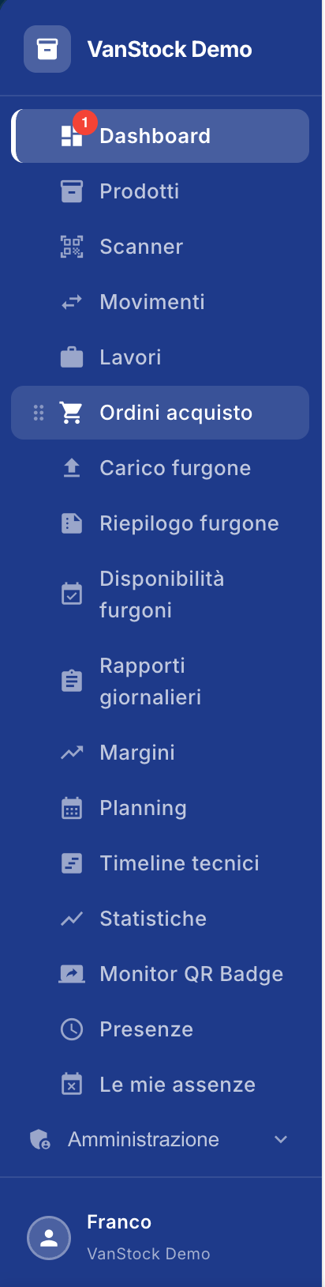
The left side menu of the application allows each user to customize the order of the menu items according to their needs and the features they use most frequently.

1. Reorder menu items
The items in the menu can be moved freely by drag & drop.
To change your order:
- Locate the item you want to move.
- Hover over the dots to the left of the entry icon.
- Press and hold the mouse button.
- Drag the item to the desired location.
- Release the mouse button.
The item will be immediately repositioned in the menu.
Example: If you use the Purchase Orders feature frequently, you can drag it up to the top of the menu items.

2. Personal organization
The menu order is personal to each user.
This means that each user can organize the items according to their preferences without changing the display of the menu of other users.
For example:
- an administrator can highlight the Administration, Reports and Statistics functions;
- an operator can place Scanner, Movements and Van Loading at the top;
- Another user can choose a completely different order.
The setting is automatically saved for the individual user and is also maintained in subsequent accesses to the application.

In summary
Function | Description
Moving | Items can be dragged to the desired position
Drag & drop | Reordering is done by dragging the dots to the left of the entry
Customization | Each user can choose their own order
Rescue | The sort order is automatically stored
Independence | Editing a user does not affect the menu of other users

Dashboard
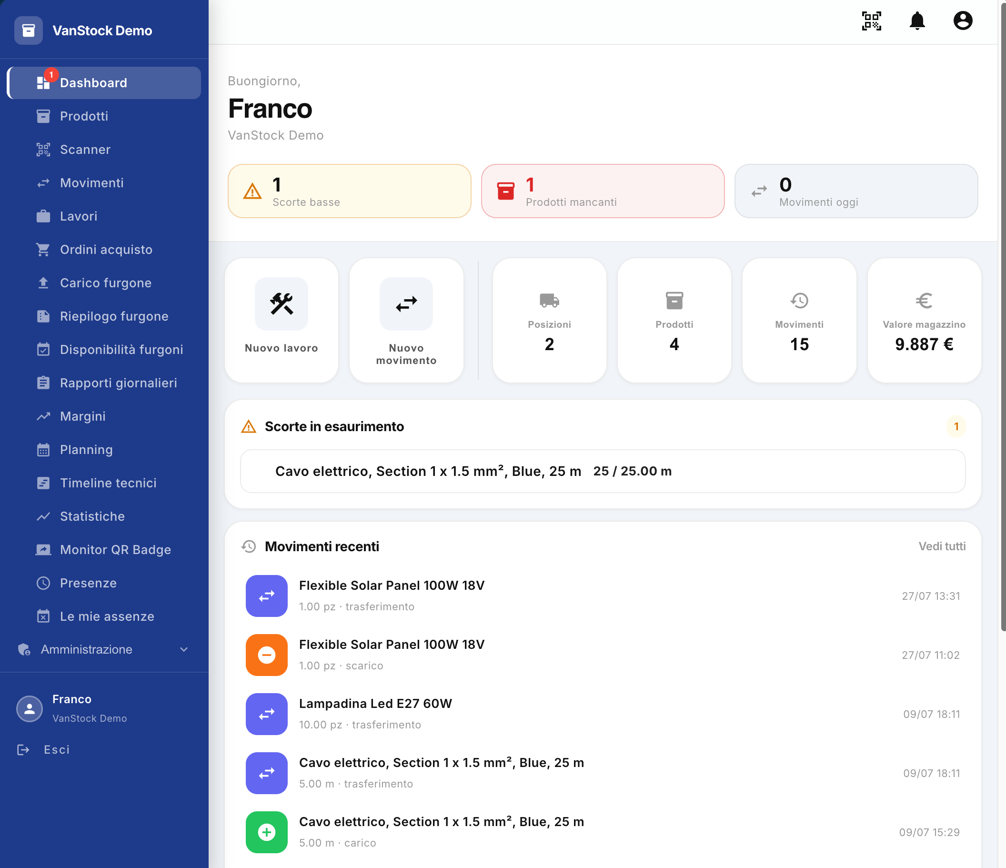
The Dashboard is the main screen of the application and provides an immediate overview of the status of the warehouse, the main activities and any situations that require attention.
From the Dashboard, the user can consult the main information, quickly access the most used functions and use direct links to view or manage anomalies in the warehouse.

1. User and work environment
At the top of the Dashboard, you'll see:
- Logon User Name: Identifies the user who is currently authenticated in the application.
- Work environment: indicates the environment to which the user is connected.
In the example shown in the figure, the logged-in user is Frank and the environment is VanStock Demo.
This information allows you to immediately verify that you are connected with you and in the correct environment.

2. KPIs and main reports
At the top of the Dashboard, there are three main indicators (KPIs), which you can select to directly access related information.

Low stock
Indicates the number of products that are close to being sold out, according to the parameters configured in the application.
Selecting Low Stock takes the user to the Products screen, with the list already filtered to display only low stock products.
The same information can be viewed in the Low Stock section, which is further down in the Dashboard.

Missing products
Indicates the presence of missing products.
By selecting Missing Products, the user is directed directly to the order that generated the missing product, so that the order and its information can be quickly verified.

Movements today
Indicates the number of movements made in the current day.
By selecting Transactions today, the user is directed to the Transactions screen, from which it is possible to consult the recorded transactions.

3. Quick access to operations
In the center of the Dashboard, there are a few buttons that allow you to quickly start the main operations.

New work
The New Job button allows you to create a new job.
By selecting the button, the user is taken to the Jobs screen, which is already set up for entering a new job.

New movement
The New Movement button allows you to post a new inventory movement.
By selecting the button, the user is taken to the Transactions screen, which is already set up for the creation of a new movement.

4. Inventory indicators
The Dashboard also presents some summary indicators relating to the status of the warehouse.

Positions
Indicates the number of locations currently in the application, such as surveyed vans and warehouses.
The value therefore allows you to have an immediate view of the number of positions available and managed by the application.

Products
Indicates the total number of products registered in the warehouse.
By selecting Products you can access the relevant screen and view the list of products in the application.

Movements
Indicates the total number of entries recorded in the application since the beginning of its use.
The value therefore represents the historical total of recorded transactions and not exclusively those made on the current day.

Inventory value
It indicates the total economic value, expressed in euros, of the products currently in stock.
The value is calculated on the basis of the products and their quantities present at that time.

5. Low stock
The Low stock section displays products that are close to being sold out.
The section is shown when there are products that meet the conditions for low stock reporting.
For each product, the main information related to availability is displayed. In the example shown:
Electrical Cable, Section 1 x 1.5 mm², Blue, 25 m — 25 / 25.00 m
The section therefore allows you to quickly identify the products that need attention without having to manually search the product list.
By selecting the Low Stock KPI at the top of the Dashboard, the user can directly access the full list of products filtered for this condition.

6. Recent movements
The Recent Entries section, at the bottom of the Dashboard, shows the last 10 entries recorded in the application.
For each entry, the main information is displayed, including:
- the type of movement;
- the product concerned;
- the quantity handled;
- the date and time of the operation.
Movements are also identified through an icon that allows you to visually distinguish the different types of operations, such as transfers, loads and unloads.
The See All link takes you to the Transactions screen and views the full list of recorded transactions.

7. Dashboard Feature Summary
The Dashboard therefore allows you to:
- verify the user and the work environment currently connected;
- quickly check for low stock;
- identify any missing products and access the relevant order directly;
- check the movements made during the day;
- create a new job quickly;
- quickly create a new movement;
- view the number of positions managed;
- view the number of products surveyed;
- view the total number of transactions recorded;
- check the overall economic value of the warehouse;
- consult products with low stocks;
- view the last 10 transactions made.
The Dashboard is therefore the starting point for the daily control and management of the warehouse, providing the user with a summary of the most important information and direct links to the related operational functions.

Products
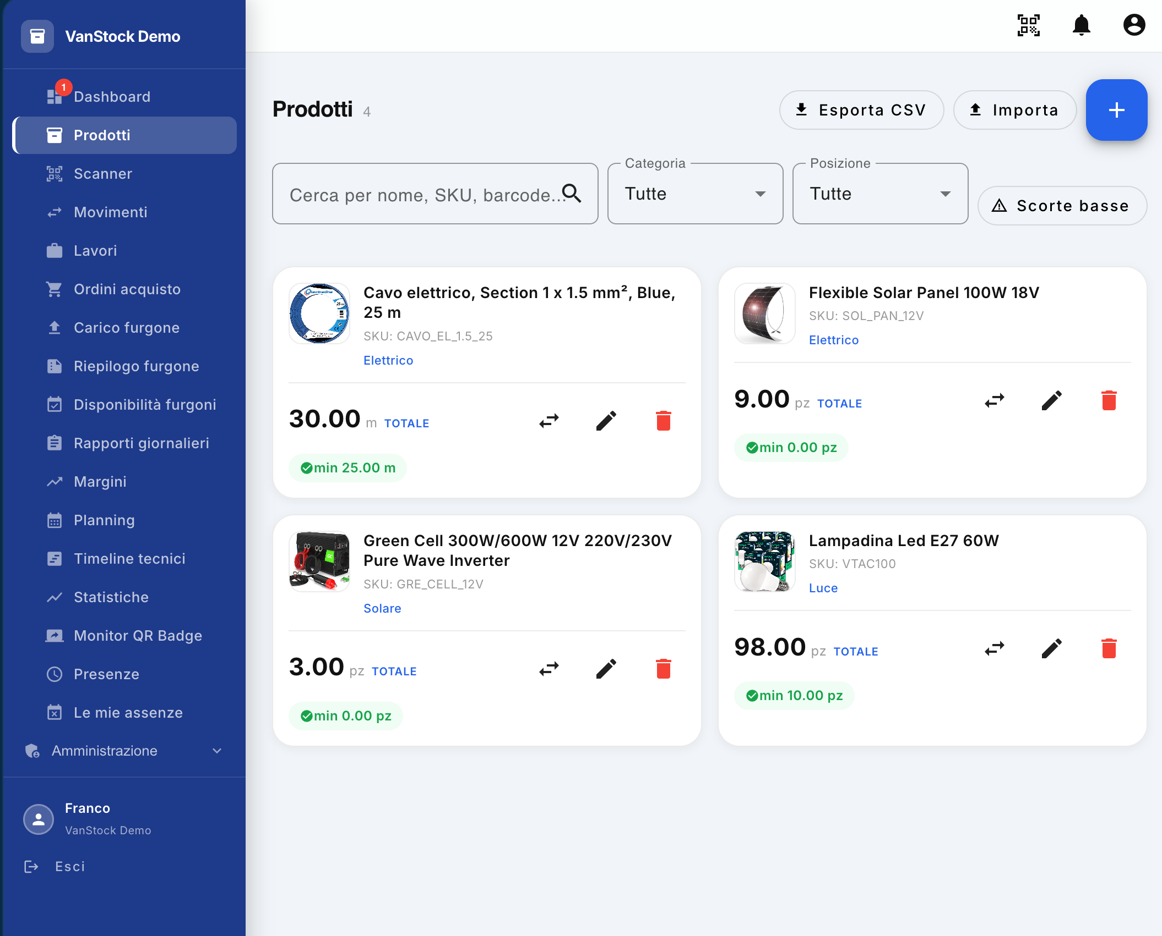
The Products screen allows you to view and manage the list of products in your warehouse. From this section it is possible to search and filter products, add new ones, modify existing data, carry out movements and delete products that are no longer needed.

1. Total number of products
A number appears next to the Products title indicating the total number of products in stock.
In the example shown, the value is 4, so there are four registered products in the warehouse.
The number is updated according to the products in the application.

2. Warehouse Export and Import
At the top of the screen, you'll find the Export CSV and Import buttons.

Export CSV
The Export CSV button allows you to export the list of products in the warehouse in CSV format.
The exported file can be used, for example, to:
- consult the warehouse data outside the application;
- make changes or updates directly on the file;
- Prepare the data for later import into the application.

Import
The Import button allows you to import a CSV file containing product data into your application.
This feature is particularly useful for batch entry of multiple products, avoiding the need to create each product individually.
You can then, for example, export the inventory, edit or integrate the data into the CSV file, and then import it back into the application to add the desired products.
Note: Before you import, make sure that your CSV file follows the format that your application expects.

3. Listing a new product
The + button, which appears in blue at the top right of the screen, allows you to create a new product individually.
Selecting the button opens the product entry mask, in which you can enter the relevant data.
The + button is therefore suitable for creating a single product, while the Import function is more suitable when a large number of products need to be entered at the same time.

4. Product research
Below the main buttons is the search field.
You can use the Search by name, SKU, barcode... to quickly locate a product in the warehouse.
The search can be carried out using, for example:
- the name of the product;
- the SKU;
- the barcode;
- other identifying data provided for by the research.
Searching allows you to quickly narrow down the displayed list and locate the product you want.

5. Filters
In addition to the text search, the screen provides several filters that allow you to narrow down the list of products.

Category
The Category filter allows you to view only products belonging to a certain category.
Selecting All does not filter on the category.

Location
The Location filter allows you to filter products based on their location, such as a certain warehouse or van.
Selecting All displays products regardless of their location.

Low stock
The Low Stock button allows you to filter the list by showing only those products that have reached or exceeded the minimum configured quantity downwards.
This feature allows you to quickly identify products that need to be replenished.

6. Product Sheet
The products are displayed in special tiles, one for each product in the list.
Each tile contains the main information about the product and the commands for its management.

Product image and name
At the top of the tile, you'll see the product image, when available, along with the main product name or description.
In this example, the product is:
Power Cable, Section 1 x 1.5 mm², Blue, 25 m

SKU
The product's Stock Keeping Unit (SKU) number is displayed below the name.
In the example:
CAVO_EL_1.5_25
The SKU represents the identification code used to distinguish the product within the application.

Category
Below the SKU, you'll see the category to which the product belongs.
The category is displayed in blue and is clickable, allowing you to use it for browsing or managing products belonging to the same category.
In this example, the category is Electrical.

7. Quantity in stock
The middle of the tile displays the total quantity currently available for the product.
The quantity is accompanied by the unit of measurement associated with the product.
The example of the electrical cable shows:
30.00 m — TOTAL
This means that at that moment there are a total of 30 meters of that product in the warehouse.
The unit of measurement depends on the configuration of the product: it can be, for example, pieces, meters or other units provided for by the application.

8. Minimum quantity and low stock
Below the available quantity, the minimum quantity configured for the product is displayed.
In the example:
min 25.00 m
This value indicates that a minimum quantity of 25 meters has been set for the product.
When the available quantity falls to or below this value, the product is considered to have low stock.
The situation is reported in the Dashboard, where the user can view an alert regarding low stock.
This feature allows you to quickly identify products that need to be replenished and, when necessary, reorder them.

9. Product Actions
At the bottom of the tile, there are three icons that allow you to perform the main operations on the product.

Handling
The icon with the two arrows allows you to carry out a movement of the product.
The function allows you to move a certain quantity of the product to or from another position, for example:
- from a warehouse to a van;
- from a van to a warehouse;
- from one warehouse to another warehouse;
- from one van to another van.
Movement updates the quantities available at the affected locations.

Edit
The pencil icon allows you to edit the product data.
By selecting this icon, you can access the edit mask and update the information configured for the product.

Delete
The red trash can icon allows you to delete the product.
Deletion should be done carefully, as it will remove the product from the list of products managed by the application.

10. Operational management of products
The Products screen is therefore the main point for managing the master data and the availability of products.
From this screen, the user can:
- view the total number of products present;
- search for a product by name, SKU or barcode;
- filter products by category;
- filter products by location;
- view only products with low stock;
- view the available quantity of each product;
- verify the minimum quantity configured;
- create a new product;
- import multiple products via CSV file;
- export the warehouse list in CSV format;
- move a product between different positions;
- modify the data of a product;
- delete a product.
The screen therefore allows you to have both the master data of the products and their availability in the warehouse under control, while providing the necessary tools for the main management operations.

Creating a new product
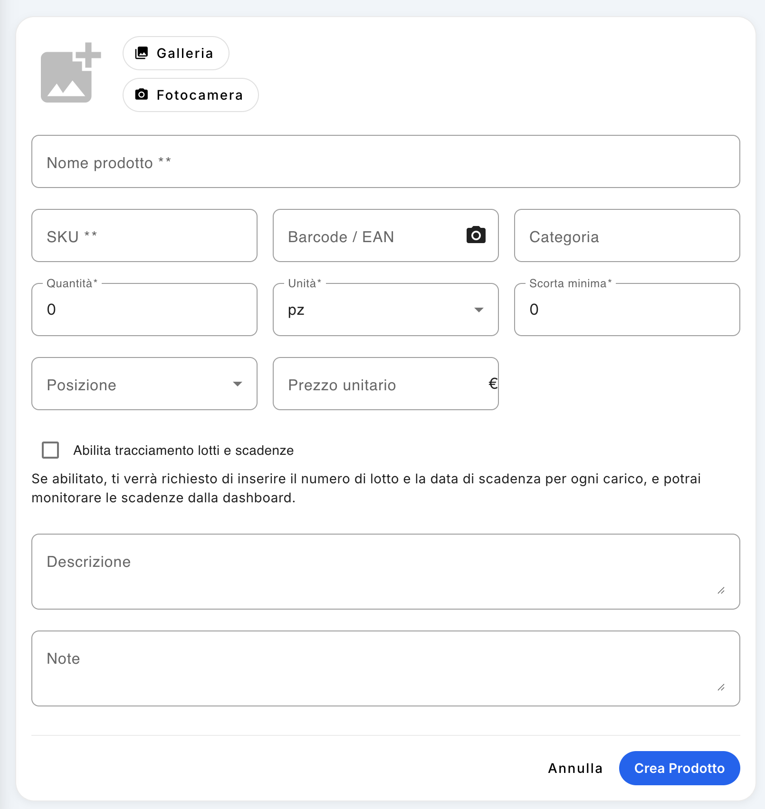
From the Products screen, selecting the + button allows you to create a new product individually.
The creation screen allows you to enter all the information you need to identify and manage the product within the warehouse, including quantity, location, price and, if necessary, information related to batches and expiry dates.

1. Product Image
At the top of the screen, you can associate an image with your product.
The image can be inserted in two ways:
- Gallery: allows you to select an image already on the device;
- Camera: Allows you to directly take a photograph of the product using your device's camera.
The image is used to facilitate visual recognition of the product within the Products list.

2. Product Name
The Product Name field is required and allows you to enter the name by which the product will be identified in the application.
It is advisable to use a clear and sufficiently descriptive name, so as to allow easy identification of the product during subsequent searches and movements.

3. SKU
The SKU field is required.
The SKU (Stock Keeping Unit) is the product identification code used within the application.
Each product must be identified by a SKU consistent with the coding system adopted.

4. Barcode / EAN
The Barcode / EAN field allows you to associate the relevant barcode with the product.
The code can be entered manually or scanned via the camera, by selecting the icon in the field.
This function allows you to use the camera of your smartphone or compatible device as a barcode reader, or a special barcode reader, to directly capture the code shown on the product.
The use of the barcode subsequently facilitates the search and identification of the product.

5. Category
The Category field allows you to associate the product with a category.
The category allows you to organize your products and then use the corresponding filter on the Products screen.
It is therefore advisable to assign the correct category to each product, in order to keep the warehouse master data tidy and easily consultable.

6. Quantity
The Quantity field indicates the initial quantity of the product that is entered into the system when it is created.
The quantity must be consistent with the unit of measure selected in the next field.
For example, if the unit is set to pieces, a quantity of 10 will be 10 pieces; if the unit is set to meters, it will be 10 meters.

7. Units of measurement
The Unit field allows you to define the unit of measure used for the product.
Different units of measurement can be used, depending on the type of product, for example:
- pieces (pcs);
- kilograms (kg);
- liters (L);
- milliliter (ml);
- meters (m);
- other units available or configurable in the application.
The choice of the unit is important because it determines how the quantities of the product will be expressed and managed in subsequent loading, unloading and handling operations.

8. Scorta minima
The Minimum Stock field allows you to define the minimum quantity that must be maintained for the product.
This value is used by the system to identify low stock situations.
When the available quantity of the product reaches or falls below the minimum quantity set, the product is reported as low stock and the anomaly is highlighted in the Dashboard.
Setting the minimum stock then allows you to automatically track the products that need to be replenished.

9. Location
The Location field indicates the location where the initial quantity of the product is recorded.
The location can be, for example:
- a central warehouse;
- a certain compartment of the warehouse;
- a van;
- another position surveyed in the application.
The correct selection of the position is important because it allows you to know where the product is physically located and allows you to correctly manage its subsequent movements.

10. Unit price
The Unit Price field allows you to enter the economic value of a single unit of the product.
The price is expressed in euros (€).
The data is also used to calculate the total value of the inventory displayed in the Dashboard.

11. Tracking lots and expirations
You can activate the Enable batch and expiry tracking option.
This feature should be used when you need to keep track of the batch number and expiration date of your products.
When enabled, the following will be required during each subsequent loading of the product:
- the batch number;
- the expiration date.
In this way, the application can maintain information relating to the different batches and allow the monitoring of expiry dates directly from the Dashboard.
This feature is especially useful for products for which batch and expiration date traceability is important.

12. Description
The Description field allows you to enter additional information that is useful for identifying or describing the product.
It can be used, for example, to specify technical characteristics, dimensions, model, color or other information that does not fit in the main fields.

13. Notes
The Notes field allows you to add additional annotations related to the product.
The notes can be used for operational information or special indications that you want to keep in the product master data.

14. Product creation
After filling in the necessary data, selecting the Create Product button registers the product in the application.
The Cancel button allows you to exit the screen without creating the new product.
Fields marked with * are required and must be filled in before you can complete the creation.

15. Summary of product data
To successfully create a new product, you can then configure:
- product image;
- product name;
- SKU;
- barcode/EAN;
- category;
- initial quantity;
- units of measurement;
- scorta minima;
- position;
- unit price;
- tracking of batches and deadlines;
- description;
- notes.
A correct compilation of this data allows the application to manage the product not only as an element of the master data, but also in relation to the quantity available, the position, the economic value, the minimum stocks and, when applicable, the traceability of batches and expiry dates.

Scanner Barcode
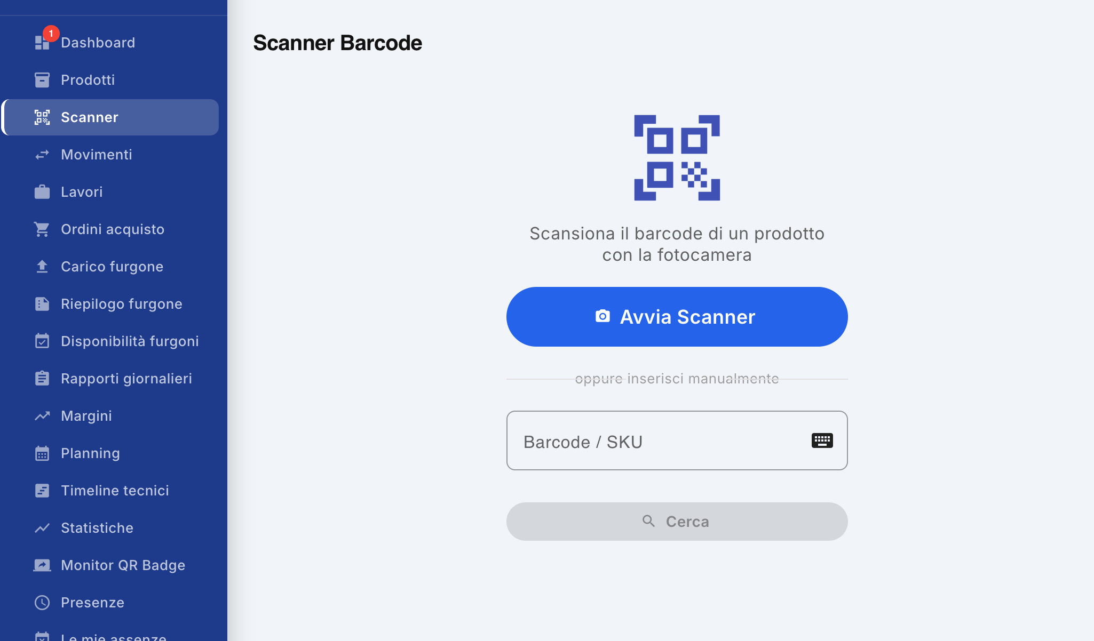
The Barcode Scanner feature allows you to quickly locate a product using the barcode, without having to manually search the Products screen.
The function uses the camera of the device from which the user is connected to the application to read the barcode of the product.

1. Start the scanner
To use the scanner, go to the Scanner item from the side menu.
The Start Scanner button appears on the screen.
By selecting the button, the application prompts you for access to your device's camera and starts scanning mode.
Note: To use this feature, you must allow the app to access your device's camera.

2. Barcode scanning
Once the camera is started, frame the barcode of the product.
The application automatically detects the code and uses it to identify the associated product.
Scanning eliminates the need to manually type in the name, SKU, or barcode on the Products screen.

3. Access to the product sheet
Once the barcode has been recognized, the application identifies the corresponding product and allows you to directly access the relevant product sheet.
This mode is particularly useful when you are physically working in the warehouse and have the product available: you just need to frame the code to quickly reach the associated information and functions.
This way you don't have to:
- access the Products screen;
- manually search for the product;
- identify the product within the list;
- Open the relevant tab.

4. Manual code entry
In addition to scanning via camera, you can manually enter the code in the Barcode/SKU field.
This mode can be used when:
- the barcode is not readable by the camera;
- the product does not have an easily scannable barcode;
- you have the SKU code or barcode directly;
- You are using a device that cannot be scanned by camera.
After entering the code, selecting Search for application searches for the corresponding product.

5. Operational Usage
The Barcode Scanner is therefore a tool for quick access to a product sheet.
It is particularly suitable for activities carried out directly in the warehouse, because it allows a product to be identified simply by using the device's camera, reducing the time needed for research.
The feature allows you to:
- scan the barcode using the camera;
- quickly identify the product;
- directly access the relevant card;
- avoid manual search in the Products list;
- manually enter the barcode or SKU when necessary.

Movements
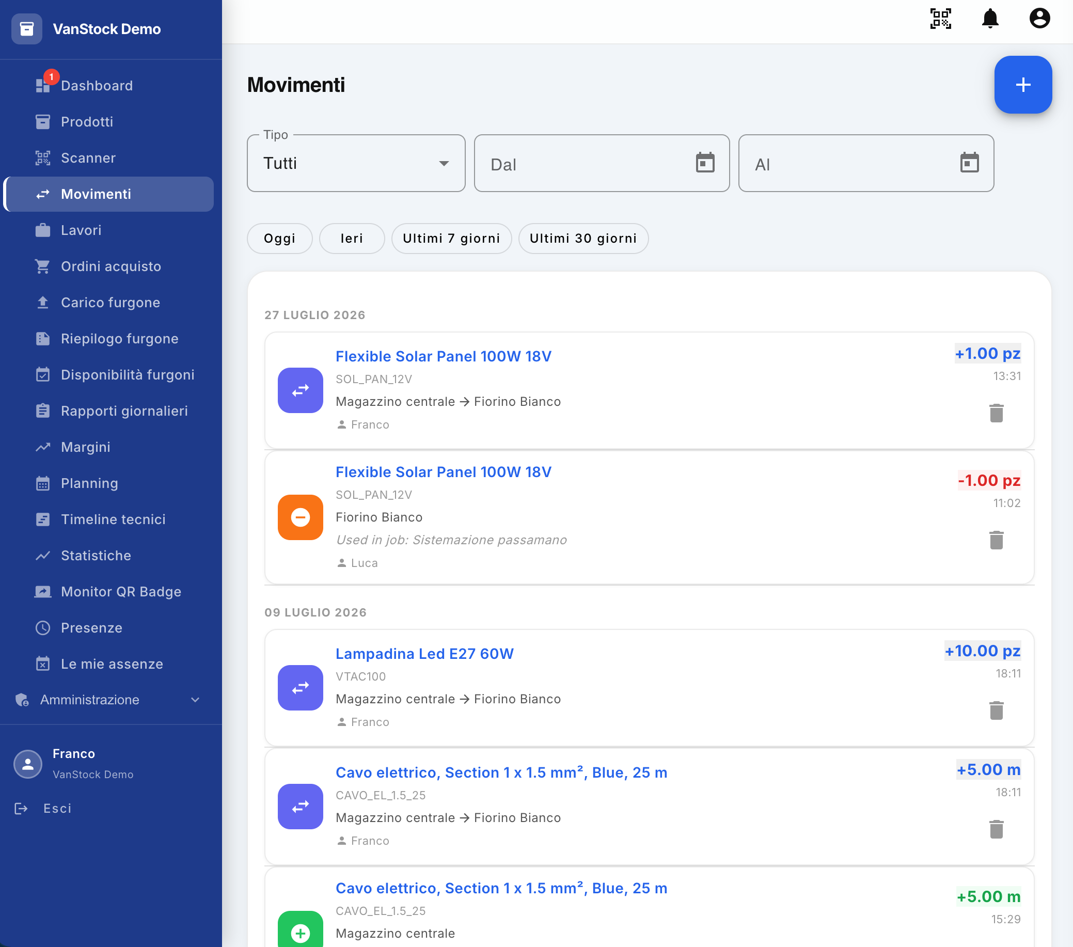
The Transactions screen allows you to consult and manage the history of movements carried out in the system.
Each movement represents a variation in the availability of a product and allows you to know which product has been handled, in what quantity, from which position, for what reason and by which user.
From the screen it is also possible to create a new movement and filter the history by type and period.

1. Creating a new movement
At the top right of the screen, there is a blue + button .
By selecting the button, you can access the procedure for creating a new movement.
The function allows you to register a new warehouse operation and consequently update the availability of the product concerned.

2. Motion filters
At the top of the screen, filters are available to help you quickly locate the gestures of interest.

Type
The Type filter allows you to select the type of motion to be displayed.
Selecting All displays all entries, regardless of their type.

Date range
You can specify a time range using the following fields:
- From: start date of the period;
- To: End date of the period.
This allows you to view only movements made within the selected range.

Quick filters
To speed up the search, four preset filters are available:
- Today: Displays the current day's movements;
- Yesterday: Displays the previous day's transactions;
- Last 7 days: Displays the movements of the last seven days;
- Last 30 days: Displays the movements of the last thirty days.
Quick filters allow you to search without having to manually enter dates.

3. List of transactions
At the bottom of the screen, the list of recorded transactions is displayed.
Transactions are organized chronologically and grouped by date.
Each row contains the main information about the operation, including:
- type of movement;
- product name;
- SKU;
- position involved;
- quantity handled;
- possible reference to associated work;
- the user who carried out the operation;
- hour of movement.
The color and symbol of the icon allow you to immediately recognize the type of movement.

4. Transfer
The transfer gesture is identified by the purple icon with two white arrows.
Indicates that a quantity of product has been moved from one location to another.
For example, a product can be transferred:
Central warehouse → Fiorino Bianco
In this case, the quantity is transferred from the central warehouse to the Fiorino Bianco van.
Handling therefore involves a change in the availability of the product in the positions involved.

5. Using a Product
The usage gesture is identified by the orange icon with the minus symbol.
Indicates that a certain amount of product has been used and therefore removed from the location availability.
For example, a usage can be associated with a job.
In the example shown, the product:
Flexible Solar Panel 100W 18V
It was used for work:
Handrail arrangement
by the user Luca.
The product was in the White Florin position.
The quantity used is then subtracted from the availability of the product present in that location.

6. Loading a product
The load movement is identified by the green icon with the plus symbol.
Indicates that a certain amount of product has been added to the availability of a location.
For example, a load can occur after a purchase order is received.
In the example shown, the following have been added:
5.00 m Power Cable, Section 1 x 1.5 mm², Blue, 25 m
at the Central Warehouse.
The movement therefore represents the increase in the quantity available as a result of receiving the product.

7. Information associated with movement
Each movement retains the information necessary to reconstruct the operation carried out.
In particular, in the list it is possible to verify:
- product affected by the movement;
- Product SKU ;
- quantity handled;
- position from which the product was taken or in which it was inserted;
- destination location, in the case of a transfer;
- associated work, when the product has been used for a job;
- the user who carried out the operation;
- date and time of the movement.
This information allows you to keep a history of the operations carried out and to check how the availability of the products has changed over time.

8. Deleting a Motion
Each movement has a trash can icon on the right of its row.
Deleting entries is an operation reserved exclusively for the administrator.
Users who do not have the relevant permissions cannot delete the posted transactions.
The administrator can use the trash to remove an entry from the history when needed.
Attention: the elimination of an entry must be carried out with particular caution, since the movement represents a change in the warehouse quantities and is part of the history of operations carried out.

9. Summary
The Movements screen allows you to:
- create a new movement;
- view the history of movements;
- filter transactions by type;
- filter entries by date range;
- use quick filters for today, yesterday, last 7 days and last 30 days;
- visually distinguish transfers, uses and loads;
- check the product, quantity and position concerned;
- verify the user who performed the operation;
- check for any work associated with a use;
- Delete transactions, when authorized, through the admin user.
The screen therefore represents the operational history of the warehouse, allowing you to monitor changes in quantities and reconstruct the operations carried out on the products.

Creating a new movement
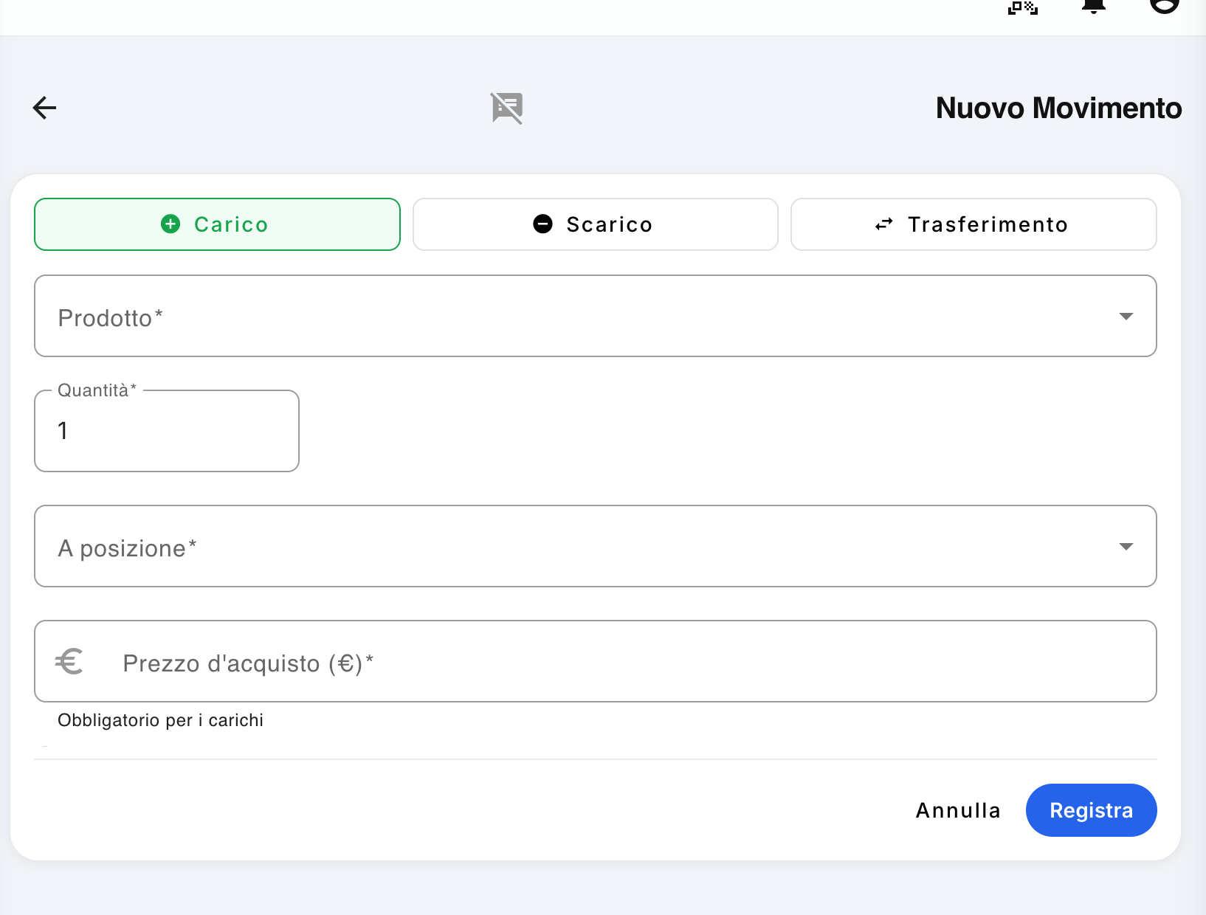
From the Movements screen, selecting the + button allows you to create a new inventory movement.
The New Movement window allows you to register three different types of operations:
- Load;
- Exhaust;
- Transfer.
The choice of type determines how the quantity of the product is changed or moved within the warehouse.

1. Movement Type Selection
At the top of the screen, there are three buttons that allow you to select the type of movement.

Loading
Load is used when a quantity of product is added to a location.
A typical case is when a vendor receives a purchase order. When purchased products arrive in the warehouse, you must post a load to update the available quantity.
If you select Load, in addition to the product, quantity and location data, the purchase price is also requested.

Exhaust
Unloading is used when a quantity of product is picked from the location, for example, because it has been used during a job.
Discharging then reduces the available amount of product at the selected location.

Transfer
Transfer is used when a quantity of product needs to be moved from one location to another.
For example, you can transfer a product from the Central Warehouse to a van, or from one van to another van, or between different locations managed by the application.
The transfer changes the quantities in the affected locations, without representing a new purchase or use of the product.

2. Product selection
The Product field allows you to select the product that is affected by the movement.
The field is required.
The choice of product also determines the unit of measurement with which the quantity must be indicated.

3. Quantity
The Quantity field allows you to indicate the quantity of product affected by the movement.
The value must be consistent with the unit of measurement associated with the product.
The quantity entered is:
- addition to availability in the case of a load;
- subtracted from availability in the event of a discharge;
- moved from one position to another in the case of a transfer.

4. Location
The To position field allows you to indicate the position affected by the movement.
For example, the location can be a warehouse, a van, or another location that you have registered in your application.
In the case of a load, indicates the location where the received product will be registered.
In the case of a transfer, identify the destination location of the product.
In the case of a discharge, it identifies the location from which the product is taken.
The correct selection of the location is essential to keep the availability of products in the different warehouses and vans up to date.

5. Note and reference work
At the top of the screen, there is a special icon for notes.
By selecting this icon you can add additional information to the movement, in particular:
- a note relating to the transaction;
- the reference site or work to which the movement is associated.
This feature is particularly useful, for example, when a product is downloaded because it is used during a specific job.
In this way, in addition to recording the decrease in product availability, it is possible to specify for which construction site or job it has been used.
The reference to work therefore makes it possible to maintain greater traceability of movements and to understand the reason why a particular product was picked or used.
Example: A Flexible Solar Panel is used during the Handrail Arrangement work . By recording the unloading, it is possible to associate the movement with the related work, so that the history displays not only the product and the quantity used, but also the work for which the unloading was carried out.

6. Purchase price
The Purchase Price (€) field is required only for Load type entries.
When a product is received as a result of a purchase from a supplier, the price actually paid for the product must be indicated.
The purchase price is recorded together with the movement and is an important data for subsequent margin statistics.
Important: For Load type entries, the purchase price is a required field. For Unloading and Transfer, the purchase price is not required.

7. Motion recording
Once the required data has been filled in and the note and reference work have been entered, by selecting Record the movement is saved.
The operation updates the availability of the product based on the type of movement selected and is added to the history of the Transactions screen.
The Cancel button allows you to exit the mask without recording the movement.

8. Examples of use

Example 1 — Load from supplier
An order containing 10 bulbs is received.
- Select Load.
- Select the product.
- Enter quantity 10.
- Select the position where the bulbs are deposited.
- Enter the purchase price.
- If necessary, add a note.
- Select Record.
The quantity of the product in the position is incremented by 10 units.

Example 2 — Discharge for use
During a job, 2 pieces of a certain product present on a van are used.
- Select Drain.
- Select the product.
- Enter the quantity 2.
- Select the location of the van.
- Open the notes section.
- Select the reference job/jobsite.
- If necessary, insert an additional note.
- Select Record.
The availability of the product on the van is reduced by 2 units and the movement remains associated with the indicated work.

Example 3 — Transfer
You need to transfer 5 meters of electrical cable from the central warehouse to a van.
- Select Transfer.
- Select the product.
- Enter the quantity 5 m.
- Select the destination location.
- If necessary, add a note or reference.
- Select Record.
The 5 meters are subtracted from the availability of the central warehouse and added to the availability of the destination van.

9. Summary
The New Movement form therefore allows you to update the availability of the warehouse through three fundamental operations:
- Load → add products to a location;
- Unloading → removes products from one location;
- Transfer → move products from one location to another.
For each movement, the product, quantity and location concerned must be indicated . In the case of a Cargo, the purchase price must also be indicated.
Through the notes icon it is also possible to add a note and associate the movement with the related construction site or work, improving the traceability of the operations carried out.

Works / Construction sites
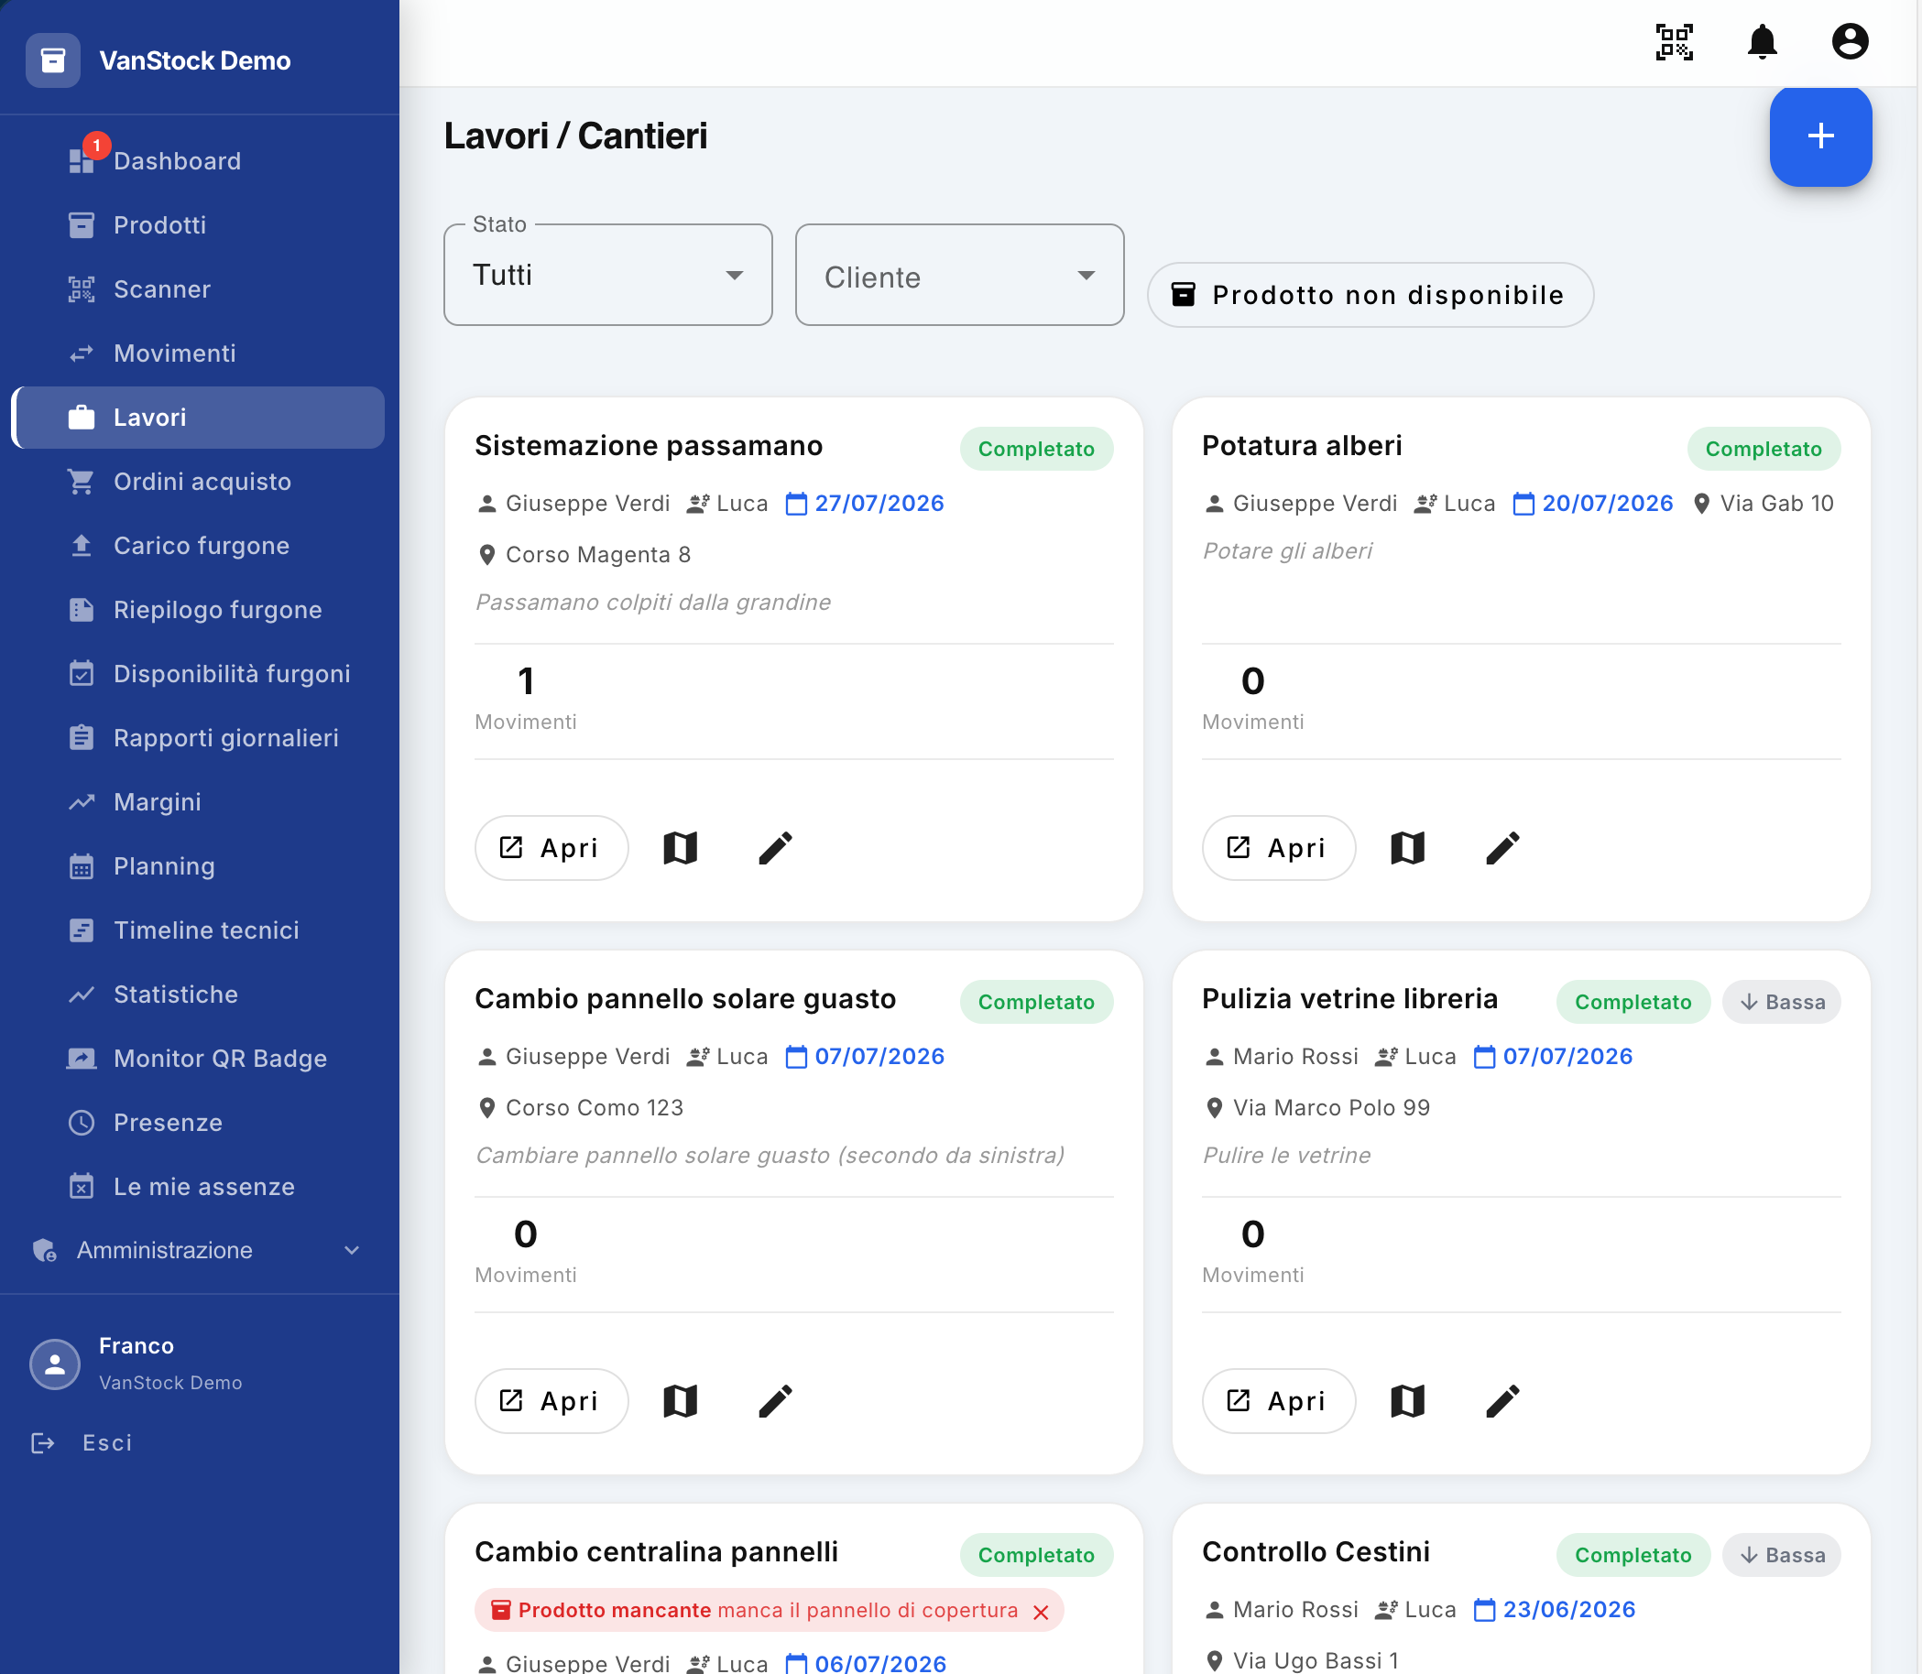
The Jobs / Jobs screen allows you to view and manage the list of jobs in the system. Each job represents an intervention to be performed and contains the information necessary to identify it, assign it to the operator and monitor its progress.

1. Creating a new job
At the top right of the screen, there is a blue + button.
By selecting the button you can access the form for creating a new job.
In addition to the identification data of the intervention (Title, Customer, Assigned Operator, Scheduled Date and Time, Priority, Address and Notes), the mask allows you to optionally specify the materials necessary for the completion of the work:
Material Integration (Optional): By clicking on the + Add Required Items (or Materials) button, a modal window opens in which you can search and check the necessary products, indicating the required quantity (Required Qty).
Van Stock Tip: If materials are specified, the system will compare the demand with the actual stock in the individual vans. The operator will see a visual recommendation (Green badge for vans that have 100% of the material on board, Red badge if any component is missing) to facilitate the choice of the most suitable vehicle.
The new job can then be assigned to the worker in charge of the intervention and monitored through the relevant card.

2. Filters
At the top of the screen, there are two filters that allow you to narrow down the list of jobs displayed.

Status
The Status filter allows you to view jobs based on their progress.
The available statuses are:
- Open – the job has been created but has not yet started;
- In progress – the work has been taken over and is being carried out;
- Completed – the job has been completed;
- Canceled – the job has been canceled and should not be performed.
Selecting All displays jobs regardless of their status.

Customer
The second filter allows you to select jobs associated with a specific client.
This makes it possible, for example, to quickly identify all the interventions required by a particular customer.

Product not available
The Product Not Available filter is also available.
This filter allows you to quickly isolate and highlight all jobs for which the lack of one or more materials necessary for execution has been reported (via mobile app or Van Stock control), allowing the office to intervene promptly for restocking or reprogramming.

3. Job sheets
Each job is displayed within a tile that contains the main information relating to the intervention.
The card allows you to have an immediate view of the status of the work, the customer, the worker in charge, the date and place of the intervention.

Title and status
The title of the job is displayed at the top of the tile.
For example:
Handrail arrangement
A colored indicator appears next to the title, identifying the current status of the job.
For example, the green Completed badge indicates that the work has been completed.

4. Customer, Worker and Date
The next part of the tab displays the main information about the work assignment:
- Customer – the customer for whom the intervention is to be performed;
- Worker – the operator in charge of carrying out the work;
- Date – the date the job was assigned.
For example, on the Handrail Arrangement tab:
- Client: Giuseppe Verdi;
- Worker: Luca;
- Date: 27/07/2026.
This information allows you to quickly identify who requested the intervention, who must perform it and when it was assigned.

5. Address of the intervention
The tile also displays the address where the work is to be done.
For example:
Corso Magenta 8
The address therefore indicates the physical place where the worker will have to go to carry out the intervention.

6. Job Description
Below the address, you'll see the job description.
The description contains the information provided by the customer at the time of requesting the intervention and allows the worker to understand the activity to be carried out.
For example:
Passamano hit by hail
The description can then provide useful details about the issues encountered or the task required.

7. Movements associated with work
Each tile also shows the number of movements made within the job.
The number allows you to quickly understand how many movements of products have been recorded in relation to that intervention.
For example, if you see:
1 Movement
This means that a product movement associated with the job has been posted.
This information is particularly useful for verifying the use of materials during the execution of the intervention.

8. Available Actions
At the bottom of each tile, there are three functions.

Open
The Open button gives you access to the detail of the job.
Within the detail it is possible to consult the complete information relating to the intervention and the activities associated with it.

Map
The map icon allows you to view geographical information on the map about the operations carried out during the work.
The map can show:
- the points where the operations were carried out;
- the related geographical markers/placeholders;
- the positions associated with the activities;
- the thumbnails of the photographs taken during the intervention, positioned on the map at the point where the photograph was acquired.
This function then allows you to visually associate activities and photographs with their geographical location.

Edit
The pencil icon allows you to enter the editing mode of the work.
This feature allows you to edit the job data, according to the user's permissions.

9. Product Not Available Reporting
When the worker takes charge of a job but finds that the van is missing one of the products needed to perform it, the job may be reported as Product Not Available.
The report is highlighted directly in the relevant tile with a red message.
For example:
Product missing – cover panel missing
This indication allows you to immediately identify the jobs that cannot be completed due to lack of material.
The Product Not Available filter also allows you to view only these jobs, making it easier to manage jobs that require procurement.

10. Summary
The Works / Construction sites screen allows you to:
- view all the jobs in the system;
- create a new job;
- filter jobs by status;
- filter jobs by customer;
- identify jobs with unavailable products;
- verify customer, worker, date and address of the intervention;
- consult the description provided by the customer;
- check the number of movements associated with the job;
- open the details of the work;
- view the operations and associated photographs on the map;
- edit the job data.
The screen is therefore the main point of reference for monitoring and managing interventions, allowing you to quickly identify the status of each job and any problems related to the availability of materials.

Details of works
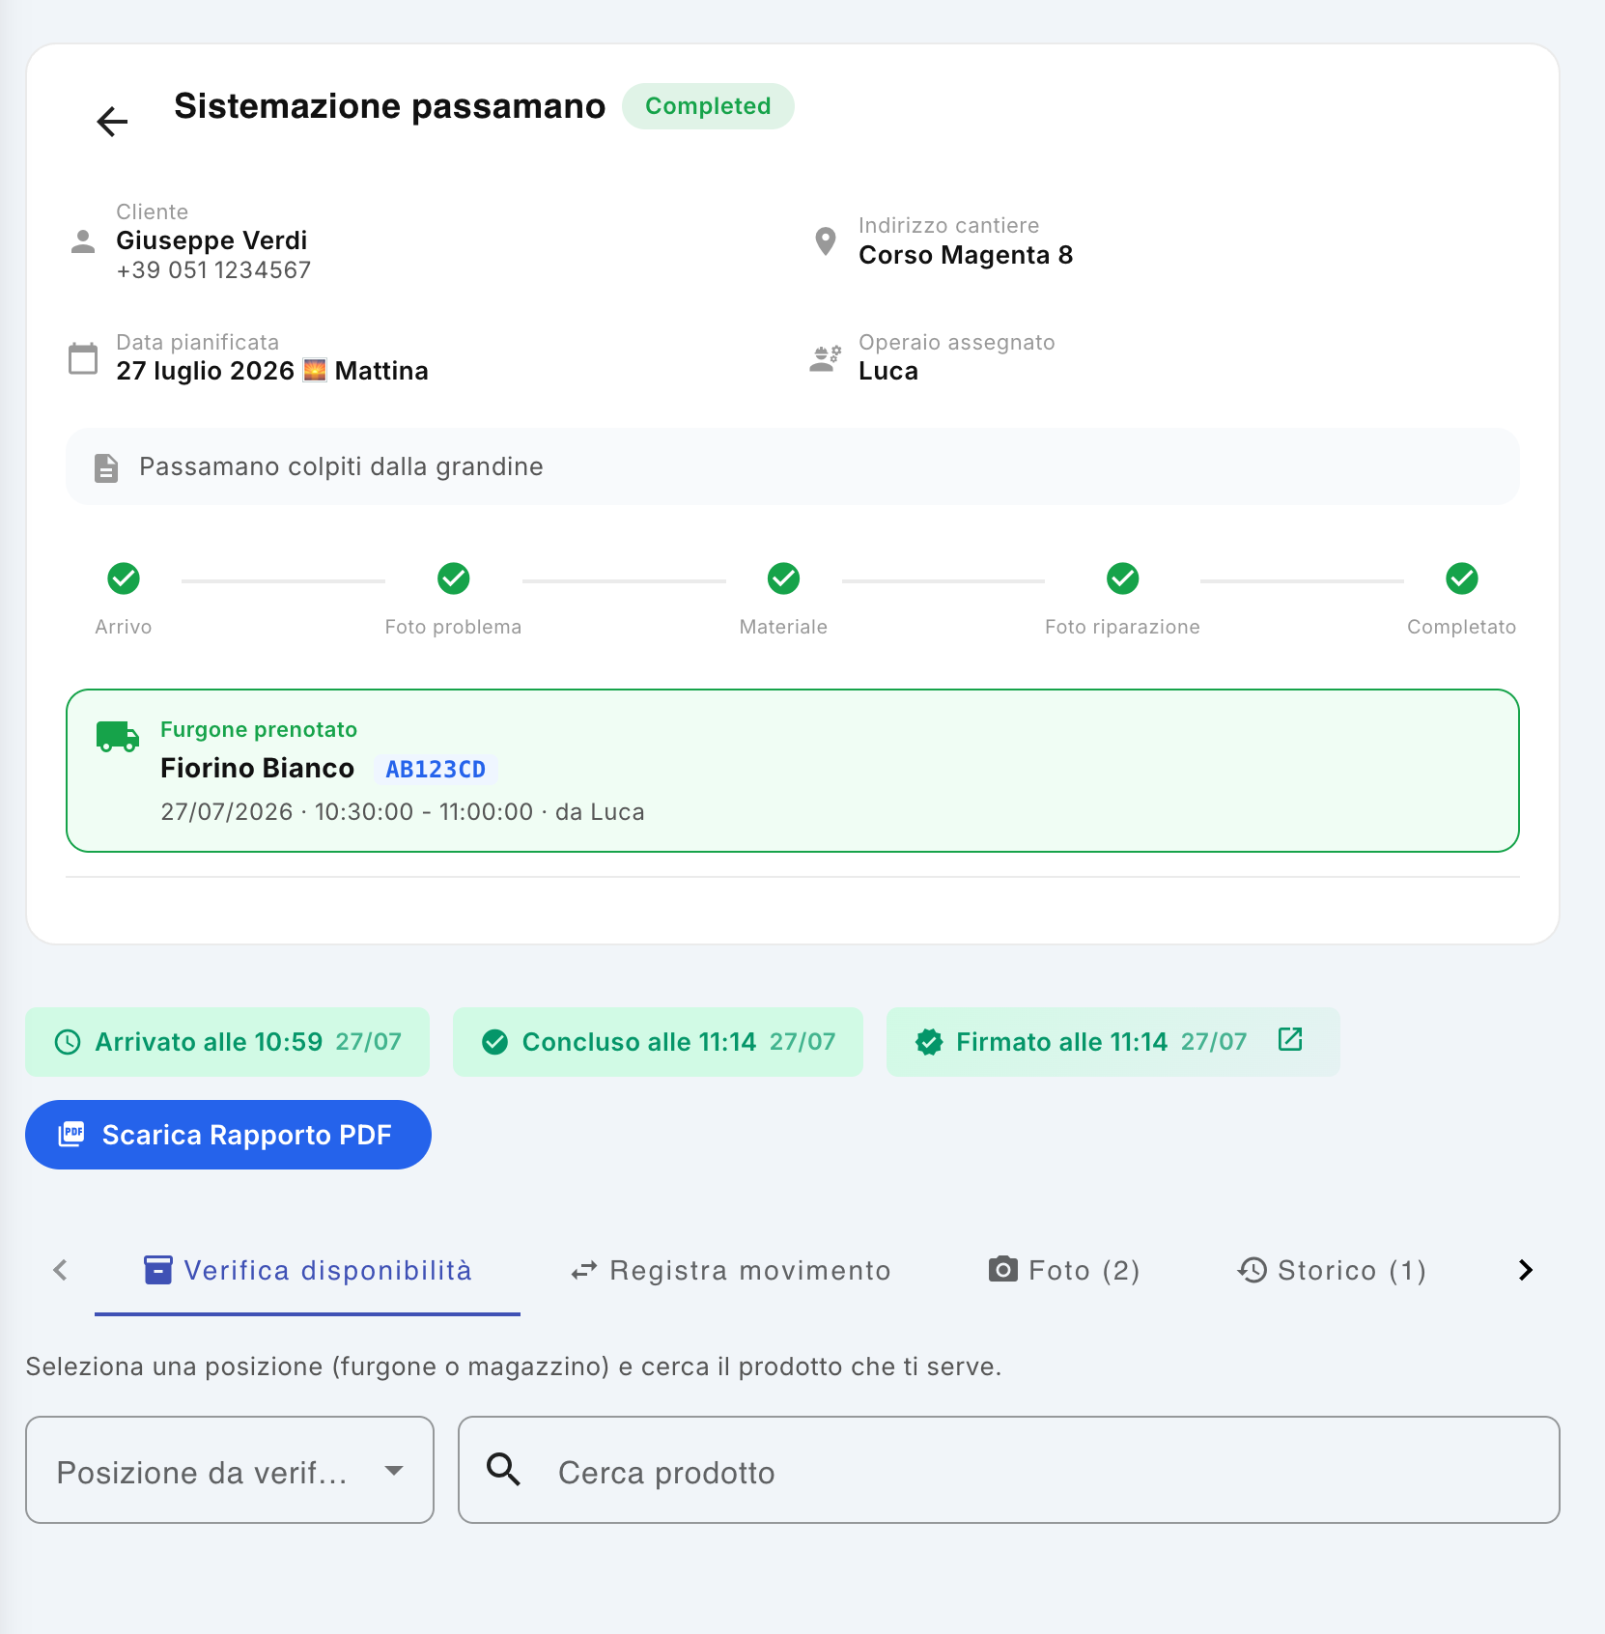
The Job Detail screen allows you to view all the information relating to an individual job, track its progress, check the availability of the necessary materials, record product movements and consult the documentation associated with the intervention.

1. Main information of the work
At the top of the screen, the main information of the job is displayed:
- Job title: Identify the job, such as Handrail Arrangement.
- Job status: Indicates the current status of the job. The example displays Completed, indicating that all planned tasks have been completed.
- Customer: Shows the customer's name and phone number.
- Construction site address: indicates the place where the work is to be carried out.
- Planned date: indicates the date and time frame for the intervention, for example, July 27, 2026 – Morning.
- Assigned Worker: indicates the operator in charge of carrying out the work.
- Description/note: contains the information provided by the customer or indications relating to the intervention. In the example: Passamano hit by hail.
This information allows you to immediately have a complete view of the intervention without having to access other sections of the application.

2. Work Progress
Below the main information there is a sequence of five phases that allows you to follow the progress of the intervention.
The phases are:
- Arrival – confirms that the worker has physically arrived at the work address.
- Problem photo – indicates that photographs of the problem you are experiencing have been taken.
- Material – indicates that material was used to carry out the intervention.
- Photo repair – indicates that photographs were taken after the repair was performed.
- Completed – indicates that the work has been completed and that the customer has confirmed the intervention by signing.
The dots progressively turn green as the worker completes the different phases. When all phases are completed, the work changes to the status of Completed.

3. Booking the van
When a van has been booked for the intervention, a special green box is displayed containing the booking information.
The following are indicated:
- the van booked;
- the license plate of the vehicle;
- the worker who made the reservation;
- the date of the reservation;
- the time interval during which the van was occupied.
In the example, the Fiorino Bianco, plate AB123CD, was booked by Luca for 27/07/2026 from 10:30 to 11:00.
This information allows you to check which vehicle has been associated with work and in which time slot.

4. Hours of the intervention and signature of the customer
The next part shows the actual times relating to the intervention:
- Arrived at: indicates the time when the worker reached the workplace.
- Completed at: indicates the time of conclusion of the intervention.
- Signed at: Indicates the time the customer signed to confirm that the job was performed.
Next to the signing time, there is an icon that allows you to view the image of the customer's signature.

5. PDF Report
The Download PDF Report button allows you to generate and download the report for your job.
The report collects the information of the intervention and constitutes the summary documentation of the work carried out.

6. Operational sections of the detail
At the bottom of the screen there are four tabs that allow you to access the main operational functions associated with the work.

6.1 Check availability
The Check availability section allows the worker to check in advance if the material necessary to carry out the work is available in the booked van.
You can:
- select the location to be checked, for example the van;
- search for the necessary product;
- Check the quantity available.
This feature allows you to carry out a check before going to the site, reducing the risk of arriving at the construction site without the necessary material.

6.2 Record Motion
The Record Motion section allows you to record the usage of a product while the job is being performed.
For example, if a solar panel is used during the arrangement of the handrail, the worker can record the discharge of the product by associating it with the work.
The recorded movement automatically updates the availability of the product and is associated with the specific intervention.

6.3 Photos
The Photos section allows you to browse the photographs associated with the work.
Images can document, for example:
- the initial situation and the problem encountered;
- the activities carried out;
- the final result of the repair.
The number displayed next to Photos indicates how many images have been associated with the job.

6.4 History
The History section allows you to consult the movements of the products associated with the specific job.
The number displayed next to the History item indicates how many movements have been recorded for the intervention.
In this way, it is possible to verify which materials have been used and maintain traceability of the operations carried out.

7. Work Workflow
The Work Detail screen then accompanies the intervention from planning to completion:
Planning → Arrival → Photo of the problem → Verification/Use of equipment → Photo of the repair → Completion → Signature of the customer
Throughout the process, the application keeps associated with the job information about the customer, the worker, the van, the materials used, the photographs, the schedules and the final confirmation of the customer.

Geolocation map of work
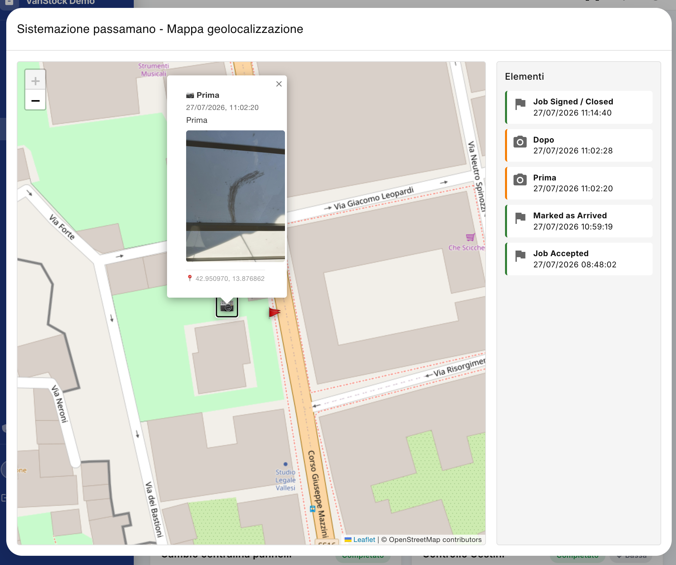
The Geolocation Map feature allows you to view the events recorded during the execution of a job on the map, showing where and when the activities were performed and where multimedia content, such as photographs and videos, was captured.
The map is accessible from the Jobs screen, by clicking on the map icon on the job tile.

1. Map Header
At the top of the window, the title of the job is displayed followed by the words Geolocation Map.
For example:
Handrail arrangement – Geolocation map
This means that you can always immediately identify which intervention the displayed information refers to.

2. Map View
The main part of the screen is occupied by the geographical map, on which the events recorded during the execution of the work are reported.
Items are placed on the map using the GPS coordinates detected by the device during operations.
In this way, it is possible to graphically verify the place where the various activities were carried out.
The map can normally be used to:
- move around the region;
- enlarge or reduce the view;
- identify the location of events;
- Select the items on the map.

3. Items recorded while working
On the right side of the screen there is the Elements panel, which contains the chronological list of events recorded during the intervention.
Items may include, for example:
- Job Accepted – job acceptance;
- Marked as Arrived – arrival of the worker at the site of the intervention;
- Prima – photograph taken before the intervention;
- After – photograph taken after the surgery;
- Job Signed / Closed – completion of the work and signature of the client.
For each item, the event type and its date and time are displayed.
The list therefore allows you to chronologically reconstruct the main activities carried out during the work.

4. Viewing photographs
The elements related to the photographs are identified on the map by a special camera icon.
Clicking on the camera icon on the map opens a box containing information about the photograph.
The box can show:
- the type of photograph, such as Before or After;
- the date and time of the shot;
- the image acquired;
- the geographical coordinates of the point where it was taken.
This allows you to check not only what was photographed, but also where and when the photograph was taken.

5. Usefulness of geolocation
The map allows you to document the execution of the intervention in a timely manner.
The association between event , date, time, geographical location and multimedia content allows for complete traceability of the activities carried out by the worker on site.
The feature is especially useful for:
- document the arrival at the site of the intervention;
- check where the activities have been carried out;
- associate the photographs with the geographical point where they were taken;
- compare Before and After photographs;
- reconstruct chronologically the execution of the work;
- provide more complete documentation of the intervention to the customer or administrator.

In summary
The Geolocation Map represents a geographical and chronological view of the intervention: events are recorded during the execution of the work and associated with the GPS position of the device. The photographs and other acquired content can then be located directly on the map and opened to consult their details.

Creating a new job
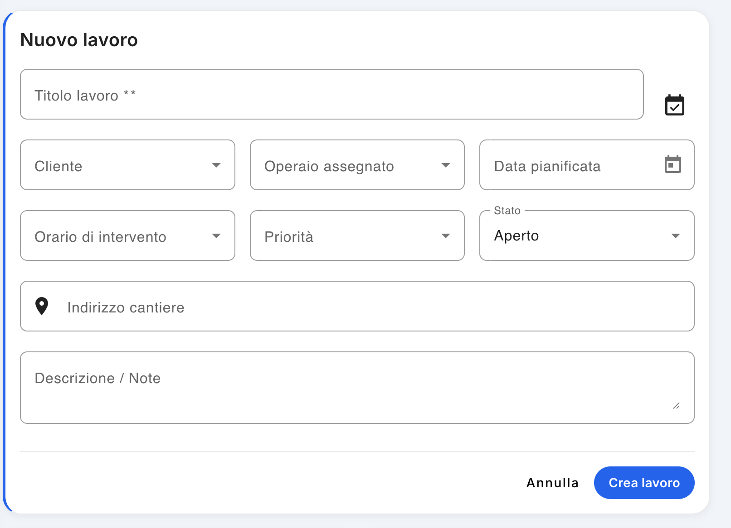
The New Job feature allows you to register a new job in the system, assigning it to a customer and a worker, and defining the date, time, priority, and location of the job.

1. Opening the mask
To create a new job, from the Jobs / Yards screen press the + button in the top right corner.
The New Job form opens.

2. Compilation of work data
The form contains the following fields:
- Job Title * – enter the name or title of the job, such as Handrail Arrangement.
- Customer – select the customer for whom the work is to be performed.
- Assigned worker – select the worker who will perform the intervention.
- Planned date – indicate the day scheduled for the intervention.
- Intervention time – define the scheduled time slot.
- Priority – establish the priority level of the intervention.
- Status – indicate the initial status of the job.
- Construction site address – enter the address where the work is to be carried out.
- Description / Notes – enter any additional information, customer indications or details useful to the worker.
The Job Title field is required.

Speaking time
In the Intervention time field , you can choose between:
- All day
- Morning
- Afternoon
- Custom timetable
If Custom time is selected, an additional field appears in which the precise time of the intervention must be indicated.

Priorities
The priority can be set at four levels:
- Low
- Normal
- High
- Urgent
Priority allows you to immediately distinguish the interventions that require more attention.

Status
You can set the status of the job between:
- Open
- Ongoing
- Completed
- Cancelled
Normally, a new job is created with a status of Open.

3. Planning via vehicle calendar
Next to the Job Title field is a calendar icon.
This feature allows you to quickly check the availability of vehicles and workers before assigning a new job.
Pressing the icon opens a weekly view in which you can view the status of vehicle bookings.
For example, by selecting a box relating to the Fiorino Bianco – plate B123CD, corresponding to a certain day and time, the system shows the workers available for that band at the bottom.
This mode allows you to check availability before creating work and avoid overlapping in the schedule.

Selection of the available worker
Once you've determined your desired day and time:
- check the box corresponding to the vehicle and the time slot;
- check the available workers displayed at the bottom;
- Select the desired worker.
At this point, the system automatically pre-fills the data linked to the selection in the new job form:
- Assigned Worker
- Planned date
- Speaking time
- Custom time, if applicable.
In this way, the assignment is made taking into account the actual availability of the worker and the vehicle planning.

4. Job creation and assignment
After verifying all the data, press Create job.
The work is recorded in the system and assigned to the selected worker.
The worker receives a notification on his mobile app regarding the new intervention. From your application you can therefore:
- accept the job;
- refuse work.
The outcome of the assignment will then be recorded in the system and will be visible in the management of the works.
Tip: Use the calendar icon before assigning a job when it is important to check the availability of the vehicle and the worker at the same time. This allows you to schedule your work without time conflicts.

Purchase orders
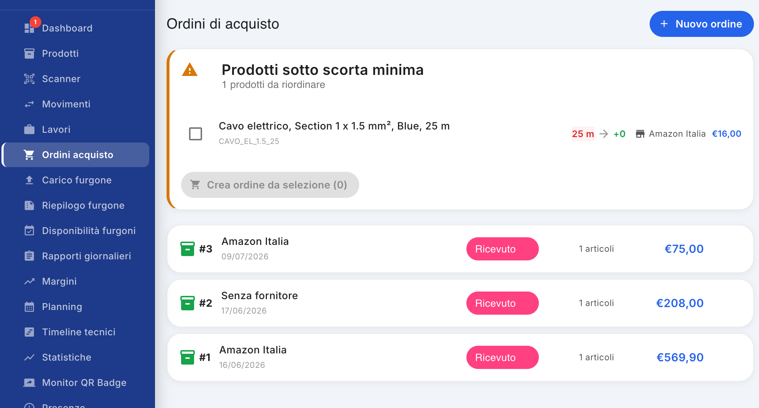
The Purchase Orders section allows you to manage orders placed with suppliers, quickly check any products under the minimum stock and consult the history of orders already received.

1. Create a new order
To create a new purchase order, click the + New Order button in the upper-right corner of the screen.
The window dedicated to order creation will open, in which it will be possible to enter the products to be purchased and the related information.

2. Products under minimum stock
At the top of the screen, you may see the Products under minimum stock tile.
This tile appears only when one or more products have reached a quantity that is less than the configured minimum stock.
For each product, the following are shown, among other information:
- the product name and code;
- the quantity currently available;
- the quantity needed for reordering;
- the associated supplier;
- the purchase price.

Quickly create a replenishment order
You can select one or more products using the relevant selection box.
After selecting the desired products, the Create Order from Selection button allows you to quickly create a new order that is already pre-populated with the selected products.
This feature allows you to directly turn a minimum stock report into a purchase order, without having to search for and re-enter products.

3. List of orders received
Below the minimum inventory pane, you will see a list of orders that have already been placed.
For each order, the main information is provided:
- order number, e.g. #3;
- supplier from whom the purchase was made;
- date of order;
- order status;
- number of items in the order;
- total amount of the order.
In the example shown, the orders present are in the Received status, which indicates that the ordered goods have been received.
The amount displayed on the right represents the total paid for the order.

4. Using the Screen
The Purchase Orders screen therefore allows you to have an immediate view of both the reordering needs and the purchases already made.
In particular:
- products under minimum stock highlight what needs to be reordered;
- the Create Order from Selection function speeds up the preparation of a new order;
- The order list allows you to quickly consult the supplier, date, status, number of items and purchase value.
Tip: Use the Products under minimum inventory pane as a starting point for recurring reorders to keep inventory on hand and prevent a product that you need from being unavailable for work.

Purchase Order Detail
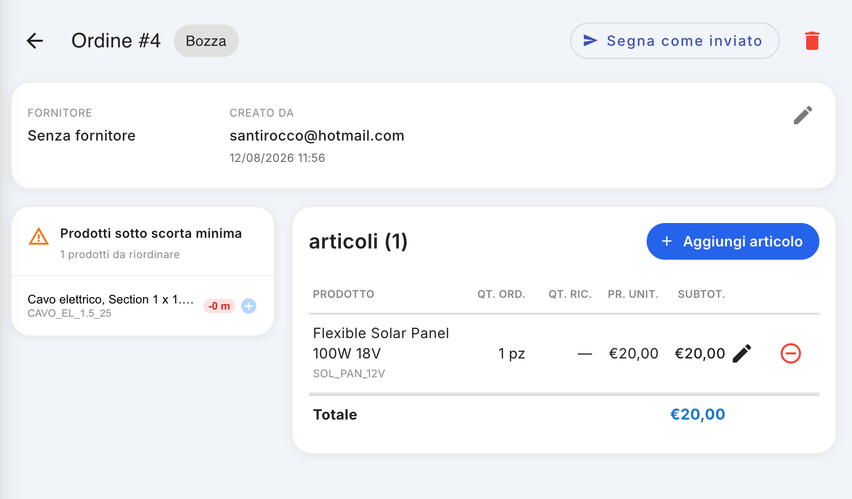
The Purchase Order Detail screen allows you to view and manage a single order, entering the products to be purchased, changing their quantities and prices, and updating the order status.

1. Order Header
At the top of the screen are:
- Order number: Identifies the order progressively. This example displays Order #4.
- Order status: indicates the current status of the order. At creation time, Draft is displayed.
- Mark as Sent – Allows you to change the status of the order, indicating that the order has been sent to the vendor.
- Trash: Allows you to delete or cancel the order.
Note: The Mark as Sent command is used to record in the system that the order has been sent to the supplier; it does not necessarily represent the automatic sending of the order to the supplier.

2. Order Information
Immediately below the header there is a summary band containing the main information of the order:
- Vendor: Indicates the vendor to whom the order is intended. If it is not specified, No vendor is displayed.
- Created by: Indicates the user who created the order.
- Date and time created: Indicates when the order was created.
- Pencil: Allows you to edit the order information, especially the vendor.
This section then allows you to quickly check who the order is intended for and who created it.

3. Products under minimum stock
If you have products in the system whose available quantity has fallen below the minimum stock, the Products under minimum stock pane appears.
The tile shows the products that you should reorder and, for each, the main information about the product and the missing quantity.
To quickly add a product to your order, you can use the small blue + button next to the product.
The product is thus placed directly in the list of items in the order, avoiding having to search for it manually.

4. Item Management
On the right side of the screen there is the Items section, which contains all the products placed in the order.
To add a product manually you can use the + Add Item button.
The selected product is added to the list and the main information is displayed:
- Product: Product name and code;
- Qt. ord.: quantity ordered;
- Qt. ric.: quantity actually received;
- Pr. unit.: unit price;
- Subtot.: The subtotal calculated for the item.

Edit an article
Next to each article is a pencil icon.
By clicking on the pencil you can edit the data of the article, including:
- quantity ordered;
- quantity received;
- unit price;
- price/total of the item.
This function can be used both during order preparation and to update the information when the goods are actually received.

Delete an article
Next to the pencil is a red icon with the symbol "–".
Clicking on this icon removes the item from the order. This is useful, for example, when a product has been added by mistake or no longer needs to be reordered.

5. Order total
At the bottom of the Items section , the Order Total is displayed .
The total is calculated on the basis of the items in the order and their prices. This allows you to immediately verify the overall value of your order before proceeding with its submission.

6. Workflow
Managing a new order can be done by following these steps:
- Create a new order, which is initially saved as a Draft.
- If necessary, select the vendor.
- Add products:
  - from the Products under minimum stock box, using the + button;
  - or via + Add Item.
- Check and edit quantities and prices using the pencil icon.
- Delete any items entered by mistake using the red – icon .
- Check the order total.
- Once the order is complete, use the Mark as Sent button to update the order status and close the window.

Charge van
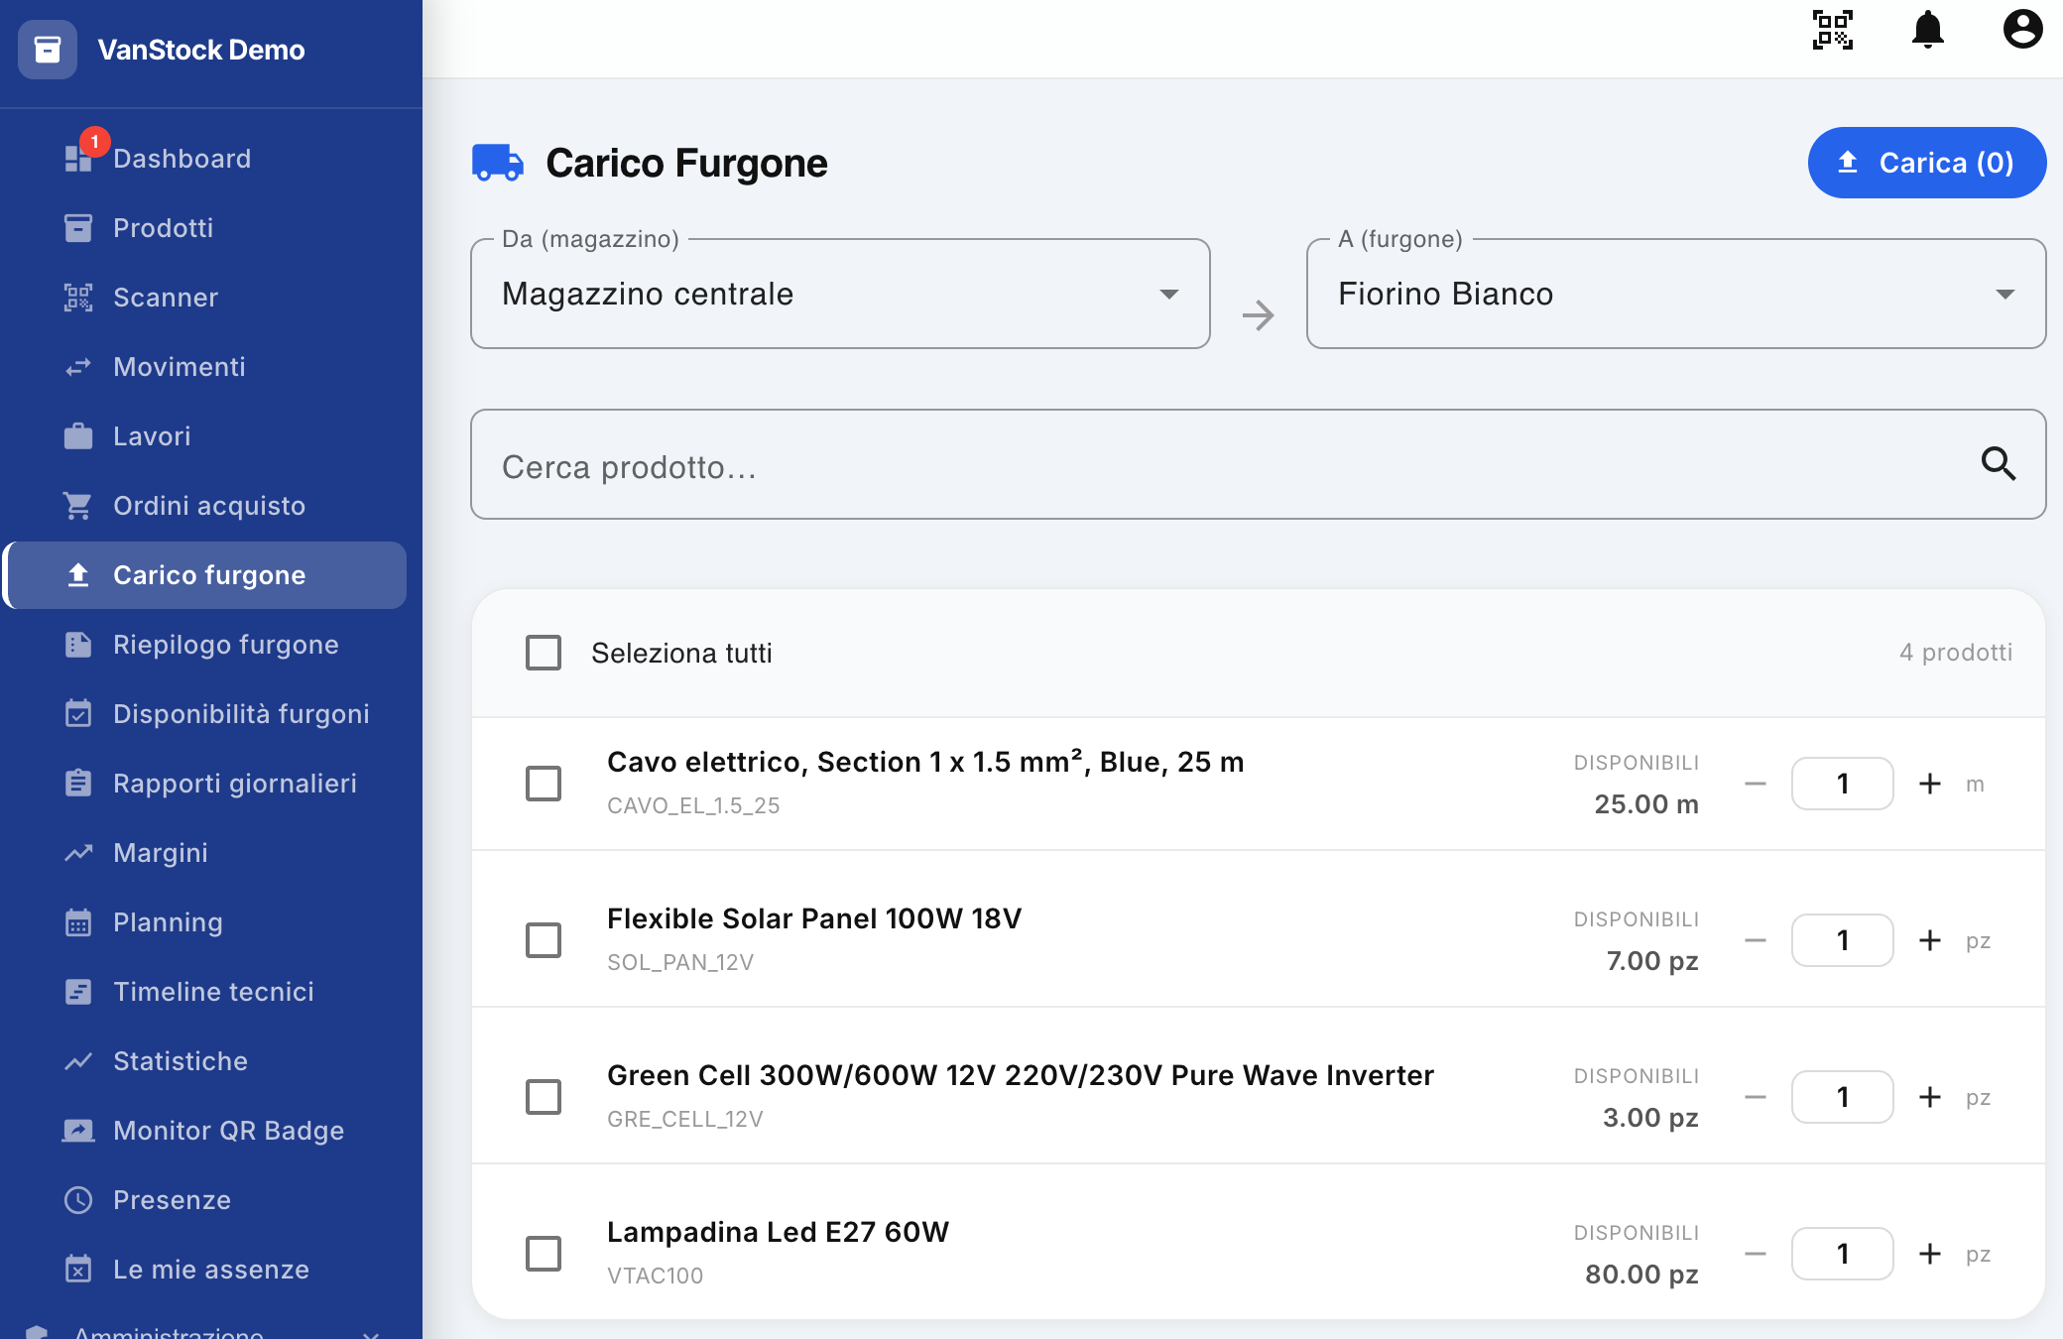
The Load Van feature allows you to transfer products from a warehouse to a van, automatically recording the relevant warehouse movement.
This function is used, for example, to prepare a van before an intervention, providing the worker with the materials necessary to carry out the assigned work.

1. Select warehouse and van
To get started, go to the Upload Van section from the side menu.
At the top of the screen, there are two fields:
- From (warehouse): indicates the warehouse from which the products will be taken;
- A (van): indicates the van on which the products will be loaded.
An arrow appears between the two fields that represents the direction of the transfer.
Example: If you select Central Warehouse as the origin and White Florin as the destination, the selected products will be transferred from the warehouse to the White Florin.

2. Search for a product
Below the source and destination selection, the Search for Product field is available.
You can type in a product name or code to filter the list and quickly locate the item you want to upload.
If no search is performed, the complete list of products available in the selected warehouse is displayed.
For each product, the following are indicated:
- product name;
- product code;
- quantity available in stock;
- units of measurement;
- quantity you want to charge.

3. Select products
To add a product to the load, you can select the checkbox to the left of the relevant row.
There is also a Select All box, which allows you to select all the products displayed at once.
Selecting a product does not necessarily transfer only one unit: the quantity can be changed directly on the product line.

Change the quantity
For each selected product, the following commands are available:
- – to reduce the quantity;
- + to increase the quantity;
- numeric field to enter the desired quantity directly.
The quantity indicated takes into account the availability in the warehouse.
Example: If you have 25 m of electrical cable in the warehouse, you can select the product and indicate the quantity you want to transfer to the van.

4. Check your selection
The blue Upload button in the top right corner shows the number of selected products in parentheses.
For example:
- Upload (0) → no product selected;
- Upload (2) → two products have been selected.
The number then indicates how many items/products have been selected for transfer, not necessarily the overall quantity of individual units.
Before proceeding, it is advisable to check:
- the warehouse of origin;
- the destination van;
- the selected products;
- the relative quantities.

5. Load
Once you have selected all the products and set the desired quantities, click on the Upload button.
The system performs the transfer of products:
Warehouse → Van
and automatically records the related inventory movements.
As a result:
- the availability of products in the warehouse is updated;
- the transferred products are added to the availability of the van;
- the movement documenting the transfer is recorded.

Operational example
Suppose you have to prepare the White Florin for an operation.
- Select Central Warehouse in the From field.
- Select White Forint in the To field.
- Search for the product you need.
- Select it.
- Set the quantity to be loaded using +, – or by entering the value directly.
- Repeat for all necessary products.
- Check the number listed in the Upload button.
- Click Upload to confirm the transfer.
When finished, the products will be available on the van and the handling will be recorded in the system.
Note: the functionality is therefore not limited to changing the availability of the van: each loading generates a movement that allows you to keep track of the movement of products from the warehouse to the vehicle.

Daily van summary
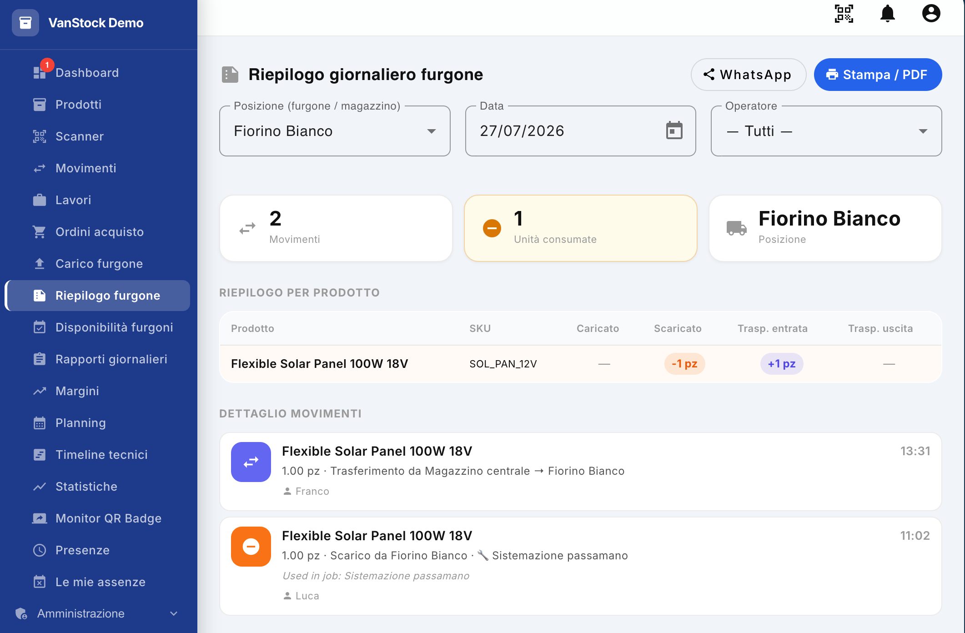
The Daily Van Summary feature allows you to view and share a complete report of the activities and movements made by a particular van or other location on a specific day.
The report allows you to check which products have been loaded, unloaded or used, by which operator and in which context of which work.

1. Select the report parameters
To view the summary, use the filters at the top of the screen:
- Location (van/warehouse): Select the van or warehouse whose activities you want to analyze.
- Date: Select the day you want to scan.
- Operator: You can select a specific operator or All to view the activities of all operators.
After you set the parameters, the summary is updated to show the selected location and date information.

2. Summary of activities
At the top of the screen, some summary data for the day is displayed:
- Entries: Total number of entries recorded for the selected location.
- Units consumed: total quantity of products used during the work.
- Location: Indicates the van or warehouse selected for the report.
This information allows you to immediately have an overview of the activity carried out during the day.

3. Summary by product
The Product Summary section shows in detail the products involved in the movements of the day.
For each product, information is indicated such as:
- Product
- SKU
- Loaded: Quantity transferred to the selected van or location.
- Downloaded: Quantity taken or consumed from the location.
- Incoming Transp.: Quantity transferred inbound.
- Output Transp.: Quantity transferred to the output.
This allows you to quickly reconstruct the movement of each product throughout the day.

4. Detail of movements
The Transaction details section presents the individual operations carried out chronologically.
Each movement shows, depending on the type of operation:
- the product concerned;
- the quantity handled;
- the type of movement;
- the position of origin and/or destination;
- any associated work;
- the operator who carried out the operation;
- the time the movement was recorded.
Movements are also visually identified by a special icon:
- Transfer: indicates the movement of a product, for example from the Central Warehouse to the White Florin.
- Unload/Consumption: Indicates that the product has been picked up from the van and used for a job.

Example
Let's suppose that during the day a solar panel was transferred from the Central Warehouse to the White Florin.
In the details of the transactions it will be possible to view:
- the transfer of the product from the warehouse to the van, with relative time and operator;
- subsequently, the consumption of the product for the work "Handrail arrangement", with an indication of the operator who used it.
The report then lets you know what was used, when, by whom, and for what work.

5. Print or export the summary
In the top right corner are available the functions to share the report:

Print / PDF
The Print / PDF button allows you to print the summary or generate it in PDF format.
This feature is useful, for example, to archive the report of the day or keep a copy of it.

WhatsApp
The WhatsApp button allows you to share the summary via WhatsApp.
Depending on the device used:
- if WhatsApp Web is available, the service will open in your browser;
- if you have the WhatsApp app installed, the app will open.
The report can then be quickly shared with the relevant people.

6. Usefulness of the daily summary
The Daily Van Summary is a real report of the vehicle's activities. It allows you to easily control:
- which operators used the van;
- what work has been carried out;
- which products have been used;
- which products were transferred to or from the van;
- quantity and times of individual movements.
The functionality is therefore particularly useful for controlling the use of materials, reconstructing daily activities and maintaining complete traceability of the movements made on the van.

Van availability
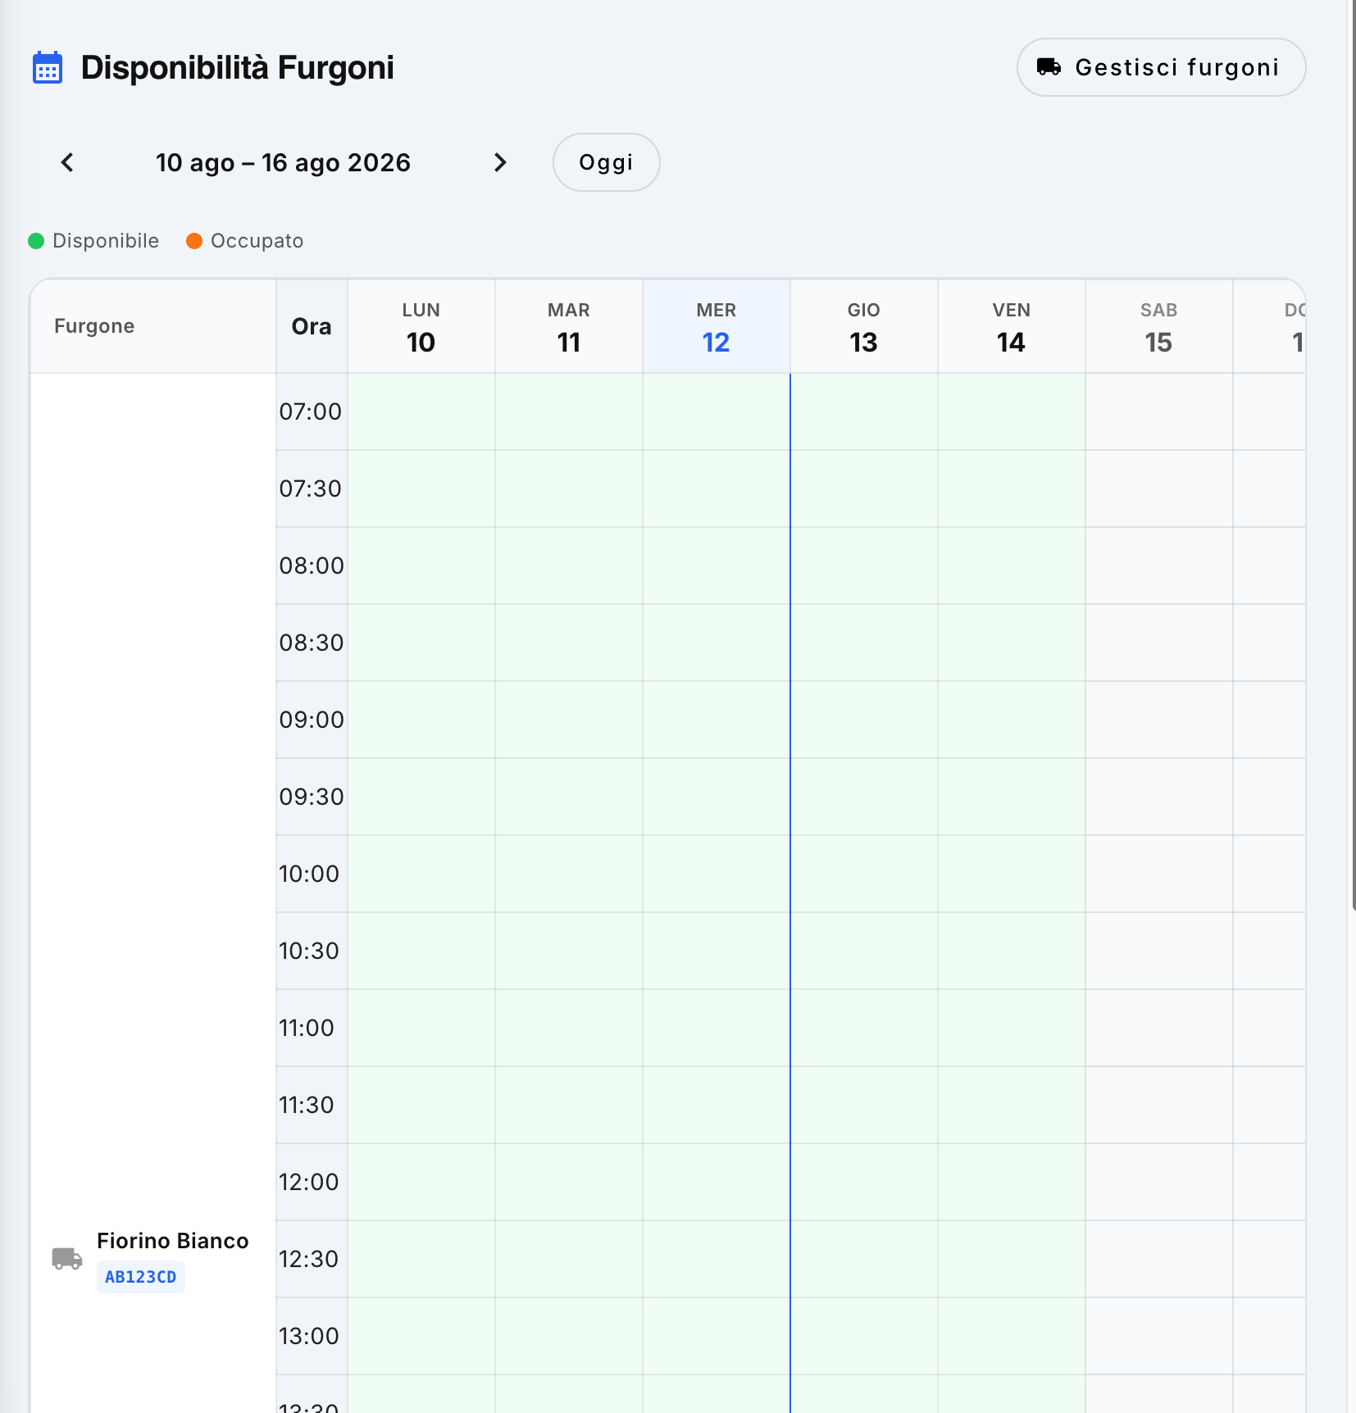
The Van Availability section allows you to quickly check the availability of company vans, displaying in a weekly calendar the periods in which each vehicle is available or occupied.
This feature is useful for planning interventions and checking in advance if a particular van can be used on a specific day and time slot.

1. Calendar view
The screen presents a weekly calendar in which:
- the lines represent the different times of the day;
- the columns represent the days of the week;
- each line of the calendar identifies a van, with its name and license plate;
- cells colored in green indicate that the van is available;
- Cells colored in orange indicate that the van is occupied.
This makes it possible to immediately identify the time slots in which a particular vehicle can be booked.

2. Check for an occupied van
When a box is occupied, you can move the mouse cursor over the box.
An information pop-up appears with information about the booking, including the operator who booked or is using the van.
This information allows you to quickly check who has engaged the vehicle in that particular time slot.

3. Navigate between weeks
At the top of the screen, you'll see the date range that you're viewing.
You can use the navigation arrows to navigate the calendar:
- left arrow → displays the previous week;
- Right arrow → displays the next week.
There's also a Today button, which allows you to quickly go back to the current week.

4. Manage vans
At the top right, there is the Manage vans button.
By clicking on the button, the user is directed to the Locations section of the Administration menu, from which the vans configured in the system can be managed.
Note: The Manage Vans button is only available to users with the Admin role.

5. Use for Planning
The calendar allows you to check the availability of the vehicle before planning an intervention.
For example, by identifying a green cell at the desired van, the day and time needed, it is possible to verify that the vehicle is free in that range.
Occupied cells, on the other hand, allow you to avoid overlapping between bookings and to check, via the popup, who is using the van.

Daily Reports
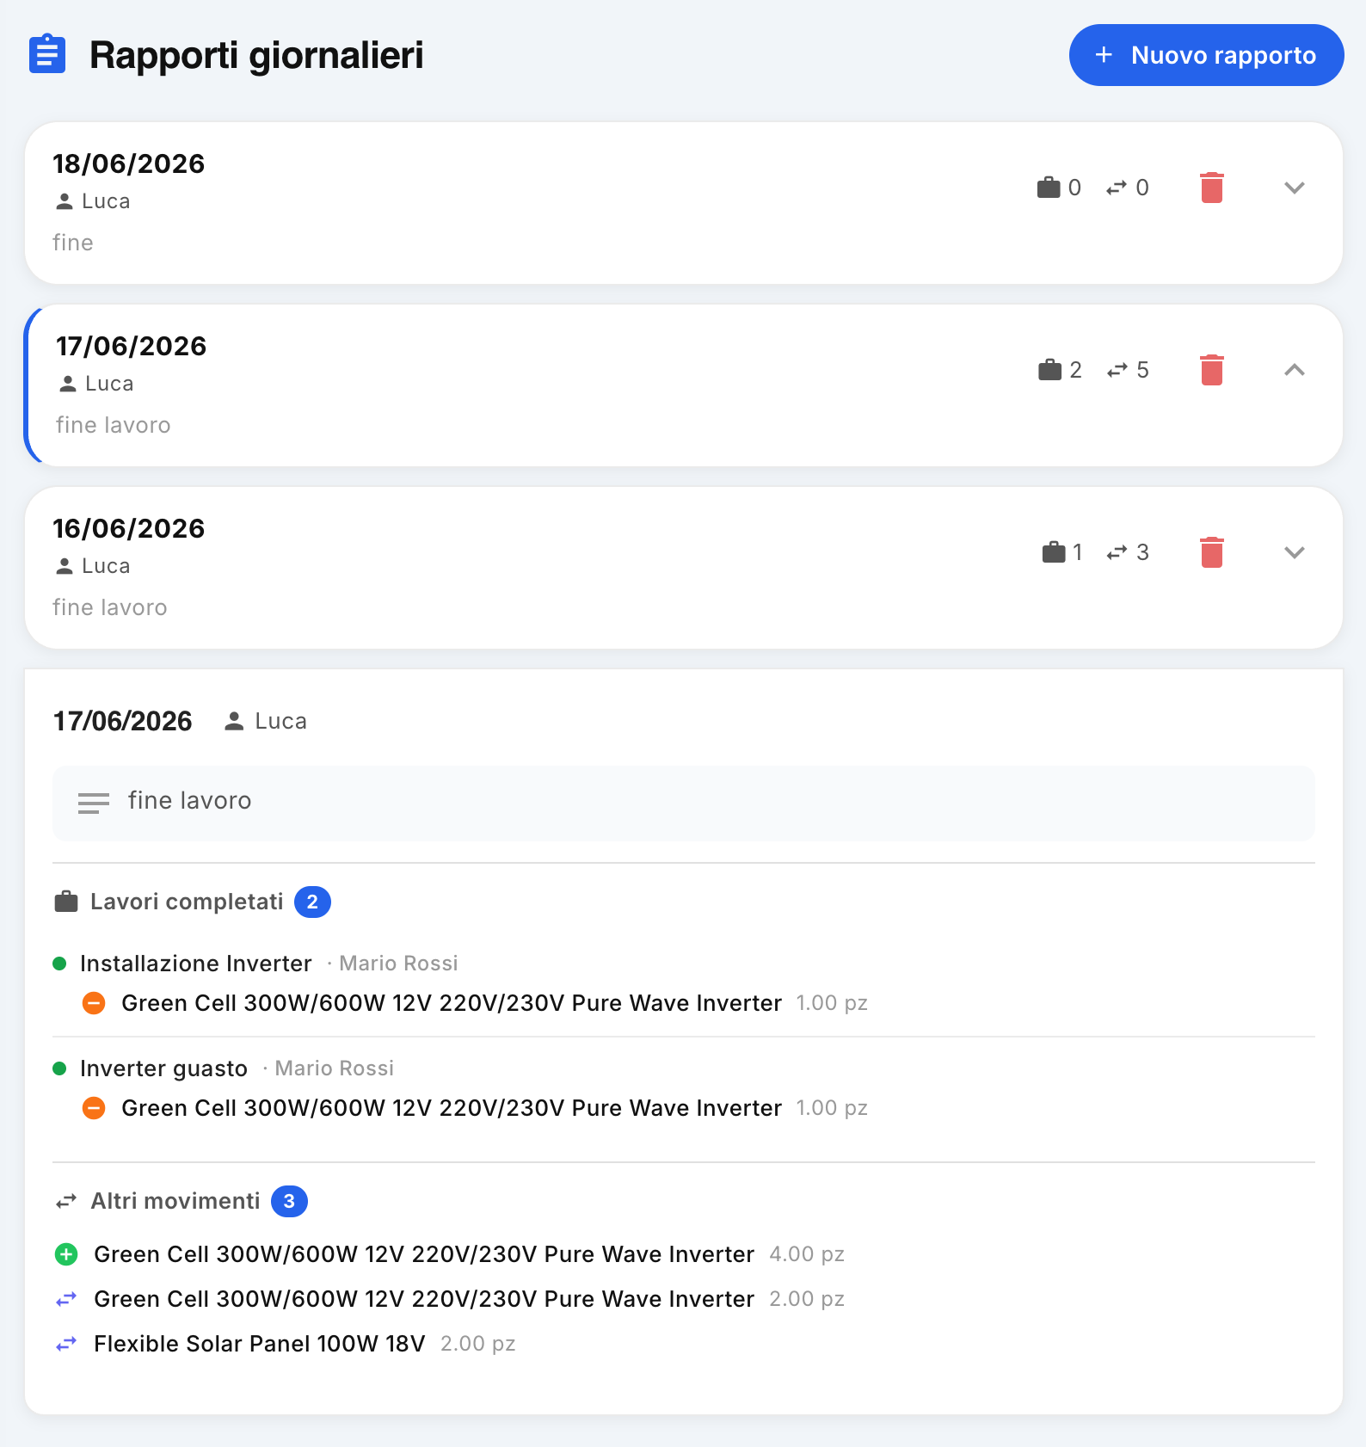
The Daily Reports section allows you to consult and create reports relating to the activity carried out by the workers during the day. The report provides a summary of the tasks performed, the jobs completed, and the inventory movements recorded by the operator.

1. List of Reports
When you open the section, you will see a list of available daily reports. For each report, the main information is reported:
- Date of the report;
- Operator who carried out the activities;
- Description or note included in the report;
- number of completed works;
- number of recorded transactions .
For each element are also available:
- Down arrow: Expands the report and displays its detail;
- Up arrow: Indicates that the report is currently expanded;
- Trash: Deletes the report.
When a report is expanded, it is highlighted with a light blue border on the left side.

2. View the detail of a report
To view the breakdown of a day, click the arrow on the right side of the report.
In detail, the activities carried out by the operator on the selected day are displayed, mainly divided into:

Completed works
This section shows the jobs completed by the worker during the day.
For each job, the following are indicated:
- the title of the work;
- any associated operator;
- the products used during the intervention;
- the quantity of products handled or consumed.
Products marked with the orange minus sign represent products that have been unloaded from the van and used in work.
For example, a job like Inverter Installation may report using a piece of Green Cell 300W/600W 12V 220V/230V Pure Wave Inverter.

Other movements
The Other Movements section lists inventory movements made by the worker that are not directly associated with the completion of a job.
For each movement, the product and its quantity are indicated. Symbols allow you to quickly distinguish the type of handling, for example:
- + green: load of products;
- − orange: discharge or consumption of products;
- Blue arrows: Transfer of products between locations, such as between warehouse and van.
In this way it is possible to reconstruct all the movements made by the operator during the day.

3. Daily Report Example
For example, if you expand the 6/17/2026 report for the Joe operator, you can view:
- 2 completed works;
- the products used in the individual jobs;
- 3 additional movements made during the day;
- the related products and quantities handled.
The report therefore makes it possible to reconstruct the entire activity of the worker's day, including intervention activities and material movements.
Note: Unlike the Van Daily Summary, which focuses on the activities and movements associated with a specific vehicle, the Daily Report focuses on the operator and provides an overall account of their working day.

4. Create a new report
To create a new report, click the + New Report button, available in the top right.
The procedure allows you to record the operator's daily report and information relating to the activities carried out.

Summary
The Daily Reports section allows you to:
- consult the operators' reports;
- check which works have been completed;
- know the products used during the interventions;
- view the inventory movements made;
- reconstruct the overall activity of a worker during a given day;
- create new daily reports;
- delete reports that are no longer needed.

Margins and costs
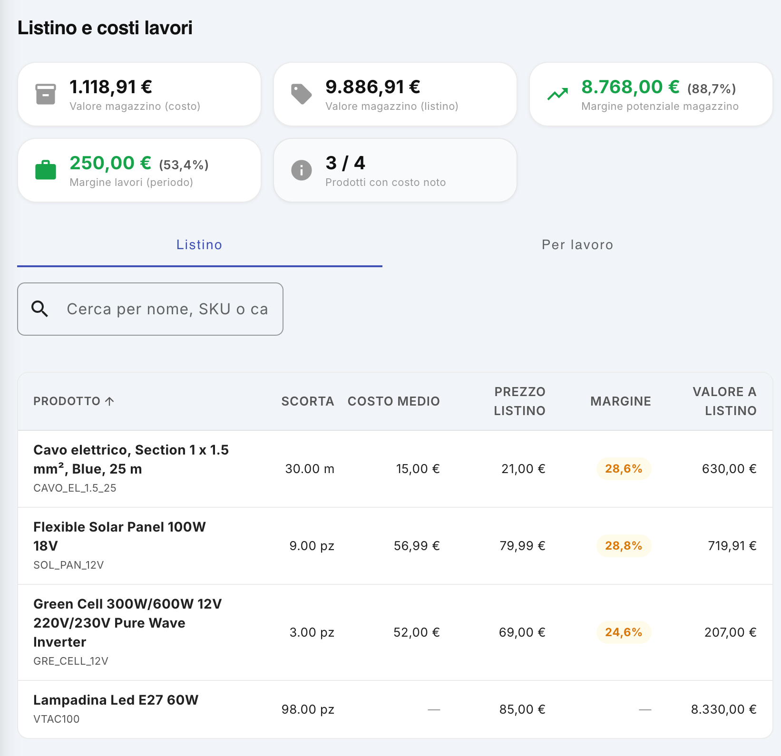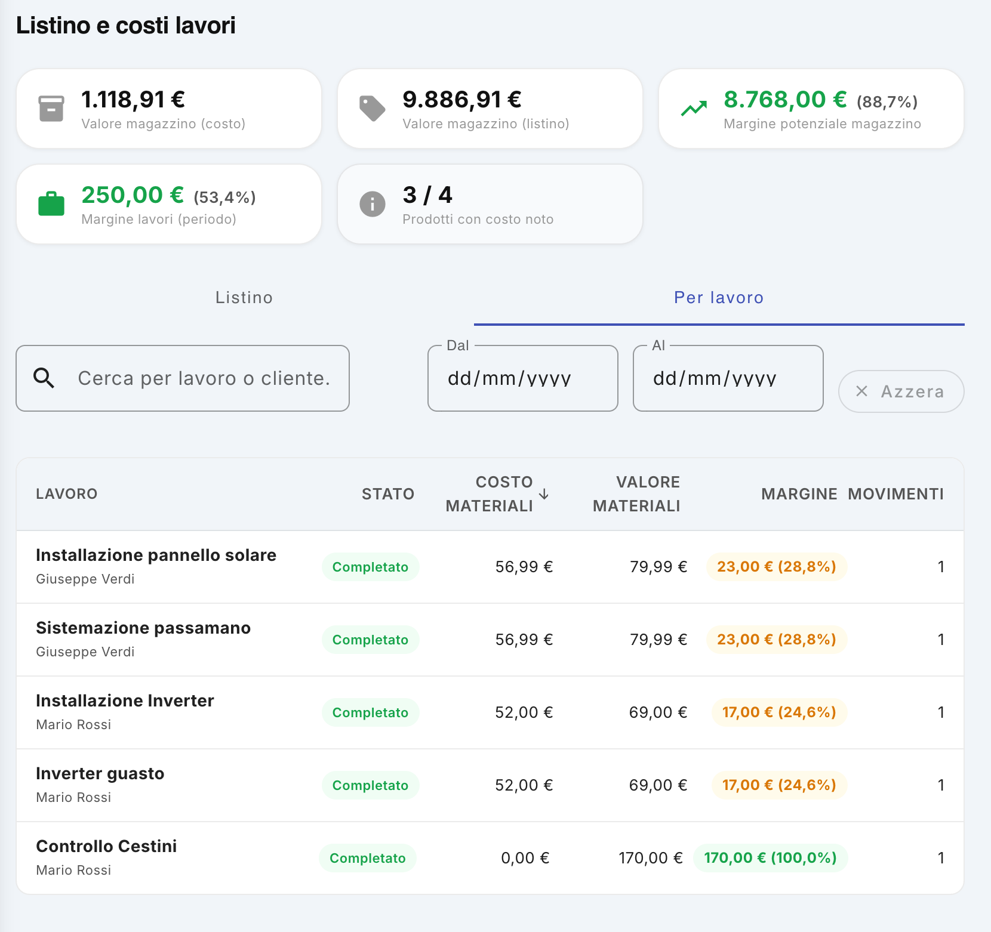
The Margins section allows you to analyze the economic value of the products in the warehouse and the materials used in the work. The screen, called Price list and work costs, provides a series of KPIs and two analysis modes:
- Price list, to analyze the economic value of the stocks in the warehouse;
- For work, to analyze the costs, value and margin of the materials used in individual interventions.
This functionality therefore allows you to have a synthetic view of the value of the warehouse, the potential margin of the products and the profitability of the work carried out.

1. Key KPIs
At the top of the screen there are some indicators that provide an immediate summary of the economic situation.

Inventory value – cost
It indicates the total value of the goods in the warehouse calculated on the basis of the cost of the products.
This value allows you to understand how much capital is currently tied up in stocks.
Example: if the value of the inventory at cost is €1,118.91, it means that the products present have a total known cost equal to this amount.
This is useful for monitoring:
- the capital invested in the warehouse;
- the economic consistency of the stocks;
- the evolution of the value of the warehouse over time.

Inventory value – list price
Indicates the theoretical value of inventory using the list prices associated with the products.
The figure allows us to understand how much the goods present would be worth overall if they were valued at list prices.
The difference between list value and value at cost represents the potential margin of inventory.

Potential inventory margin
The KPI shows the potential economic margin resulting from the difference between the list value of the products and their cost.
In simplified terms:
Potential margin = Inventory value at list − Inventory value at cost
The percentage value indicates the margin expressed in relation to the list value.
Example:
Value at cost: €1,118.91
RRP: €9,886.91
Potential margin: €8,768.00 (88.7%)
This indicator is particularly useful for understanding how much potential economic value is contained in inventories.
Please note: the margin is potential and does not necessarily represent an actual profit. For example, the calculation does not consider any discounts applied to the customer, labor costs, transportation, or other operating costs.

Margin of works
The Work Margin KPI summarizes the margin associated with the materials used in the works considered by the system.
It allows you to compare the value attributed to the materials used with their cost.
The percentage figure allows you to quickly assess the profitability of the materials used in the interventions.
This indicator can be used to identify:
- particularly lucrative jobs;
- works with reduced margins;
- materials that have the greatest impact on the economic result;
- any anomalies in the prices applied.

Products with known cost
This KPI indicates how many products, compared to the total number of products managed, have a value cost.
Example: 3 / 4
It means that 3 out of 4 products have a known cost, while for one product the cost is not available.
This is important because no-cost products can make cost and margin analysis incomplete.
It is therefore advisable to keep product costs up to date to obtain more reliable economic KPIs.

2. Price list
By selecting the Price list tab , it is possible to analyze the products in stock in detail.
A search field is available that allows you to filter products by:
- name;
- SKU;
- product code.
The table shows, for each product:
Field | Description
Product | Product name and code/SKU
Stock | Quantity currently in stock
Average cost | Average cost attributed to the product
Regular price | Product Selling Price/List Price
Margin | Percentage difference between list price and cost
List value | Total stock value at list price

How to use this data
The analysis allows us to understand not only how much material is present, but also how much economic value it represents.
For example, a product with:
- high stock;
- medium-low cost;
- list price significantly higher than cost;
It can be an important component of the potential margin.
Conversely, products with high inventories and low margins may indicate fixed capital with relatively low profitability.

3. Margin of individual products
The Margin field allows you to compare the cost of the product with its list price.
Example:
Average cost: €56.99
Regular Price: €79.99
Margin: €23.00 (28.8%)
In this case, the product generates, based on the configured values, a theoretical margin of € 23.00 per unit.
Comparing products allows you to quickly identify those that have:
- high margin;
- reduced margin;
- no known cost;
- high overall value of stocks.

4. Analysis "For Work"
The By Work tab allows you to move the analysis from the single product to the single intervention.
You can search for a job or client and, when expected, narrow down the analysis across a date range:
- From
- To the
You can also reset the filters via the Reset button.
The table shows for each job:
- Work;
- State;
- Cost of materials;
- Material value;
- Margin;
- Movements.

5. Material cost
The Material Cost represents the cost associated with the products used in the work.
This value allows us to understand how much the material actually used in the intervention cost the company.
It is particularly useful for comparing different jobs and checking which jobs require more quantities or higher value products.

6. Material value
The Material Value represents the value attributed to the materials used in the work on the basis of their list prices.
The comparison with the cost allows you to determine the margin associated with the materials used.
Example:
Material cost: 56,99 €
Material value: 79,99 €
Margin: €23.00 (28.8%)

7. Margin per job
The Margin field shows both the economic value and the margin percentage.
This allows you to immediately understand how much value is generated by the materials used in each intervention.
The works can then be compared to identify:
- those with the greatest economic margin;
- those with higher percentage margins;
- those that use a lot of material but produce a small margin;
- any works in which the economic values are anomalous.

Example
If two jobs have:
- the same cost of materials;
- the same value of the materials;
will have the same margin.
If, on the other hand, a job uses more expensive materials but the value attributed does not increase proportionately, the percentage margin may be lower.

8. Movements
The Entries column indicates the number of inventory entries that are associated with the work.
The data allows you to quickly understand how much the work involved material handling.
A large number of entries can indicate, for example:
- use of numerous products;
- more loading/unloading operations;
- material transfers;
- repeated movements during the intervention.
The number of entries should be interpreted in conjunction with the cost and value of the materials, as many entries do not necessarily mean a higher margin.

9. How to use the screen to generate value
The Margins section is not only used to display economic data, but can also support some operational decisions.

Optimize inventory
The comparison between stock, average cost, list price and margin allows you to identify the products that most represent the value of the warehouse.
You can therefore pay particular attention to the products:
- with very high stocks;
- with high list value;
- with a particularly low margin;
- with out-of-date costs.

Identify the most profitable products
By comparing product margins, it is possible to understand which items have the highest margins.
This information can be used to support decisions related to:
- procurement;
- inventory management;
- definition of prices;
- choice of materials to be used.

Analyze the profitability of the works
The By Work tab allows you to compare the interventions carried out and understand which ones generate the most value through the materials used.
The analysis can be used to identify jobs with:
- high value of materials;
- high margin;
- reduced percentage margin;
- particularly high material costs.
This can help identify any work in which the price applied, materials used or operating methods deserve verification.

Check the quality of economic data
The KPI Products with known cost must be considered before interpreting the economic data.
For example, if only 3 out of 4 products have a known cost, cost and margin KPIs may not represent the entire product estate.
To obtain a more precise analysis, it is therefore important to keep up to date:
- product costs;
- list prices;
- warehouse quantity;
- movements of products.

10. Overall interpretation
The Price list and work costs screen allows you to switch from a general view to a detailed one:
Warehouse → Products → Jobs → Margins
In particular:
- Inventory value at cost → how much capital is tied up in stocks;
- List inventory value → how much the stocks are theoretically worth at the configured prices;
- Inventory potential margin → what theoretical margin could be generated from inventories;
- Work margin → which theoretical margin is associated with the materials used in the interventions;
- Products with a known cost → how complete the database necessary to carry out the analysis is;
- Analysis by product → which items have greater value and margins;
- Analysis by work → which interventions generate greater value through the materials used.
Note: The margins displayed are calculated based on the costs and prices configured in the system. They should therefore be considered as management indicators and not necessarily as corporate net income, as they may not include labor, transportation, overhead costs, discounts, or other costs incurred by the company.

Planning
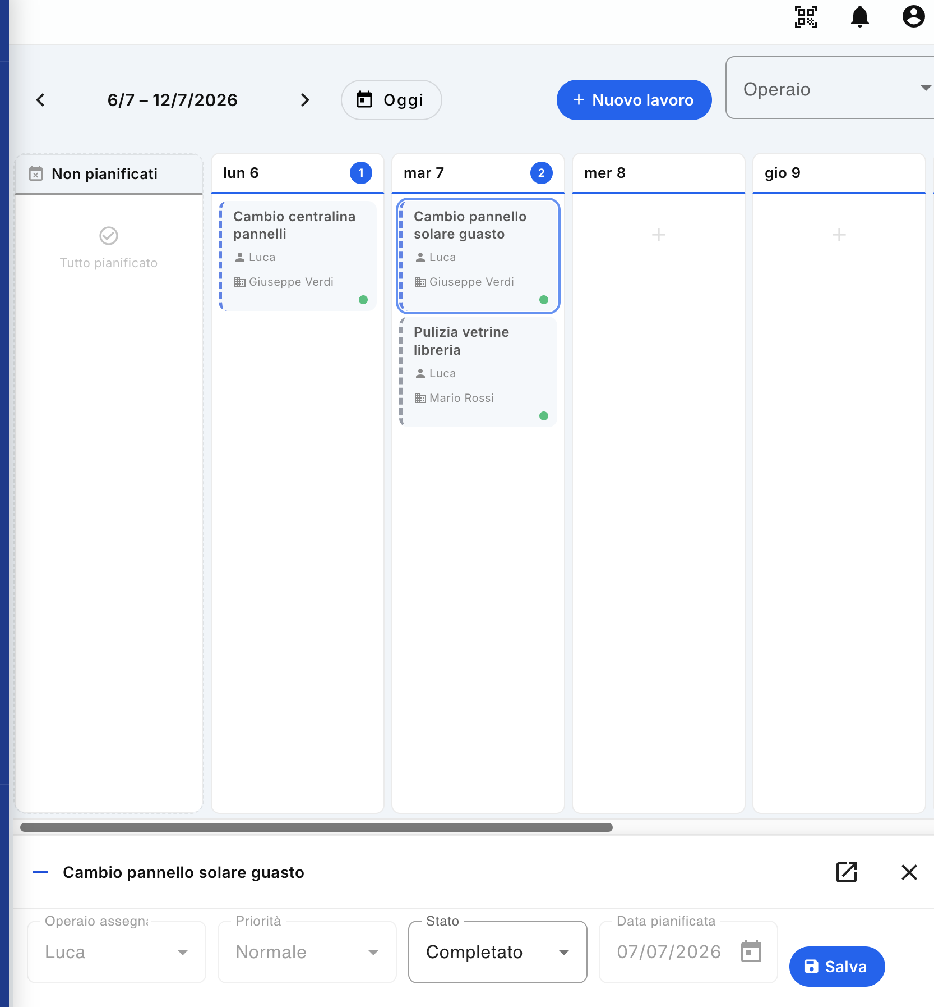

1. Feature Description
The Planning section, accessible from the main menu on the left, allows you to organize and view the planned jobs in a simple and immediate way, distributing them on the different days of the week and associating them with the workers in charge.
Planning therefore allows you to have an overall view of the scheduled activities and to quickly check which jobs are planned, on which day and to which worker they are assigned.

2. Weekly View
When the screen opens, a weekly calendar is shown.
Each column represents a day of the week, and within the columns, the jobs scheduled for that day are displayed.
For each job, a box is shown containing the main information, including:
- job name;
- assigned worker;
- customer;
- status of the work, also graphically represented by the color of the relative indicator.
The screen then allows you to quickly understand the distribution of jobs over the week.

Navigating between weeks
At the top of the screen, there are side arrows that allow you to move between the previous and next weeks.
The Today button allows you to immediately return to the week that includes the current date.

3. Filter by worker
In the upper right part there is the Worker filter.
Using this filter, you can only view jobs that are assigned to a specific worker.
This feature is particularly useful, for example, when you want to quickly check:
- what activities a particular worker must perform;
- how his works are distributed during the week;
- if a worker has a particularly busy day;
- which activities are still to be completed.

4. Unplanned work
On the left side of the screen, you'll see the Unplanned section.
This area represents jobs that have not yet been included in the schedule.
When all jobs are already scheduled, the section shows the message:
Everything planned
This allows the user to immediately see if there are any tasks that have yet to be scheduled.

5. Create a new job
The + New Job button at the top of the screen allows you to create a new job directly.
Clicking on the button takes you to the job creation screen, from which you can enter all the necessary information and then assign the job to a worker and a date.
This feature allows you to create a new task without having to leave the Planning section and manually search for the relevant functionality in the menu.

6. State of play
The works in the calendar are represented graphically through their status.
In the example shown, the green dot indicates that the job has been completed.
This allows you to quickly distinguish between completed tasks and tasks that still need to be managed.
The status of the work is therefore important information for the manager, because it allows him to check the progress of the planned activities at a glance.

7. View the detail of a job
Clicking on a job tile opens the detail panel at the bottom of the screen.
The panel allows you to view and, when required by the user's permissions, modify some information of the job.
The information displayed may include:
- assigned worker;
- priorities;
- status;
- Scheduled date.
When you are done editing, you can use the Save button to confirm the changes.

Changing the status
Changing the status from the Schedule is an operation reserved for the administrator user.
For example, an administrator can use this feature if they need to change the status of a job or cancel a previously scheduled task.
Users without the necessary permissions can view the information, but they cannot make changes that are reserved for the administrator.

8. Open the job on the Jobs screen
In the detail panel there is also the button with the diagonal arrow icon towards the upper right corner.
Clicking on this button opens the job directly in the relevant screen of the Jobs section.
This feature comes in handy when you need access to all the information and features available for that job, going beyond just managing your schedule.

9. Operational use of Planning
Planning is the main tool for planning workers' activities.
A correct use of the feature allows you to:
- plan activities in advance;
- distribute the work among the workers;
- check the daily workload;
- quickly identify any unplanned jobs;
- check the progress of activities;
- check the status of the work directly from the calendar;
- intervene on programming when necessary.

Recommended Workflow
- Go to the Planning section.
- Select the week you want to schedule.
- Check for any jobs in the Unplanned section.
- Assign jobs to workers and their dates.
- Use the Worker filter when you want to control the scheduling of an individual person.
- Check the status of your tasks during the week.
- If necessary, open the job detail to edit the job information, according to the user's permissions.
- Use the Jobs screen shortcut to access the full task management.
In this way, the Planning becomes a synthetic operational view of the organization of work, useful both for planning future activities and for checking the progress of those already assigned.

Technical timelines
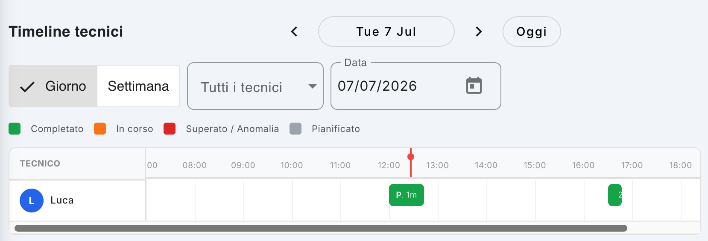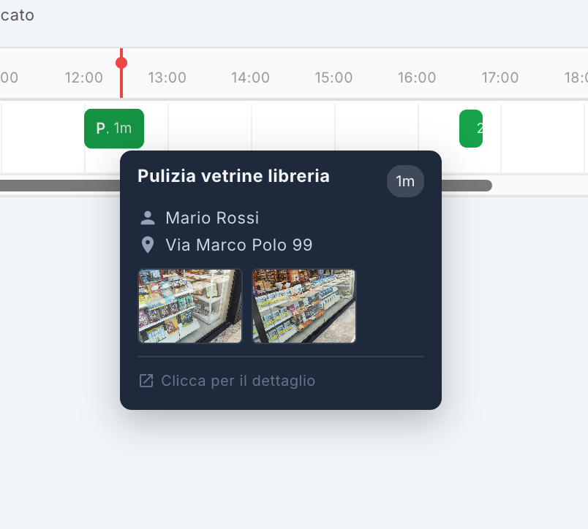

1. Feature Description
The Technician Timeline allows you to view the activities carried out by technicians in a chronological way, allowing you to have an immediate view of when each technician worked, what activities they performed and for how long.
The screen can be used for both a daily and weekly view and allows you to filter the information by individual technician.
It is particularly useful for checking the progress of activities in the field, verifying the interventions carried out and reconstructing the working day of the technicians.

2. Timeline Navigation
At the top of the screen, you will find controls to navigate between the different dates.

Day / Week
You can choose between two display modes:
- Day: Shows in detail the activities carried out on the selected day.
- Week: Allows you to have a broader view of the activities spread over the week.

Date selection
The displayed date can be changed using:
- the side arrows, to move forward or backward in the calendar;
- the Date field, in which you can directly select a date;
- the Today button, which immediately takes you back to the current day.

3. Technician filter
The All Technicians menu allows you to filter the timeline.
You can view:
- the activities of all technicians;
- the activities of an individual technician.
This filter is especially useful when you want to analyze the day of a particular operator without viewing the activities of others.

4. Reading the timeline
The middle part of the screen has a time grid.
Each row corresponds to a technician, and the timeline shows the tasks in the time slot they were performed.
For example, on the screen the technician Luca presents two activities:
- an activity around 12:00;
- a second activity in the afternoon, around 4:30–4:45 pm.
The position of the activity on the timeline therefore allows you to immediately understand when the intervention has taken place.

Duration of the activity
The block size on the timeline represents the duration of the task. When available, the duration is also indicated within the block.
This allows you to have not only a list of interventions, but also a temporal representation of the technician's day.

5. Task colors and status
The timeline uses different colors to quickly identify the status of tasks.
Color | Status | Meaning
🟢 Green | Completed | The activity has been completed
🟠 Orange | Ongoing | The task is currently running
🔴 Red | Passed / Anomaly | The task has an abnormal situation or has exceeded the expected time
⚪ Grey | Planned | The activity has been scheduled but has not yet been completed
The legend at the top of the screen allows you to immediately interpret the colors used.

6. Detail of an activity
Hovering over a timeline activity displays a detail pop-up.
The pop-up may read:
- job name;
- duration of the activity;
- technician who carried out the intervention;
- address where the work was carried out;
- photographs associated with the intervention;
- link to access the details of the work.
For example, hovering over a task can display the "Library window cleaning" job, the technician in charge, the address of the job, and the photographs taken during the task.

Photos of the surgery
The photographs shown in the popup allow you to visually verify the activity carried out by the technician.
This is especially useful for:
- document the work performed;
- verify the result of the intervention;
- have photographic proof of the activity;
- check the place where the work was carried out.

7. Access to job detail
In the popup you will find the "Click for details" command.
Using it, it is possible to open the complete work sheet and consult the available information relating to the intervention.
The Timeline therefore represents a synthetic and chronological view, while the detail of the work allows you to deepen the information relating to the individual activity.

8. Operational Usage
The Technical Timeline can be used by the manager or administrator to:
- check what activities were carried out during the day;
- check when the technicians have carried out the interventions;
- compare the activities of different technicians;
- identify any in-progress, completed or anomalous activities;
- verify the duration of the interventions;
- consult the photographs collected on site;
- verify the place where an intervention was carried out;
- reconstruct a posteriori the activity carried out by a technician.

In summary
The Technician Timeline provides a temporal representation of field activities and allows you to quickly switch between the general view of the day or week and the detail of the individual intervention, including information about the technician, location and photographic documentation.

Statistics
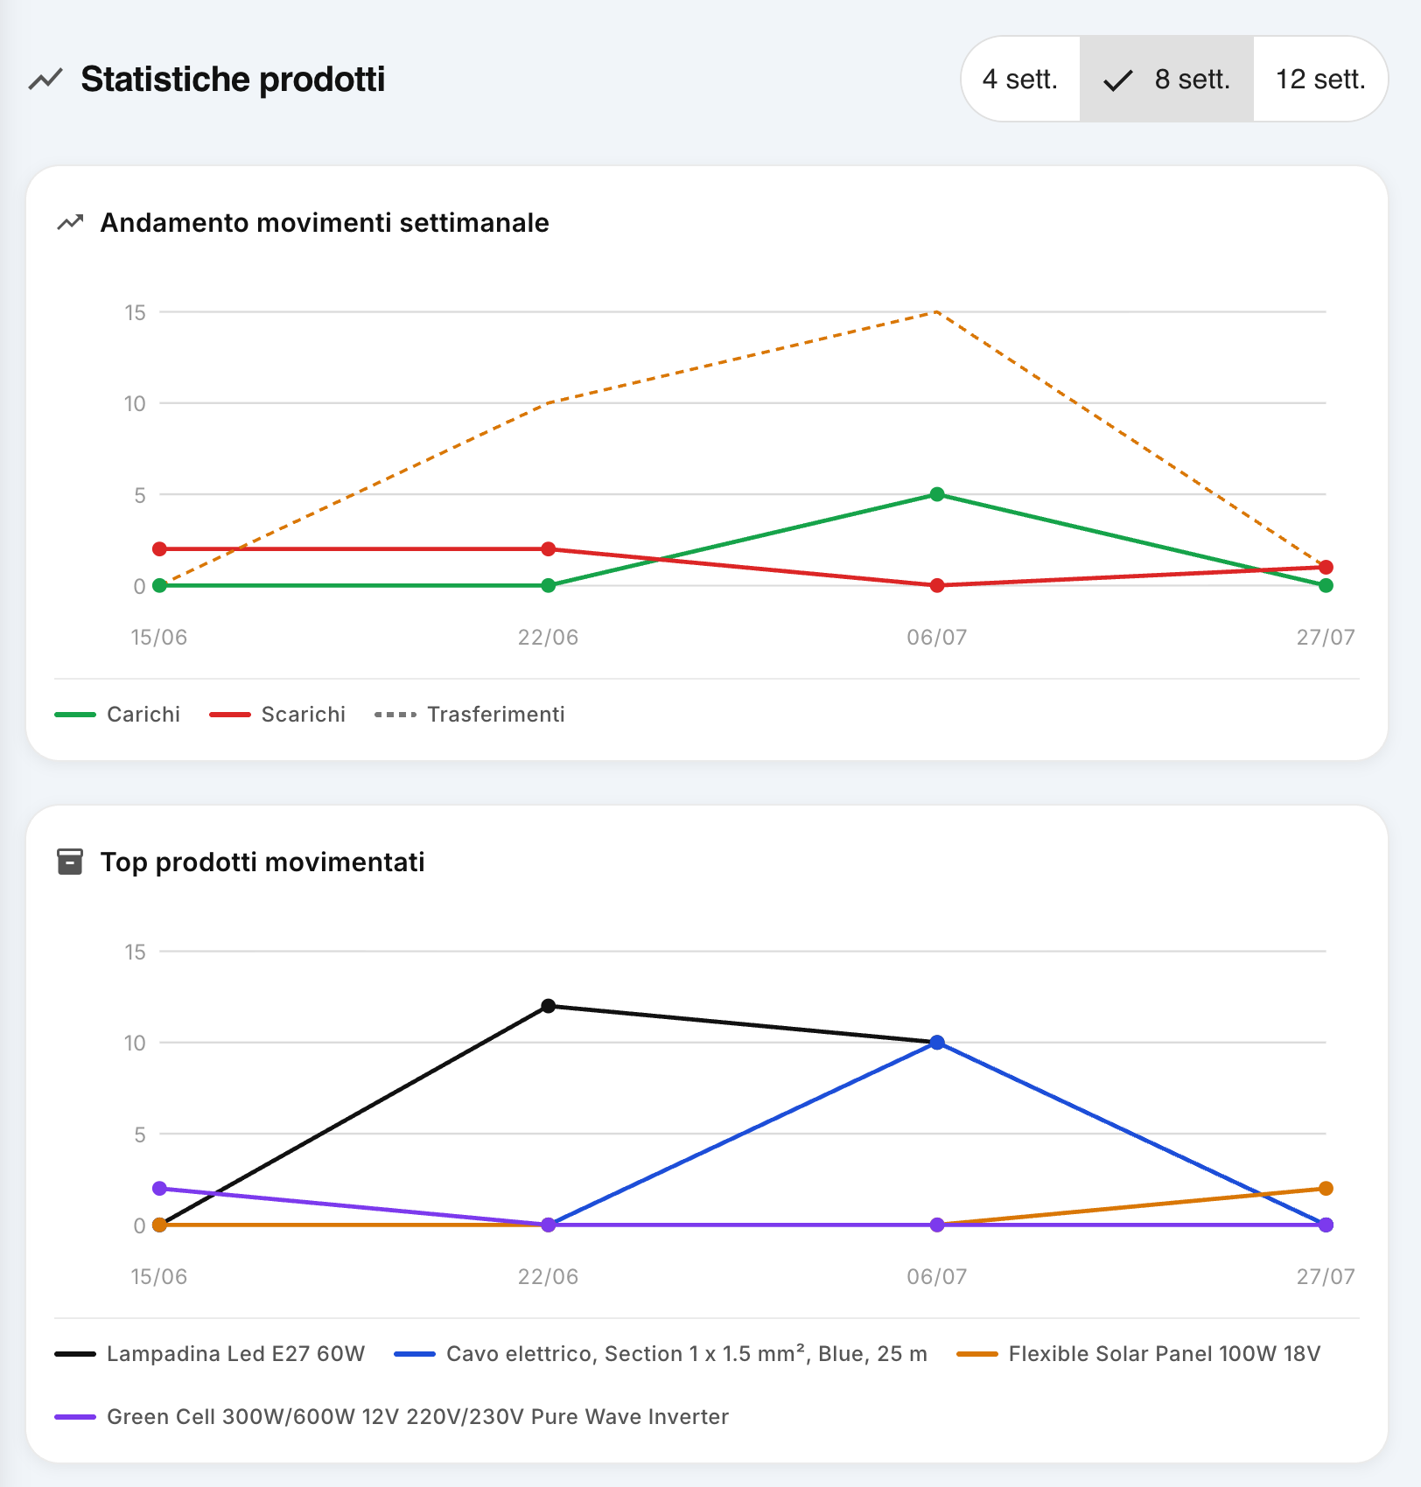

1. Feature Description
The Product Statistics screen allows you to analyze the trend of warehouse movements over time and to identify the products that have been handled the most.
The feature is useful for having a summary view of warehouse activity, checking the progress of loads, unloading and transfers and identifying the products with the greatest handling.

2. Period selection
At the top of the screen, you can choose the time range to analyze:
- 4 weeks
- 8 weeks
- 12 weeks
Selecting the period automatically updates the charts shown on the page.
A shorter period allows you to analyze recent activity in more detail, while a longer period allows you to identify trends and variations over time.

3. Weekly movement trend
The first chart, called Weekly Movement Trend, shows the evolution of the movements made during the selected period.
Three types of movement are represented:
- Loads – quantities of products loaded at a location or in the warehouse.
- Discharges – quantities of products taken and used, for example for a job.
- Transfers – the amount of products moved from one location to another, such as from the warehouse to a van.
The graph then allows you to visually compare the activity of the different weeks.

How to interpret the chart
You may use this information to:
- identify the weeks with the greatest activity;
- check for any increases or decreases in movements;
- understand if the warehouse is experiencing a high number of transfers;
- identify periods characterized by many discharges, which may indicate greater work activity;
- Compare inventory behavior between different periods.
For example, an increase in transfers may indicate that many materials are being moved from the central warehouse to vans or other locations. An increase in discharges, on the other hand, can be associated with a greater amount of material used in the works.

4. Top products handled
The second section of the screen is Top products handled.
The chart shows the products that recorded the most movements in the selected time range.
Each product is represented with its own line and the trend can be compared between the different weeks.
This section allows you to quickly locate:
- which products are handled most frequently;
- which products had handling peaks;
- which products are not very moved;
- how the internal demand for different materials changes over time.

5. Operational use of statistics
Statistics are not just a summary of activity, but can be used to support warehouse management decisions.

Inventory planning
Frequently handled products can be considered high-turnover products. You can use this information to verify that sufficient quantities are always available and avoid out-of-stock situations.
On the contrary, products that are rarely handled can be analyzed to verify if they are purchased in excessive quantities compared to actual use.

Organization of vans
A high number of transfers of certain products may indicate that these materials are frequently taken from the warehouse to vans.
This information can help you:
- better organize the loading of vans;
- keep the most used materials on the vans;
- reduce unnecessary transfers;
- improve the availability of materials for technicians.

Work activity analysis
The trend of discharges can be used as an indirect indicator of the amount of material used in the work.
By comparing movements over time, it is therefore possible to understand whether operational activity is increasing or decreasing and identify any particularly intense periods.

6. Reading Example
Let's say that over the 8-week period, the graph shows:
- an increase in transfers in the week of 06/07;
- an increase in discharges in the same week;
- a strong handling of a given solar panel.
This may indicate that several jobs were carried out that required that material that week and that a significant amount of product was transferred to vans before being used.
The user can then dig deeper into the situation by consulting the other sections of the application, such as Daily Reports, Movements, Jobs and Margins, to check which jobs generated this movement.

7. Goal of the feature
The Product Statistics screen then provides a historical and synthetic view of inventory movements.
Its use allows you to move from simple recording of movements to data analysis, helping the user to:
- check the progress of the warehouse;
- identify high-turnover products;
- better predict the need for materials;
- optimize stocks;
- reduce unnecessary handling;
- understand the periods of greatest activity;
- support decisions related to purchasing, inventory and operational organization.
In this way, statistics become a control and planning tool, useful for transforming the data recorded by the application into concrete information for more efficient warehouse management.

Company badge and QR Code
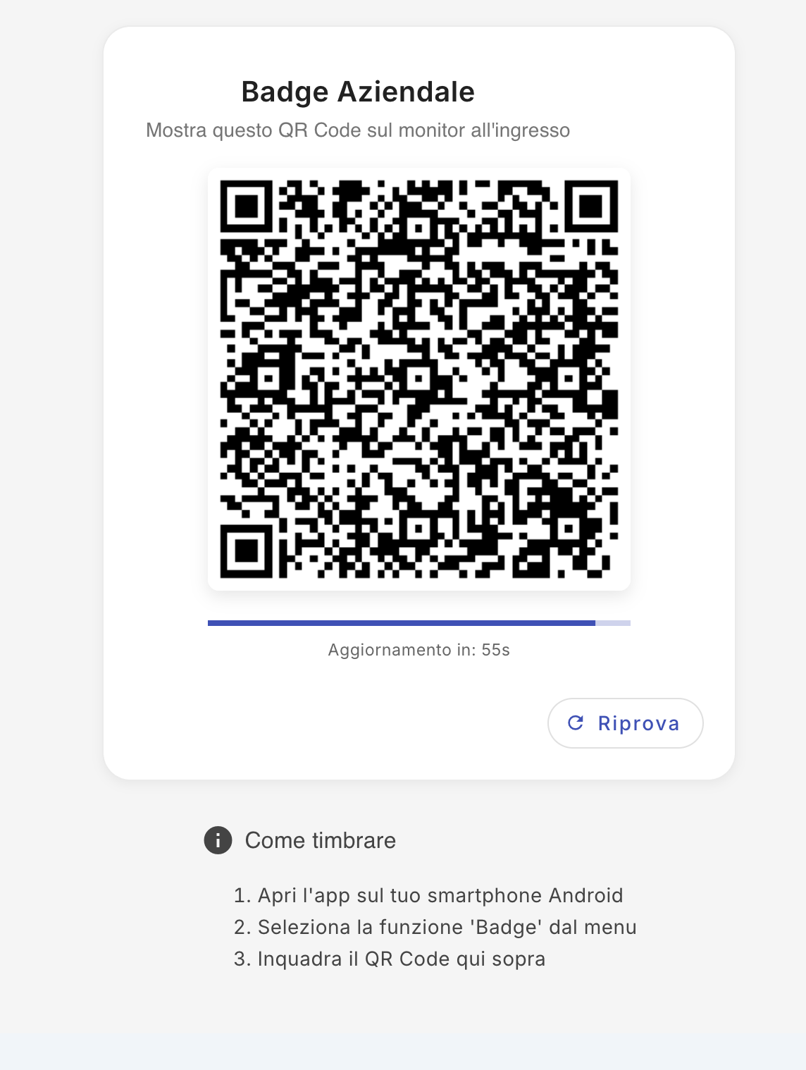

1. Feature Description
The Company Badge feature allows you to manage the clocking in of workers through a QR Code displayed on the company monitor.
The system allows operators to record the main operations related to their presence via the mobile app:
- Entrance;
- Exit;
- Start of pause;
- End of pause.
The QR Code therefore represents the access point through which the worker clocks in using his smartphone.
Note: the operating methods for clocking in via smartphone are described in detail in the Operator Manual of the mobile app.

2. Displaying the Company Badge
By accessing the Company Badge function, a dedicated screen is displayed containing:
- the company QR Code;
- an indicator of the time remaining before the code is updated;
- the Retry button;
- instructions for using the badge.
The QR Code is automatically updated at regular intervals. In the example shown, the system indicates the remaining time by saying "Update in: 55s".

3. How to use the QR Code
To clock in, the worker must use his smartphone and the company mobile application.
The general procedure is:
- Open the company app on your Android smartphone.
- Access the Badges feature from the app menu.
- Frame the QR Code displayed on the company monitor with the camera.
- The app records the required operation, such as entering, exiting, or managing the pause.
The QR Code must be framed directly from the mobile device. You don't have to manually enter worker data.

4. Updating the QR Code
For security reasons, the QR Code displayed on the monitor is updated periodically.
The screen shows a counter that indicates how much time is left until the next update.
If necessary, you can manually request a new code by pressing the Try Again button.
This mechanism prevents a code from remaining valid indefinitely and helps to make the time and attendance system more secure.

5. Use for Time and Attendance
The Company Badge allows you to centrally record the presence activities of the workers.
The main recordings are:
Operation | Description
Input | Record the start of the working day
Exit | Record the end of the working day
Start of pause | Record the start of a pause
End of pause | Record the return from the break
The information generated by the clocking in can subsequently be used by the system for the management and control of staff attendance.

6. Instructions displayed on the monitor
The screen also contains an information section "How to clock in", which summarizes the necessary steps:
- Open the app on your Android smartphone.
- Select the Badge function from the menu.
- Scan the QR Code displayed on the monitor.
These instructions are designed to allow the worker to carry out the procedure independently even without consulting the manual.

7. Operational indications
The monitor containing the QR Code should be placed in a place that is easily accessible to workers, preferably near the company entrance or exit.
The QR Code is intended for use via the company mobile app and must be kept visible and easily framed by the smartphone camera.
For detailed instructions regarding the mobile app and the individual procedures for entering, exiting and managing breaks, please refer to the Operator's Manual – Mobile App.

Attendance management
The Attendance Management section allows the administrator to control and manage employee attendance, monitor entries and exits, check for any anomalies and manage requests for changes or regularization of clocking.
The screen is divided into five main sections:
- Overview
- Events
- Anomaly
- Requests
- Audit log

1. Overview
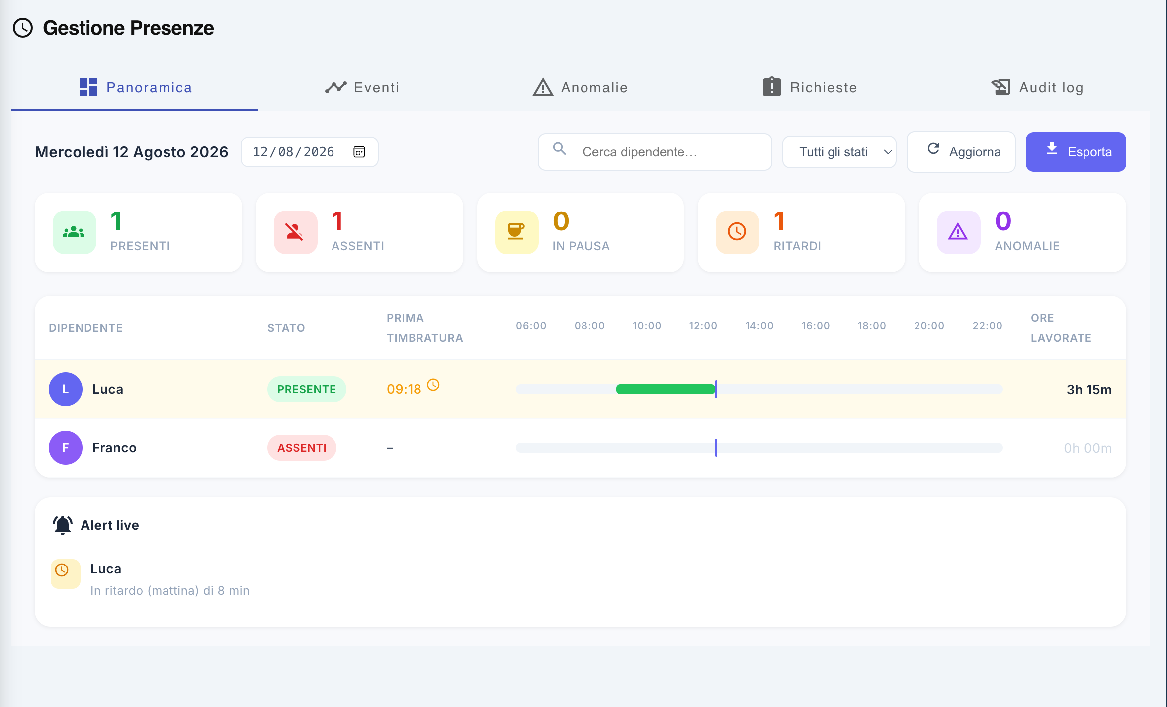
The Overview tab shows the attendance situation for the selected day.

Selection of the day
At the top of the screen, the reference date is indicated. You can:
- change the date by entering it directly;
- select a date using the calendar icon;
- Use filters to view information about specific employees or statuses.
Buttons are also available:
- Refresh, to reload the displayed data;
- Export, to export attendance information.

Attendance summary
At the top, some summary indicators are displayed:
- Present – number of employees currently present;
- Absent – number of employees who are not present;
- On break – number of employees currently on break;
- Delays – number of employees who entered after the scheduled time;
- Anomalies – number of situations that require verification.
These values allow you to immediately have an overview of the day's situation.

List of employees
Below the indicators, the list of employees is displayed.
For each employee, the following are reported:
- name of the employee;
- current status (e.g., present or absent);
- first stamping of the day;
- graphic representation of presence during the day;
- hours worked until the time of consultation.
The graphical representation allows you to intuitively visualize the employee's attendance intervals throughout the day.

Alert live
Any alerts relating to the day are displayed at the bottom of the screen.
For example, a delay may be reported:
Luca – Late (morning) by 8 min
This allows the administrator to quickly identify situations that need attention.

2. Events
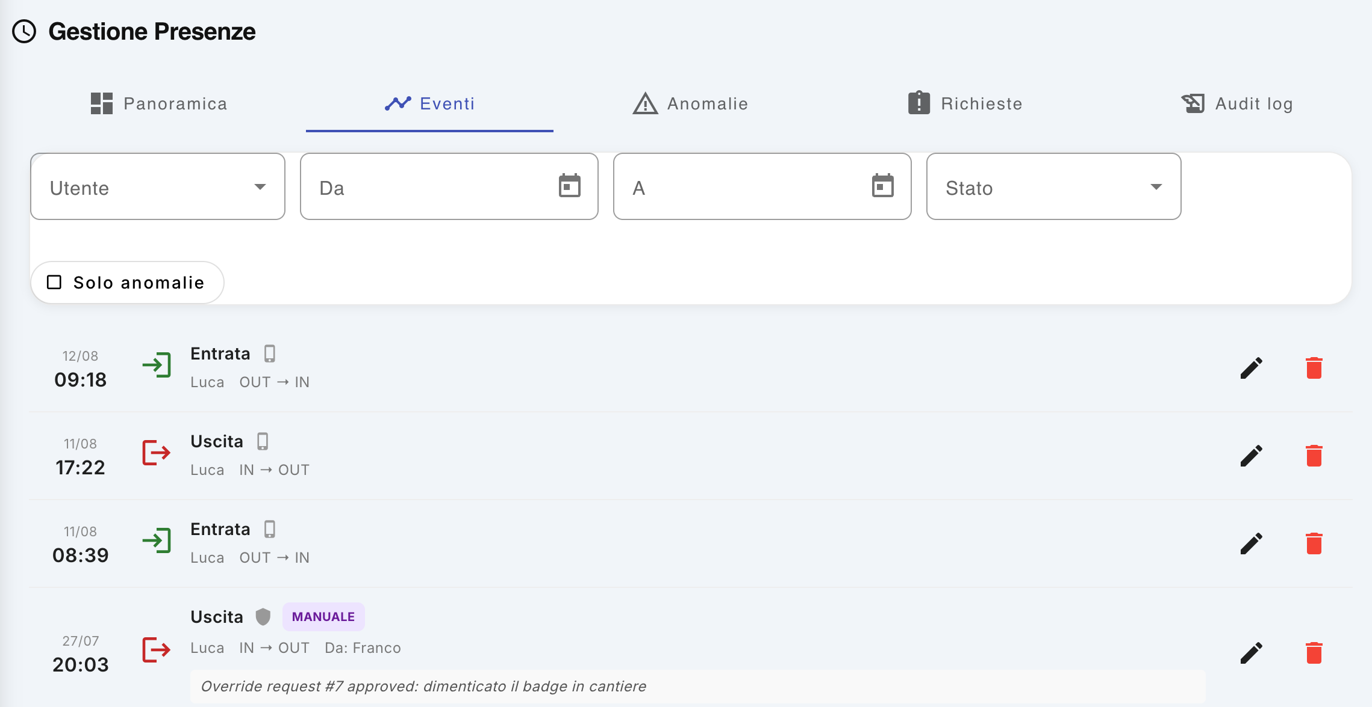
The Events tab contains the history of clocking in made by employees.
For each event, the following are displayed:
- date and time;
- event type, such as Entry or Exit;
- employee who clocked in;
- direction of clocking, e.g. OUT → IN for an entry or IN → OUT for an exit;
- any additional information, such as a clocking carried out manually.

Filters
You can filter events using:
- User;
- date range From/To;
- State;
- Anomalies Only option, to display only the events associated with anomalous situations.

Editing Events
Users with the role of administrator can intervene on clocking.
Next to each event are available:
- pencil icon – allows you to edit the event;
- trash can icon – allows you to delete the event.
These operations must only be carried out when necessary, for example to correct an incorrect clocking in or regularize a situation.
Note: Editing and deleting events is reserved to the administrator.

3. Anomaly
The Anomalies tab collects the situations that require verification with regard to attendance.
Anomalies may concern, for example:
- failure to clock in;
- incorrect sequence of entries and exits;
- unregistered output;
- other situations that prevent the system from correctly reconstructing presence.
The screen allows the administrator to quickly identify the anomalies present and to proceed with their management.
If there are no anomalies, the list is empty.

4. Requests
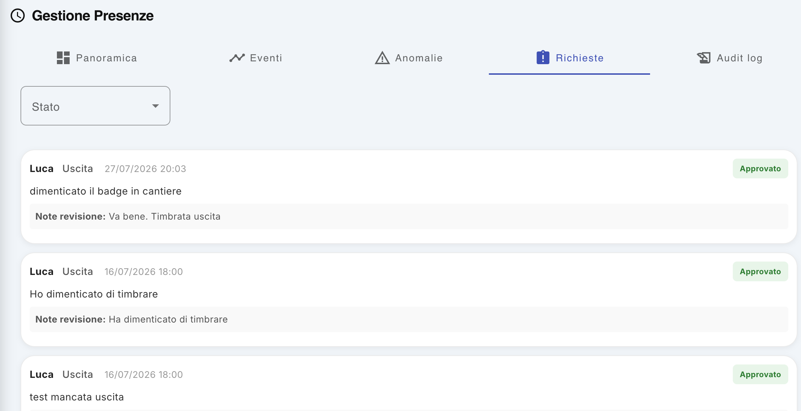
The Requests tab collects requests submitted by employees through the mobile app.
A request can be sent, for example, when an employee forgets their badge and is therefore unable to clock in normally.
The request may contain:
- employee making the request;
- type of clocking concerned;
- date and time;
- motivation provided by the employee;
- any notes relating to the revision.

Request management
The administrator can review each request and decide whether:
- approve it, recording the required clocking;
- reject it, if the request cannot be accepted.
Once the request is processed, it is marked with its status, such as Approved.
When a request is approved, there may also be a review note, which documents the reason for or the outcome of the audit.

5. Audit log
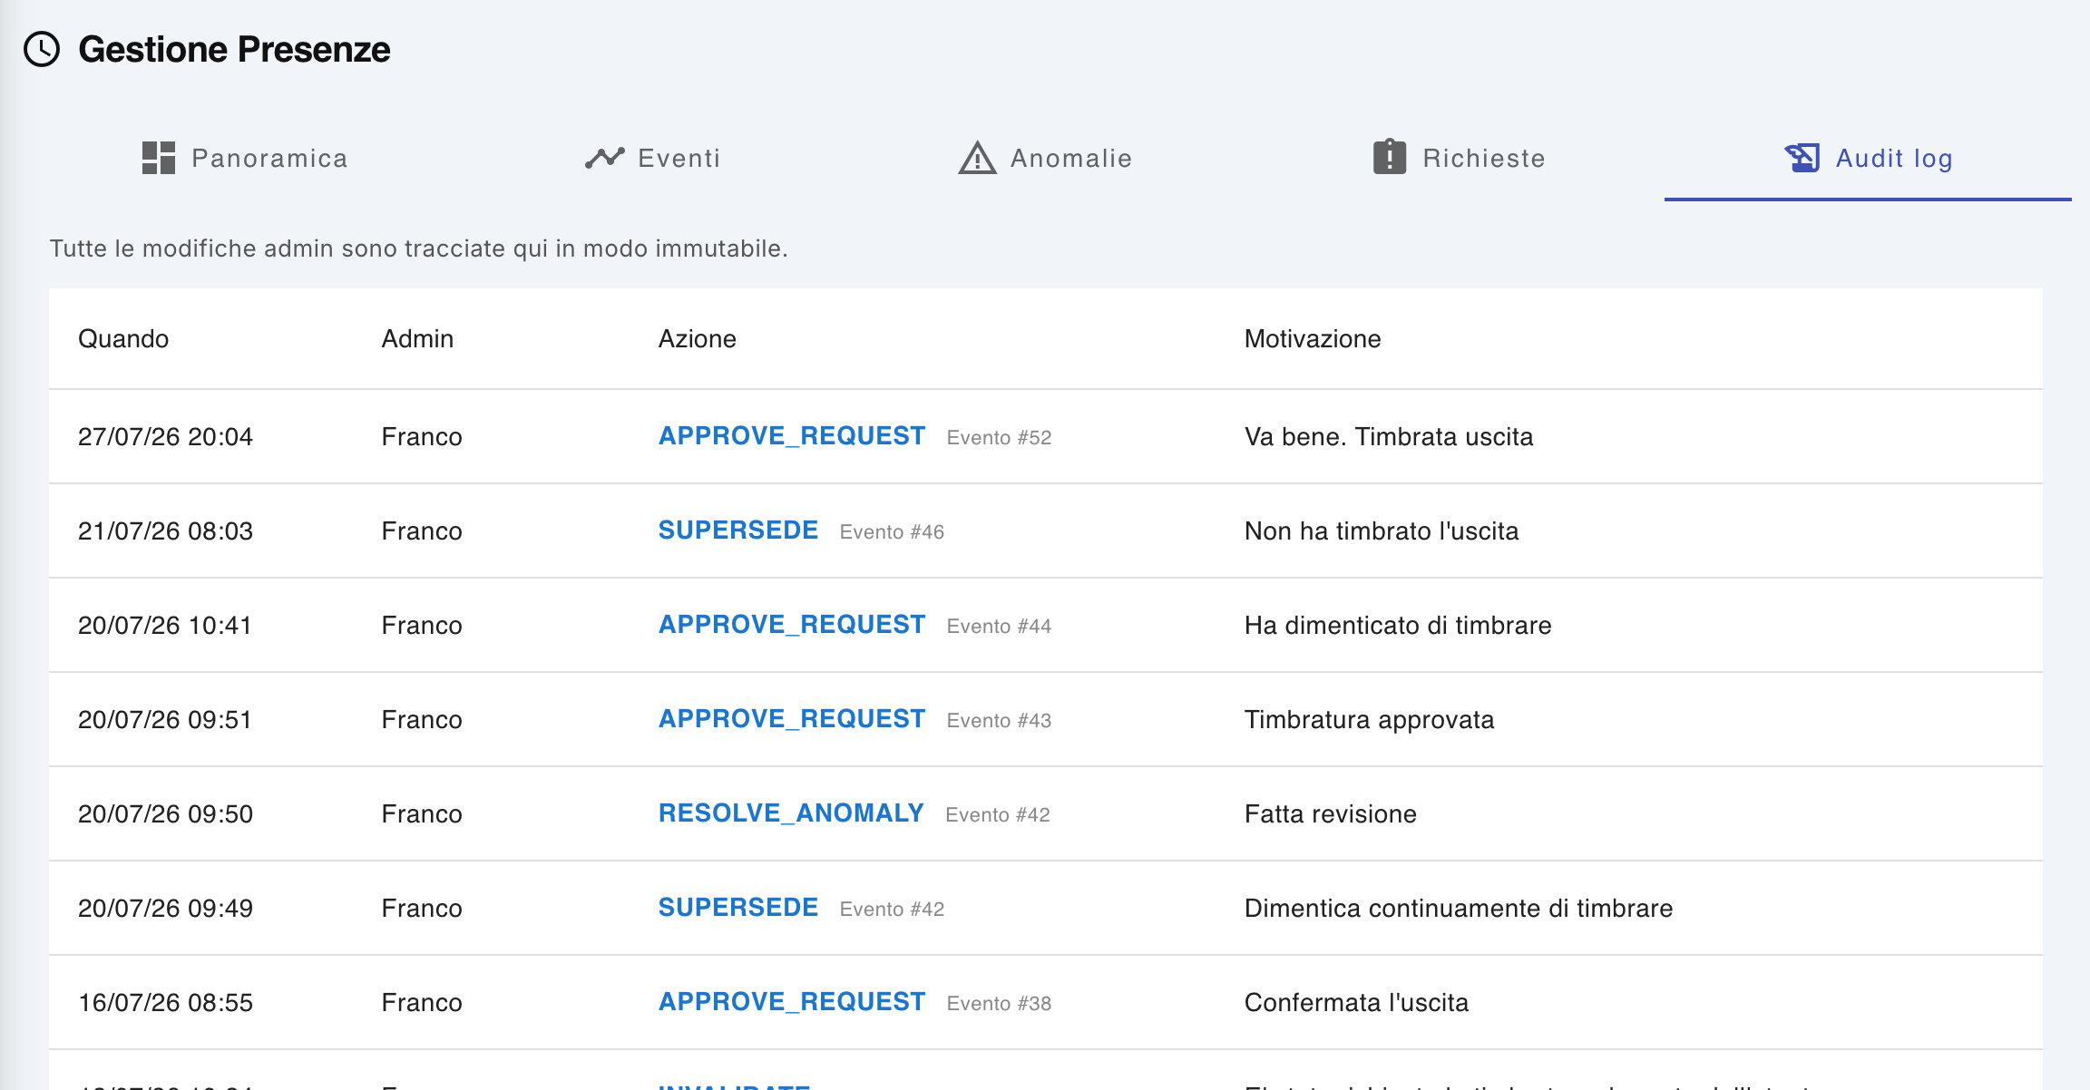
The Audit log tab contains the log of operations performed by the administrator on the attendance management system.
The log allows you to maintain complete traceability of the changes made.
For each operation, the following are indicated:
- When – date and time of the operation;
- Admin – administrator who performed the action;
- Action – operation performed;
- any reference to the event concerned;
- Motivation – reason for the intervention.
For example, the register may include operations relating to:
- approval of a request;
- refusal of a request;
- resolution of an anomaly;
- substitution or cancellation of an event;
- modification of clocking in;
- other administrative operations.
The Audit log therefore represents the history of administrative operations and allows you to check who made a change, when it was made and for what reason.

Feature summary
Fact sheet | Main function
Overview | View the day's attendance situation
Events | Consult and, for the administrator, modify or delete the clocking
Anomaly | Identify and manage abnormal situations
Requests | Review and approve or reject requests submitted by employees
Audit log | Consult the history of administrative operations
Note: The Edit, Delete, Approve, and Anomaly Management functions are only available to authorized users with an administrator role.

My absences
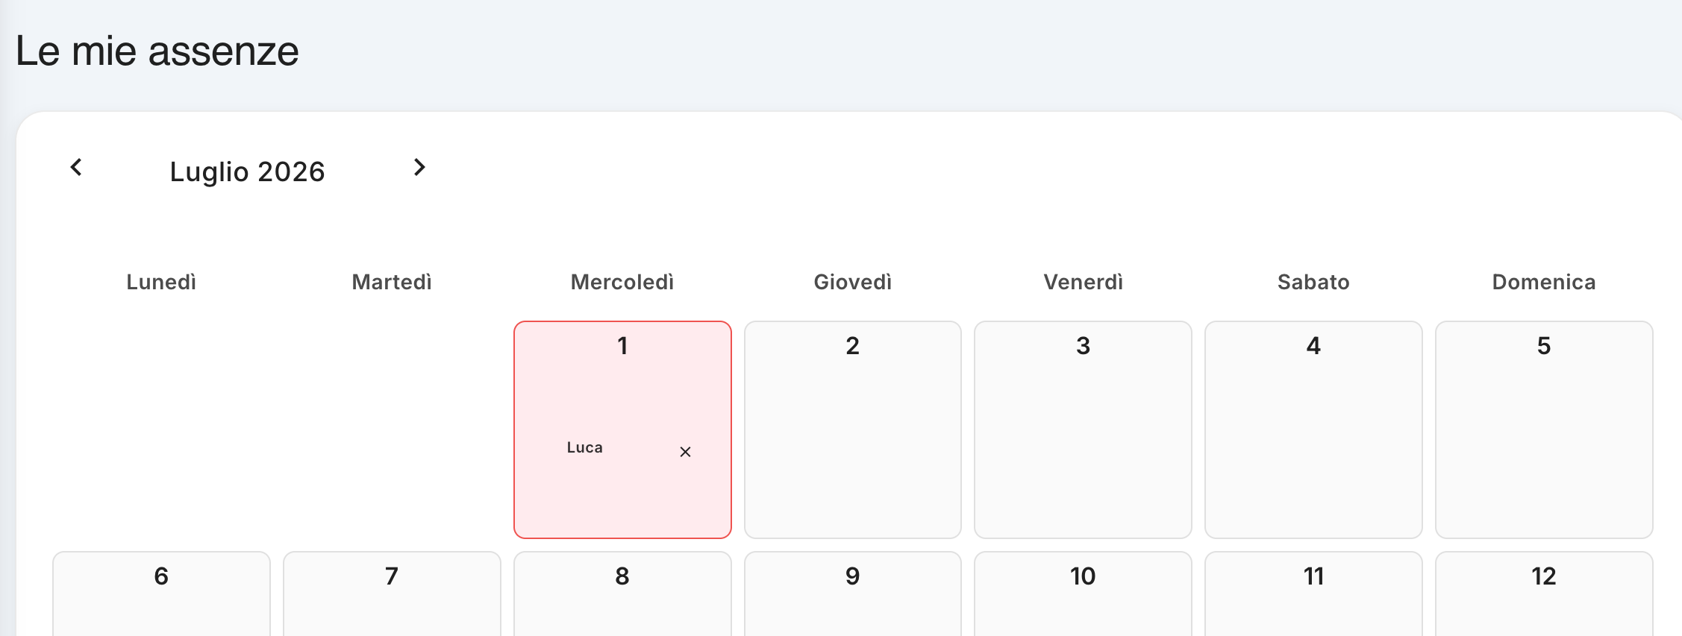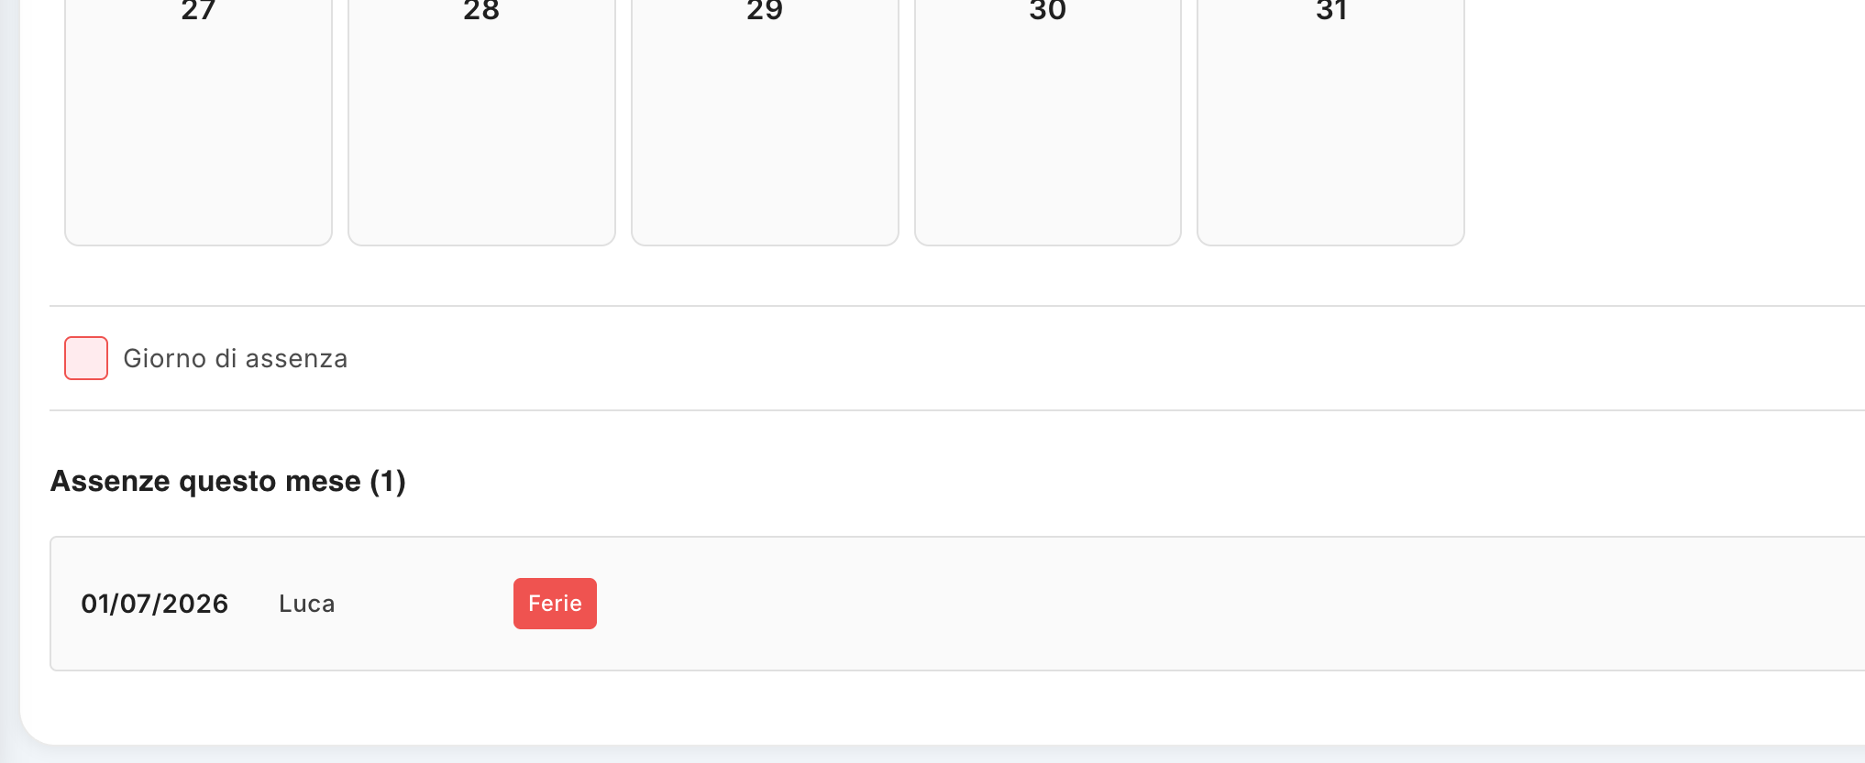
The My absences section allows you to view the absences recorded in the system, organized by month and by single day. The feature makes it easy to check the periods of absence of employees and to take into account their availability in the planning of activities.
Note: Absences are entered and managed from the mobile app. For how to enter an absence, refer to the Operator's Manual – Mobile App.

1. Access to the screen
By selecting My absences from the application menu, the monthly calendar of absences is displayed.
The screen shows :
- the reference month;
- the previous and next buttons to move between months;
- the calendar divided by days of the week;
- any absences recorded for each day;
- the summary of absences present in the month.

View by employee
The screen varies depending on the type of user:
- for a standard user, their absences are displayed;
- For an administrator, you can view the absences of employees managed by the system.
This allows the administrator to check the availability of staff in a specific period.

2. Absence calendar
The calendar presents all the days of the current month.
When there is an absence for a given day, the day is graphically highlighted. The name of the employee concerned may be indicated within the day.
In the example shown, July 1, 2026 is highlighted as the day of absence and shows the name Luca.
The legend at the bottom of the screen indicates that the highlighted box corresponds to:
Day of absence
The calendar view then allows you to quickly identify the days on which one or more employees are unavailable.

3. Navigating Between Months
To consult the absences of a different period, you can use the arrows on the sides of the month name.
- Left arrow: Displays the previous month.
- Right arrow: Displays the next month.
You can then consult the absence history month by month.

4. List of absences of the month
At the bottom of the screen, the summary of absences in the selected month is shown.
The section indicates the total number of absences, for example:
Absences This Month (1)
For each absence, the main information is reported:
- date of absence;
- employee concerned;
- type or reason for the absence.
In the example, for 01/07/2026, the employee Luca is absent for Vacation.
This section allows you to have a textual summary of the information already represented in the calendar.

5. Types of absence
Absences can be associated with different causes, for example:
- Holidays;
- Illness;
- other types of absence provided for by the organization.
The reason for the absence is recorded together with the absence and allows the administrator to understand the reason for the employee's unavailability.

6. Impact on work planning
Absences not only have an informative function, but are also used by the system to determine the availability of technicians in the planning of the work.
When an employee is absent on a given day, the system considers that employee unavailable for new work assignment on that day.
This makes it possible to avoid, during planning, the assignment of an intervention to a technician who is already absent.
Checking for absences should therefore be done before proceeding with scheduling or assigning tasks, especially when working on future dates.

7. Entering absences
Entering absences is not done from this screen.
Absences are recorded through the mobile application used by the employee.
Once the absence has been entered from the mobile app, it is made available in the system and displayed in the My absences section, as well as being considered in the management of technician availability.
For information on the procedures of:
- insertion of a new absence;
- selection of the type;
- indication of the date or period;
- any modification or management of the request;
consult the Operator's Manual – Mobile App.

8. Usage by the Administrator
For the administrator, the screen is a tool for checking the availability of personnel.
Before assigning a job, you can then check whether the technician:
- it is available on the scheduled day;
- is absent;
- is absent due to holidays, illness or other reasons;
- It can then be selected for task assignment.
In this way, absence management is integrated with work planning, reducing the risk of assignments that are incompatible with the actual availability of operators.

In summary
My absences allows you to:
- consult absences by month;
- view the days of absence directly on the calendar;
- know the employee concerned and the reason for this;
- consult the history of absences;
- check the availability of technicians for planning purposes;
- effectively preventing the assignment of work to a technician who is absent.
The entry and operational management of absences takes place from the mobile app.

Administration

Customers
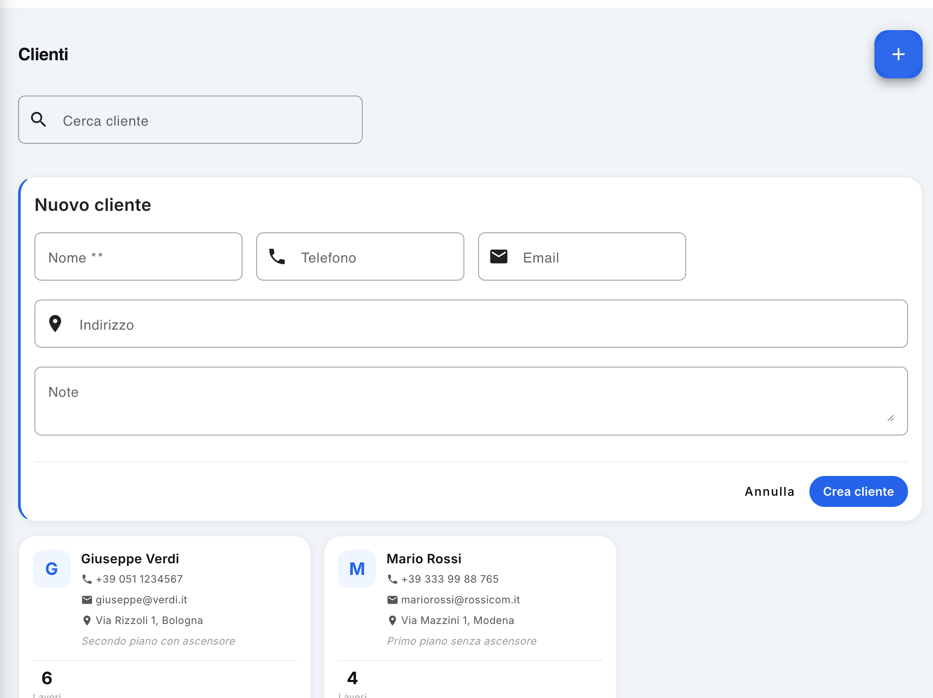
The Customers section, available within the Administration area, allows you to create, view and manage the company's customer database.
For each customer, it is possible to store the main contact data and check the number of associated jobs. The section also allows you to edit or delete existing customers.

1. Access to customer management
To access the feature:
- Enter the Administration section.
- Select the Customers item.
The list of customers already in the system is displayed.
The screen contains:
- the Search for customer field, to quickly search for a customer;
- the + button at the top right, to enter a new customer;
- the list of customers in the system.

2. Onboarding a new customer
To create a new customer, press the + button in the top right.
The New customer window appears, in which you can enter:
- Name — name or name of the customer. The field is mandatory;
- Telephone — the customer's telephone number;
- Email — email address;
- Address — the customer's address;
- Notes — any additional information useful for managing the customer.
After entering the data, press Create customer to save the new master data.
To cancel the operation without creating the customer, press Cancel.
Note: The Name field is required. The other data allow you to complete the customer's master data and can be used as a reference in the management of the works.

3. Customer List
On the main screen, a tile is displayed for each customer in the system.
Each box shows the main information of the master data, including:
- customer name;
- telephone number;
- email address;
- address;
- any notes.
The bottom of the pane also shows the number of jobs associated with the customer.
This information allows you to quickly get an overview of the activity linked to each customer.

4. Viewing the client's jobs
The number of associated jobs is indicated in the customer box .
You can also access its management via the Open Jobs button.
This feature allows you to check the still open jobs associated with the specific customer and to quickly switch from master data management to operational job management.

5. Changing customer data
To edit the data of an existing customer:
- Locate the customer in the list.
- Press the pencil icon in the pencil box.
- Edit the data you want.
- Save your changes.
The change allows you to keep the master data up to date without having to create a new customer.

6. Deleting a customer
To delete a customer from the list, press the red trash can icon in the list pane.
Deletion should be used with care, especially for customers with whom jobs are associated.

7. Search for a customer
When your list contains many customers, you can use the Search Customer field at the top of the screen.
By entering the customer's name, the system allows you to locate the customer's card more quickly without having to manually scroll through the entire list.

Summary of operations
Operation | Action
Create a customer | Press + and fill in the form
Search for a customer | Use Customer Search
View open jobs | Press Open jobs
Edit a customer | Press the pencil icon
Delete a customer | Press the red trash can icon
The Customers section is therefore the central point for the management of master data and for the connection between customers and the related jobs within the application.

Data Import and Export
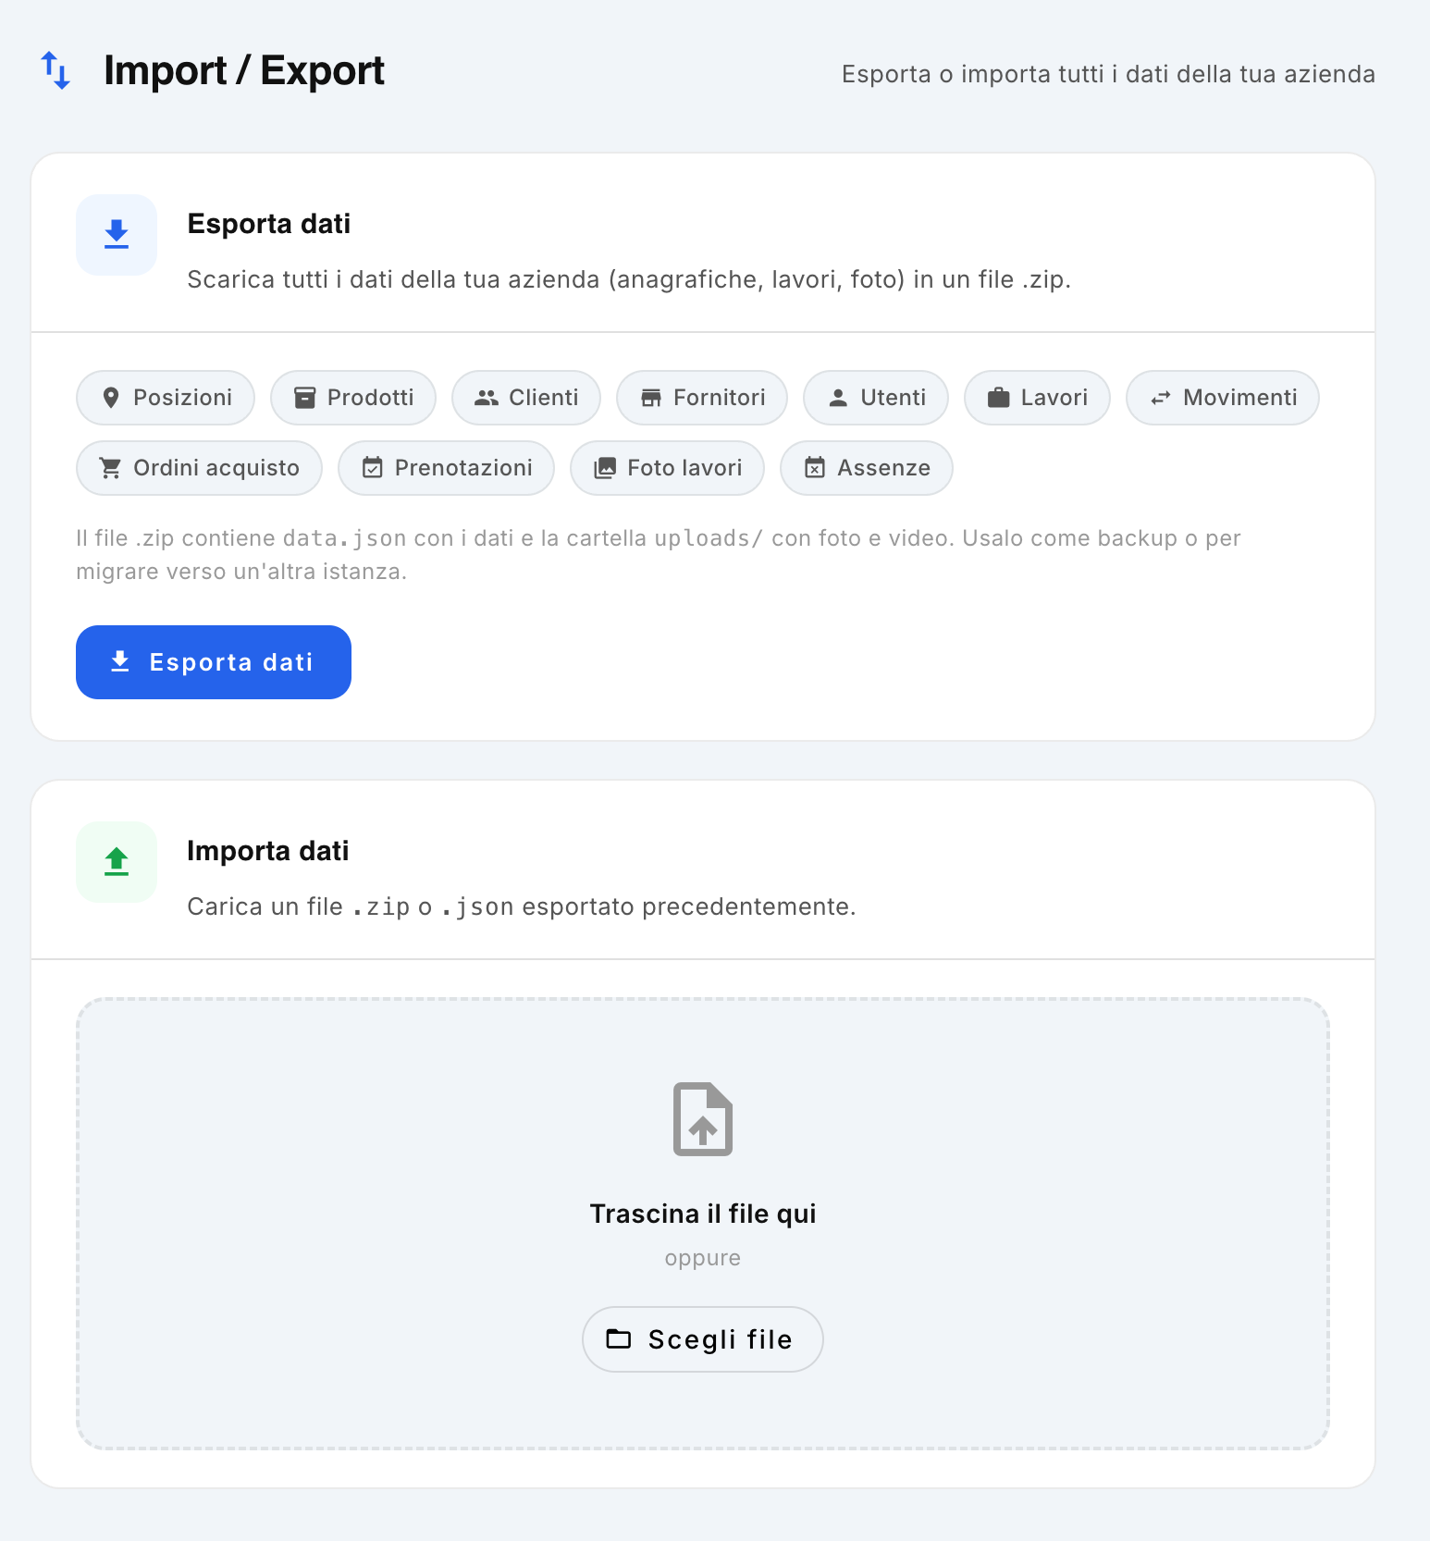
The Import/Export section allows the Company administrator to independently export the company's data and, when necessary, to re-import it later.
The feature can be used, for example, to make an autonomous backup of data, keep a copy of the company archive or transfer data to another instance of the application.
Note: This functionality is complementary to the centralized backup system. In fact, the system automatically performs a data backup every two hours, managed centrally by the administrator who manages all the companies. Import/export, on the other hand, allows the administrator of the individual company to independently manage a copy of his data.

1. Accessing the Feature
To access the feature:
- Enter the Administration section.
- Select Import/Export.
The screen is divided into two main areas:
- Export Data
- Import data

2. Data export
The Export Data function allows you to download all the main data relating to the Company in a single archive.
To start the export, press the Export Data button.
The system generates a .zip format file containing the exported data.

Data included in the export
The archive includes:
- Positions
- Products
- Customers
- Suppliers
- Users
- Works
- Movements
- Purchase orders
- Reservations
- Photos of the works
- Absences
Structured data is saved within the repository in JSON format.
The photographs and videos acquired during the execution of the works are instead collected in the relative uploads/ folder.
This ensures that the archive contains both management information and multimedia content associated with jobs.

Structure of the archive
Indicatively, the .zip file contains:
- JSON file with application data;
- Uploads/ folder containing photos and videos taken during the work.
The archive can then be kept as a copy of the Company's data or used for a subsequent import operation.

3. Data Import
The Import Data section allows you to restore previously exported data.
You can use a file:
- .zip generated by the export function;
- .json previously exported from the system.
There are two ways to upload an archive.

Dragging and dropping the file
You can drag the file directly into the Drag file here area.

File selection
Alternatively:
- Press Choose File.
- Select the file you want to import from your computer.
- Confirm the operation.
The system will then proceed to import the data contained in the file.

4. Data Recovery
Import can be used to restore a previous situation of the Company from an exported archive.
For example, an administrator can:
- Export company data.
- Keep the .zip file in a safe place.
- Use the file later using the Import Data function.
- Restore the data contained in the archive.
Please note: importing data is an administrative operation and must be carried out using a valid archive from the system. Before proceeding, it is advisable to carefully check the file you are importing.

5. Centralized Backup and Import/Export
It is important to distinguish between the centralized automatic backup and the Import/Export function available in the application.

Centralized backup
The central system automatically backs up your data every two hours.
This backup is managed by the central system administrator and concerns the companies managed by the platform.

Import / Export della Company
The function described in this chapter allows the administrator of the individual Company to:
- create a copy of your data yourself;
- to maintain a local archive;
- export the Company's data;
- re-import an archive later;
- have a copy independent of the centralized backup.
The two functions are therefore complementary: centralized backup guarantees automatic data protection at the system level, while Import/Export offers the Company administrator an additional tool of autonomy in managing their data.

6. Summary of operations
Operation | Action
Export data | Press Export Data
Save a copy of the Company | Keep the generated .zip file
Import an archive | Drag the file to the import area, or press Choose File
Exported data | Locations, products, customers, vendors, users, jobs, movements, purchase orders, bookings, job photos, and absences
Structured data | File JSON
Photos and videos | Cartella uploads/
Automatic backup | Runs centrally every two hours
Import/Export Management | Available to the Company Administrator
Good practice: We recommend that you keep your exports in a safe place and use this feature as an additional copy of your data, and not consider it a substitute for your centralized backup system.

Positions
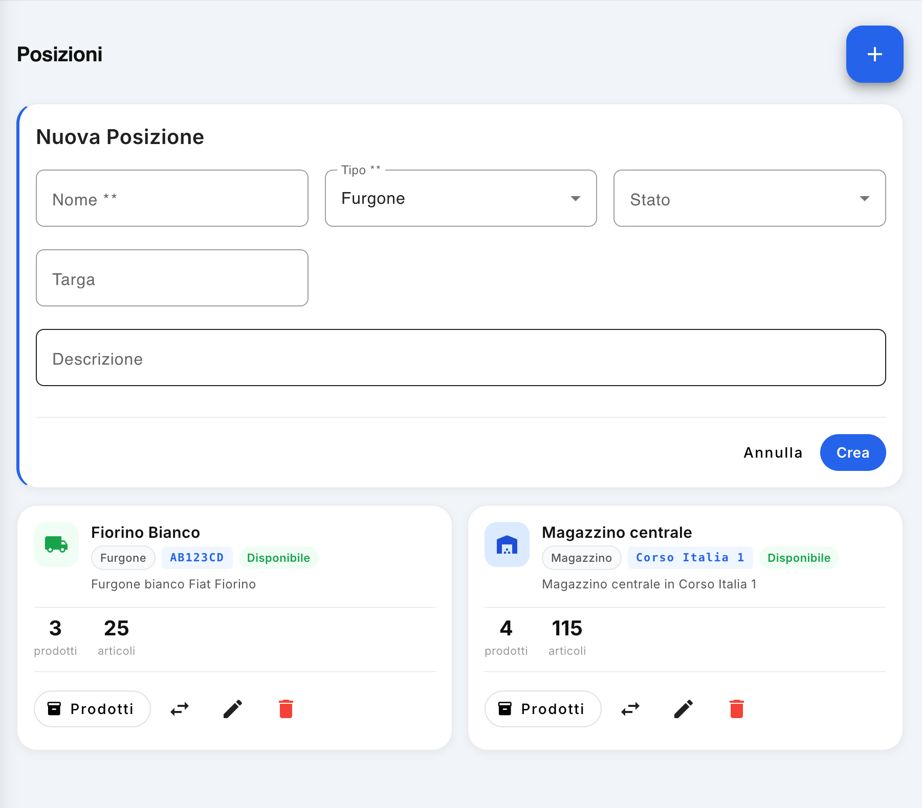
The Locations section, accessible from the Administration panel and reserved for users with the Administrator role, allows you to create and manage all the locations used by the company for storage, transport or management of materials.
For example, a location can be a warehouse, a van, a construction site, or any other physical resource where products and materials may be present.

1. Viewing Locations
The screen presents the list of available locations in the form of tiles. For each position, the main information is displayed:
- Name of the position;
- Location type, such as Van, Warehouse, or other;
- Targa, when predicted;
- Location status ;
- Description;
- number of different products present;
- Total number of items/units loaded on the location.
For example, if a line item has 3 products and 25 items, it means that there are 3 different types of products, for a total of 25 units.
This information allows you to quickly check both the availability of the location and the currently associated material.

2. Creating a new location
To create a new location, click the + button in the upper-right corner of the screen.
The New Location window appears, in which you can enter:
- Name – mandatory field that identifies the position;
- Type – select the type of location, such as Van, Warehouse, Construction Site, or other available type;
- Status – indicates the current condition of the position;
- License plate – to be filled in when the position corresponds to a vehicle;
- Description – Allows you to add additional location information.
After filling in the data, click Create to save the new location. To cancel the operation, click Cancel.

Location States
The status indicates whether a location can be used:
- Available – location is available for use;
- Busy – the location is currently in use;
- In maintenance – the location is not available for use.
For example, the Under maintenance status can be used to temporarily suspend the use of a van that is unavailable.

3. Position management
Each tile has a set of commands for managing position.

Products
The Products button allows you to directly access the management of the products associated with the position.
The product screen is opened already filtered for the selected location, allowing you to immediately view the material on the van, in the warehouse or in the relevant location.

Change of status
The arrow icon allows you to quickly change the status of the location.
It is therefore possible to go through, for example:
Available → Busy → Under maintenance
based on the current situation of the resource.

Edit
The pencil icon allows you to edit the location data previously entered, such as name, type, status, license plate or description.
After you make your changes, you can save them to update your location.

Elimination
The red trash can icon allows you to delete the location.
Before proceeding with the deletion, verify that the location should no longer be used and that there is no data or material that should be kept associated with it.

4. Using Positions in Product Management
Positions are a fundamental element for warehouse and material management.
Associating products with a location allows you to know where the material is physically located and to control the quantity available.
In particular, for a van it is possible to check directly from the relevant tile:
- how many types of products are present;
- how many total units are loaded;
- whether the medium is available or not;
- what are the identification data of the vehicle.
The direct link to the Products button also allows you to quickly switch between managing your positions and managing your inventory inventory.

5. Summary of operations
Operation | Function
+ | Create a new location
Products | View products associated with location, with auto-filter
Arrows | Quickly change location status
Pencil | Edit location data
Basket | Delete Location
Note: Position management is only available to the Admin user from the Administration section.

Suppliers
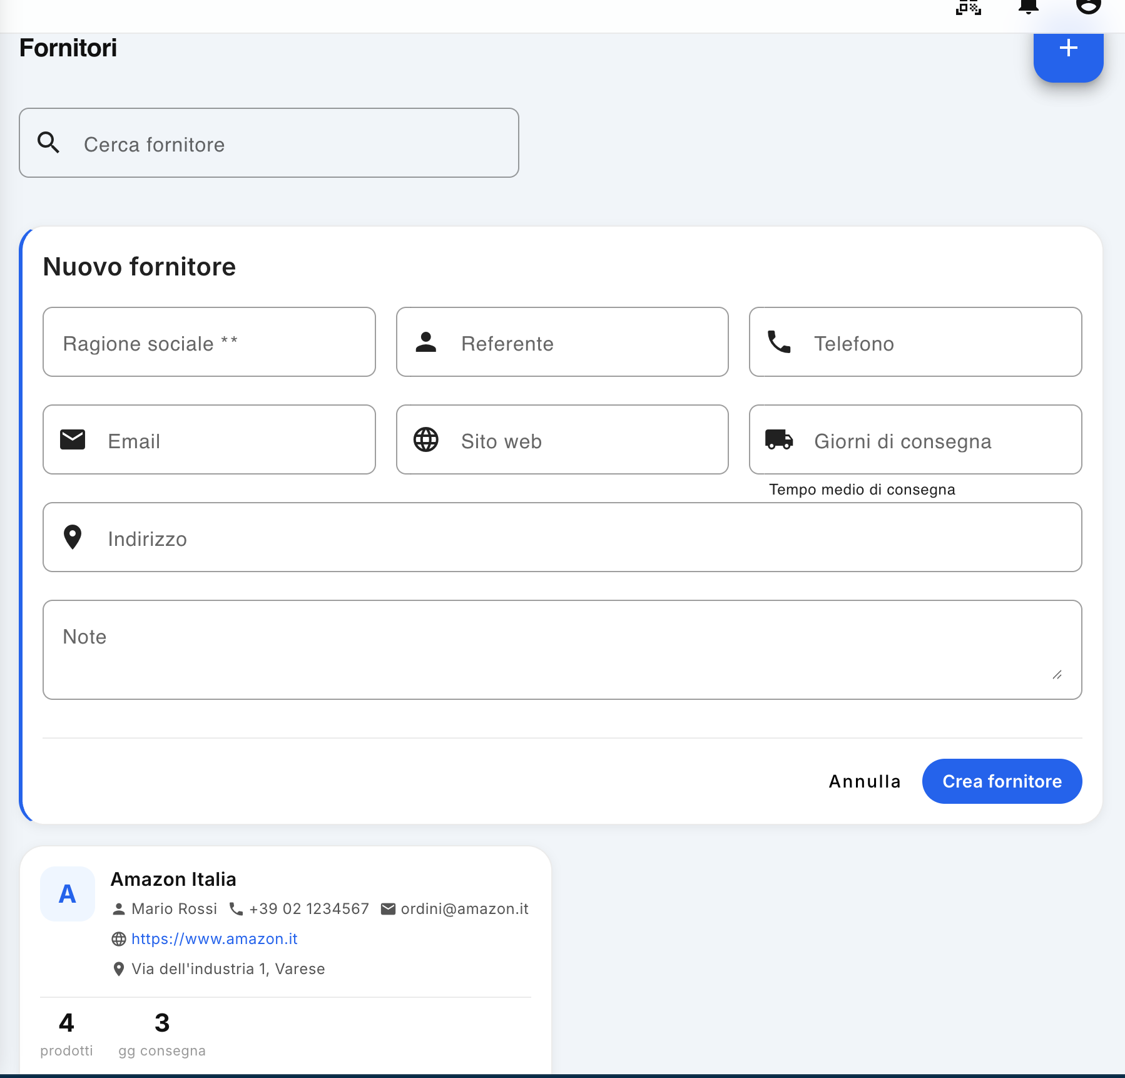
The Suppliers section, accessible from the administration panel, allows you to manage the company's supplier master data and keep the information necessary for the management of purchases and deliveries up to date.

1. Consultation of suppliers
The Suppliers screen displays the list of suppliers already present in the system.
For each supplier it is possible to view directly in the relative tab:
- Company name;
- referent;
- telephone number;
- e-mail address;
- website, if any;
- address;
- number of products associated with the supplier;
- average delivery days of the products.
There is also a Vendor Search field, which allows you to quickly locate a vendor from the list.

2. Onboarding a new supplier
To add a new supplier, click the blue + button in the upper-right corner of the screen.
The New supplier window will open, in which the available information must be entered:
Field | Description
Company name ** | Name or name of the supplier. The field is required.
Reference | Name of the contact person at the supplier.
Phone | Telephone number of the supplier or contact person.
Email | The email address used for contacts.
Website | Address of the provider's website, if available.
Delivery days | Average number of days it takes for the ordered products to be delivered.
Address | Address of the supplier's headquarters.
Notes | Any additional information useful for supplier management.
Note: The number of delivery days represents the average expected time for the supplier to deliver the products. This data can be used by the system as a reference in the management of purchases and procurement times.
After filling in the data, click on Create supplier to save the new master data.
To stop inserting without saving, click Cancel.

3. Managing Existing Vendors
Supplier information can be kept up to date directly from the list.
For each supplier it is possible to:
- modify the personal data;
- delete the supplier;
- check the number of associated products;
- Check the average delivery days.
The change is useful, for example, to update the contact person, contact details, address or average delivery times.
Deletion must be carried out carefully, as it involves the removal of the supplier from the master data available in the application.

4. Summary information
Each supplier card presents a summary of the most important information, allowing the administrator to quickly have a view of the situation without having to open the individual master data.
In particular, the number indicated under the heading products represents the number of products associated with that supplier, while the value relating to the days of delivery indicates the average expected time for the availability of the goods.
This information facilitates supplier management and allows you to keep track of the procurement times required for job management.

Users
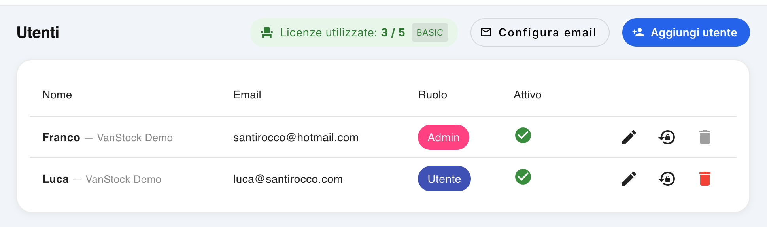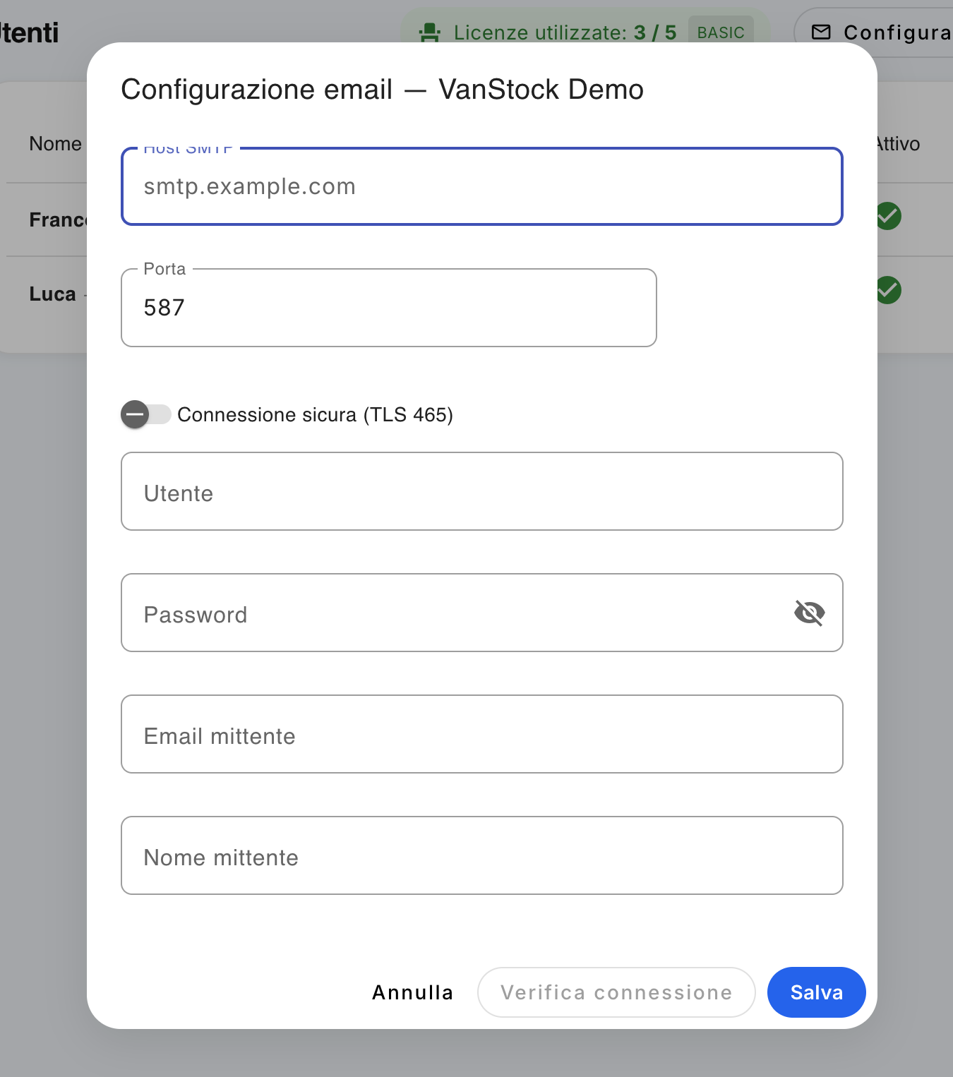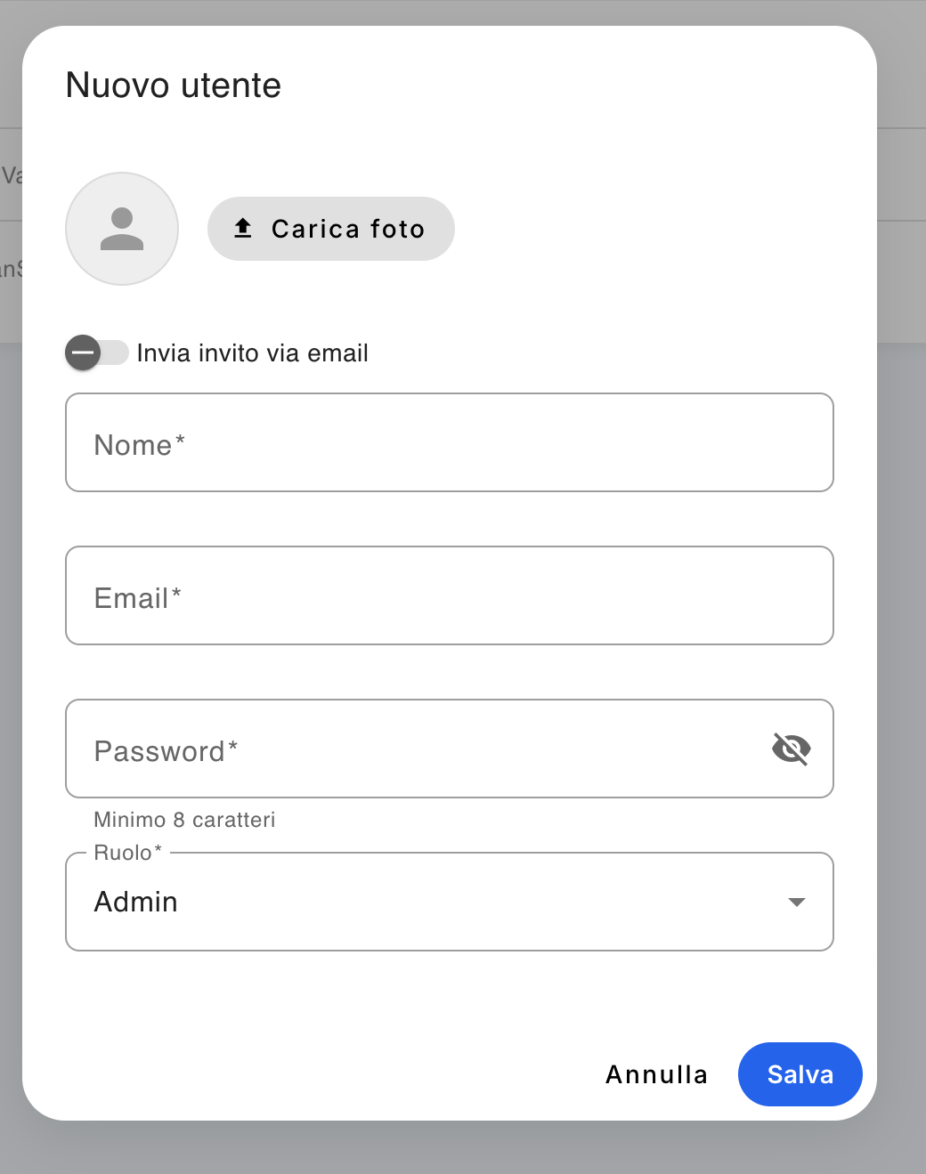
The Users section, accessible from the Administration panel, allows the company administrator to manage the users enabled to use the application, check the available licenses and configure the email service used by the system to send communications.

1. List of users
The Users screen displays the list of users registered in the company.
For each user the following are reported:
- Name;
- Email associated with the user;
- Role, which can be Admin or User;
- Activation status, which indicates whether the user is active.
The top of the screen also displays the number of licenses used compared to those available, with an indication of the license type, such as Basic or Pro.
Note: Licenses are counted based on the seats expected by the system configuration. In the example shown, 3 out of 5 Basic licenses are used: one by the company administrator, one by an operating user and one by the system administrator. In a configuration that is intended for a customer only, the system administrator is not counted in the customer's endowment.

2. Add a new user
To create a new account, click on the Add user button, present at the top right.
The New User window opens, where you can configure:
- Photo: Allows you to upload a photograph of the user;
- Send email invitation: if activated, allows you to send the user an invitation email to the platform;
- Name*: name of the user;
- Email*: email address used for access and communications;
- Password*: The user's initial password. The password must be at least 8 characters long;
- Role*: allows you to choose the user's permission level between Admin and User.
Once the data is completed, click on Save to create the account.

Available roles
Admin
He has the administrative privileges provided by the system and can access the functions reserved for the administration of the company.
User
It has the operational capabilities expected of ordinary users, without administrative privileges.
Note: Your choice of role determines the functionality and data that the user can access. Assign the Admin role only to users who need to manage the company.

3. Edit a user
To edit a user's data, click on the pencil icon in the relevant row.
You can modify, according to the available permissions:
- name;
- email address;
- role of the user;
- other configurable user data.
After making the changes, save the configuration.

4. Reset della password
In each user's row, there is an icon depicting a padlock with an arrow.
This function allows you to start the procedure of resetting the user's password.
The system uses the email service configured in the Configure email section to send communications relating to the recovery/reset procedure.

5. Delete a user
To delete a user, click on the trash can icon in the relevant row.
Deleting removes the user from the company's list of users and frees up the user license.
Note: Accounts with the Admin role cannot be deleted by the company administrator. The management and possible elimination of administrative users is reserved to the Super Admin of the system.

6. Configuring the email service
The Configure email button, at the top of the screen, allows you to configure the SMTP server used by the application for sending emails.
This configuration is important because it allows the system to send communications using the company's email address, rather than a generic system address.
The configuration is used, for example, to:
- invitations to new users;
- communications and notifications generated by the application;
- password reset procedures;
- other automatic system communications.

SMTP Parameters
In the Email Configuration window , you must enter the parameters provided by your email provider:
- SMTP host: address of the SMTP server;
- Port: The port used by the SMTP server;
- Secure connection (TLS 465): Enable the option when prompted by the provider;
- User: Credential used to authenticate to the server;
- Password: password dell'account email;
- Sender email: address from which communications will be sent;
- Sender name: The name that the recipient displays as the sender of the emails.
After entering the parameters, you can use the Connection Checker to check that the SMTP configuration is correct.
If the verification is successful, click Save to save the configuration.
Tip: SMTP parameters must be requested from the provider of the email service used by the company. Host, port, and security mode may vary depending on the provider.

7. License Management
The Used Licenses section allows the administrator to immediately check the number of licenses currently used and those still available.
For example:
Licenses used: 3 / 5 — BASIC
This means that there are 5 licenses available, of which 3 are currently assigned.
Therefore, before creating a new user, it is advisable to check the availability of a license.
Licenses can be Basic or Pro, depending on the plan assigned to the company.

Summary of operations
Operation | Function
Add User | Create a new account
Upload photo | Associate a photograph with the user
Send email invitation | Send the user an invitation communication
Pencil | Edit user data
Padlock + arrow | Start password reset
Basket | Delete the user, when allowed
Configure email | Configure the company's SMTP server
Licenses used | Show used and available licenses

Good administrative practice
It is recommended that you keep your list of users up to date by disabling or removing users that are no longer needed, and periodically checking the available licenses. The configuration of the email service must also be completed so that the system can properly manage invitations, notifications and password recovery procedures.

Features
The Feature feature allows the SuperAdmin to determine which modules and features are available for each Company.
In this way, it is possible to configure the application according to the needs of each company, showing users only the features that have been enabled.
For example, you can create the ATTENDANCE Feature and associate features with it:
- QR Monitor
- Attendance
- Absence
If the ATTENDANCE feature is enabled for a company, authorized users will be able to use these features.
If the Feature is disabled, its functionality will not be available to Company users.

1. How a Feature Works
A Feature represents a set of features belonging to the same application module.
For example:
Feature | Associated features
ATTENDANCE | QR Monitor, Attendance, Absence
WAREHOUSE | Inventory Management, Movements, Inventory
REPORT | Reporting, Exports
The Feature is configured by the SuperAdmin and can then be enabled or disabled for each Company.

Important
The availability of a Feature is independent of the permissions of individual users.
The Feature determines whether the module is available to the Company.
Instead, normal user permissions continue to dictate which users can use which features.

2. Creating a Feature
The SuperAdmin can create a new Feature from the Feature Management section.
To create a Feature, you must specify:
- Name: The name by which to identify the form, such as ATTENDANCE
- Description: A brief description of the feature
- Associated Features: The system entries that are part of the Feature

Example
Creando la Feature:
ATTENDANCE
You can associate them:
- QR Monitor
- Attendance
- Absence
Once saved, the Feature will be available for the configuration of the Companies.

3. Configure the Features of a Company
From the Feature Company section, the SuperAdmin can choose a Company and view the list of available Features.
For each Feature, its status is shown:
- Enabled: the Company can use the associated features
- Disabled: Company cannot use associated features
The SuperAdmin can change the status of the Feature at any time.

Example
For Company Company A:
Feature | Status
ATTENDANCE | ✅ Enabled
WAREHOUSE | ✅ Enabled
REPORT | ❌ Disabled
Company A users will be able to use ATTENDANCE and INVENTORY, but will not have access to the features included in the REPORT feature.

4. Effects of disabling
When a Feature is disabled for a Company, the associated features are automatically excluded from the user experience.
For example, if you disable the ATTENDANCE feature:

Web Application
Their items will no longer appear in menus, for example:
- QR Monitor
- Attendance
- Absence

Mobile Application
Its navigation element, such as Attendance, will not be displayed.
The availability of the features is then automatically adapted to the Company's configuration.

5. Re-enable a Feature
To make a feature available again:
- Go to the Feature Company section.
- Select the company that you are interested in.
- Locate the Feature.
- Set the status to Enabled.
- Save the configuration.
The features associated with the Feature will become available again according to the normal permissions of users.

6. Features and user permissions
Features do not override user permissions.
There are two distinct levels of control:
Feature Company: Determines which modules are available to the Company.
User permissions: Determines which users can use the available features.
For example, if ATTENDANCE is enabled for a Company, it does not necessarily mean that all users will be able to use Attendance.
The user must still have the authorizations provided by the system.

7. Full Example
Suppose we have three Companies:
Company | ATTENDANCE | WAREHOUSE | REPORT
Company A | ✅ | ✅ | ❌
Company B | ❌ | ✅ | ❌
Company C | ✅ | ❌ | ✅
The system will behave differently for each company.

Company A
Users will be able to use:
- ATTENDANCE
- WAREHOUSE
They will not have REPORT available.

Company B
Users will be able to use:
WAREHOUSE
The ATTENDANCE and REPORTS features will not be available.

Company C
Users will be able to use:
ATTENDANCE
REPORT
The WAREHOUSE module will not be available.

8. Changing the configuration
The SuperAdmin can change the configuration of a Company's Features at any time.
The change only affects the availability of features and does not change previously recorded data.
For example, if you disable the ATTENDANCE feature, attendance data that is already in the system is not deleted.
The Feature can then be re-enabled to make its functionality available again.

9. Good practices
Before disabling a Feature, it is advisable to verify that the Company does not have operational needs related to the functionalities included in the module.
In particular:
- check which features are associated with the Feature;
- verify the users concerned;
- verify any operational activities in progress;
- Inform Company users when the change impacts their work.

In summary
Feature management allows the SuperAdmin to customize the Company-by-Company application, making only the necessary modules available.
The operation can be summarized as follows:
SuperAdmin → creates Feature → associates features → enable/disable for Company → the system automatically shows the available features.

Fix Warehouse
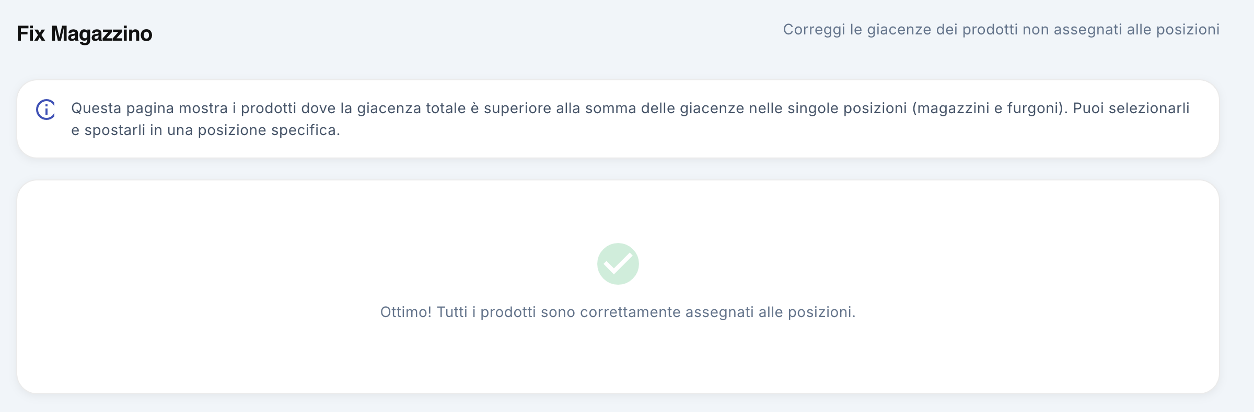

1. Feature Description
The Fix Warehouse section is a feature reserved exclusively for users with the Administrator role and allows you to check and correct any anomalies in the management of stocks.
The feature checks that all products in the company are correctly associated with a location, such as a warehouse or van.
Normally this situation should not occur, because when a product is purchased or manually inserted into the system, the position in which it is loaded must always be indicated.
The Fix Warehouse screen is therefore a control and recovery tool to be used in the event that, for any reason, some products are missing an assigned position.

2. Access to Fix Stock
The functionality is only accessible by the Administrator user.
The screen automatically shows products for which:
- the total stock recorded in the system;
- is greater than the sum of the stocks assigned to the individual positions.
In other words, the system identifies the products for which there is a quantity in the warehouse, but part or all of this quantity is not associated with a specific warehouse or van.

3. Fault check
When the screen is opened, the system automatically checks the stock situation.

Correct situation
If all products are correctly assigned to a location, a confirmation message is displayed:
Great! All products are correctly assigned to the positions.
In this case, you do not need to do anything.

Unassigned products
If, on the other hand, anomalies are detected, the screen shows the products for which the stock is not fully associated with a location.
This situation can occur, for example, when:
- a movement has not correctly recorded the destination position;
- a data entry procedure has generated a stock without position;
- There was an anomaly in the handling of the data.
The screen allows you to intervene directly to correct these situations.

4. Inventory correction
To correct anomalies, simply use the Correct command.
The feature allows you to assign products without a location to a specific location.
For each product concerned, you are asked to indicate where the quantity not yet allocated should be placed.
The administrator can then choose, for example:
- Central warehouse;
- another warehouse;
- a van;
- Any other available location configured in the system.
The correction is made by indicating the target location for each product.

Procedure
- Access the Stock Fix screen.
- Check for products that are not properly assigned.
- Press Correct.
- For each product displayed, select the destination location.
- Confirm the operation.
When the procedure is complete, the quantities that were previously missing a position are associated with the selected position.

5. Final check
After you have completed the correction, you can check the stock situation again.
When all products are correctly associated with a location, the screen displays the confirmation message:
"Great! All products are correctly assigned to the positions."
This indicates that there are no longer any inventories without an associated location.
Note: Fix Inventory is not a normal inventory management function, but a tool for checking and correcting anomalies. Under normal operating conditions, all products should always be associated with one location.

Physical inventory

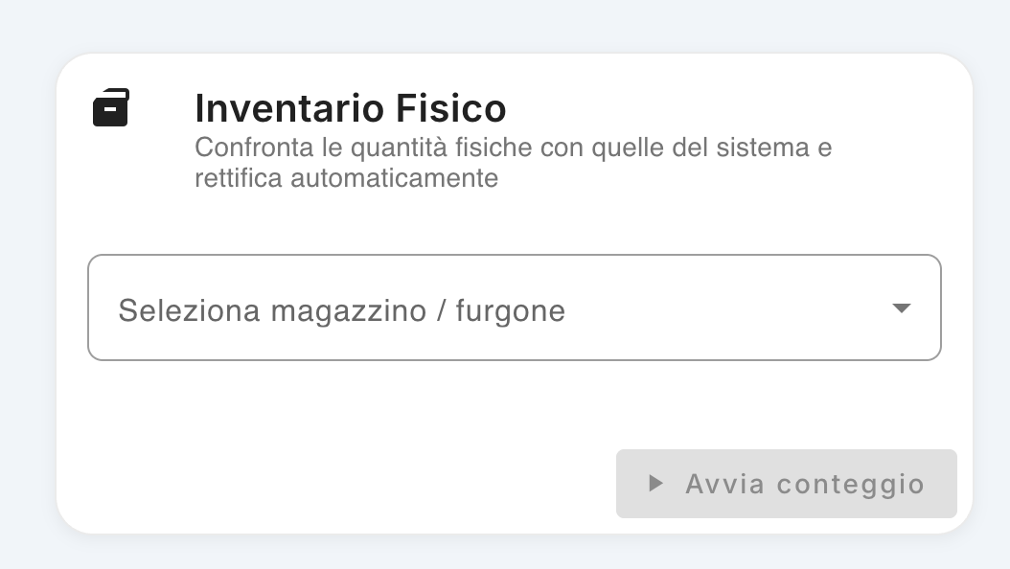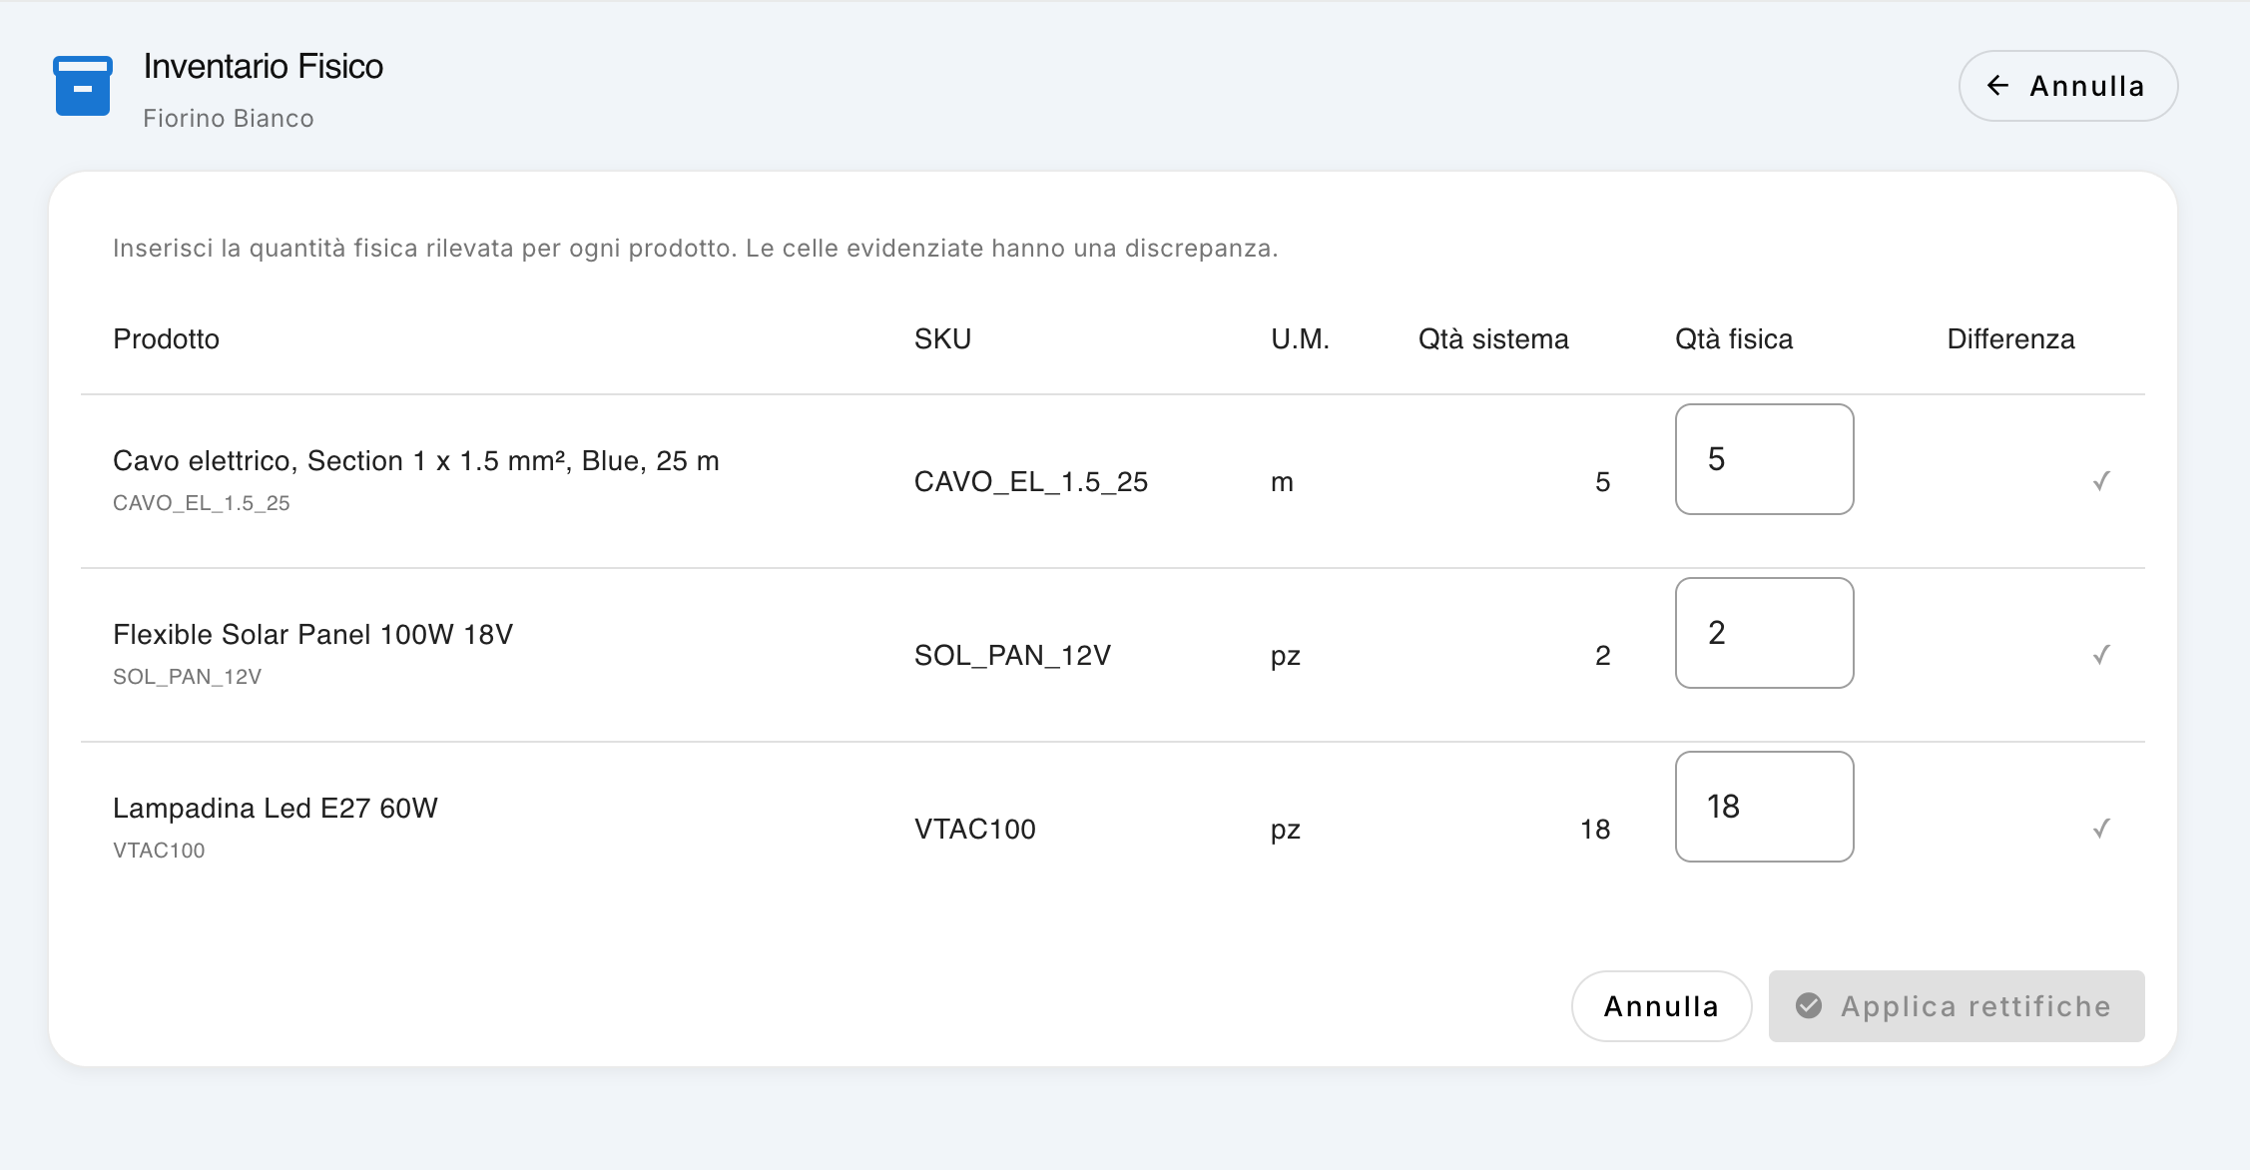The Physical Inventory feature allows you to compare the quantities of products registered in the system with the quantities that actually exist in a particular location, such as a warehouse or a van. In the event of any differences, the system stock can be corrected directly.

1. Select the location
To start an inventory:
- Go to the Physical Inventory section.
- From the Select Warehouse / Van menu, choose the location to be verified.
- Click Start Counting.
The system will load the list of products associated with the selected location.

2. Perform the count
The count screen shows, for each product:
- Product – product name and identifier;
- SKU – product code;
- U.M. – units of measurement;
- System Qty – quantity currently recorded in the system;
- Physical Qty – quantity actually detected during counting;
- Difference – any deviation between the system quantity and the physical quantity.
The operator must enter the number of units actually present in the position in the Physical Qty. column.

Example
If the system indicates:
System Qty: 5
but during the count 6 units are found, in the Physical Qty field the following must be entered:
6
The system will automatically detect the difference between the two quantities.
If the physical quantity matches the amount recorded in the system, no correction is required.

3. Apply adjustments
After you complete the count, check for any differences that you find.
If there are any discrepancies, click Apply adjustments.
The system will update the item's inventory using the physical quantities entered during the count.
This realigns the system inventory with the actual situation detected.

4. Uncount
If the count does not need to be completed, you can click Cancel to exit the screen without applying the adjustments.
Caution: Before using Apply Adjustments, carefully check the quantities entered. The operation directly modifies the stocks recorded in the system.

5. Using Physical Inventory
The feature is particularly useful for:
- periodically check the stocks of the warehouses;
- check the contents of vans;
- identify any differences between theoretical quantities and real quantities;
- correct loading, unloading or handling errors;
- keep the quantities available for work up to date and reliable.
In summary: you select the position → start the count → enter the quantities actually present → the differences occur → the adjustments are applied.

Log Error
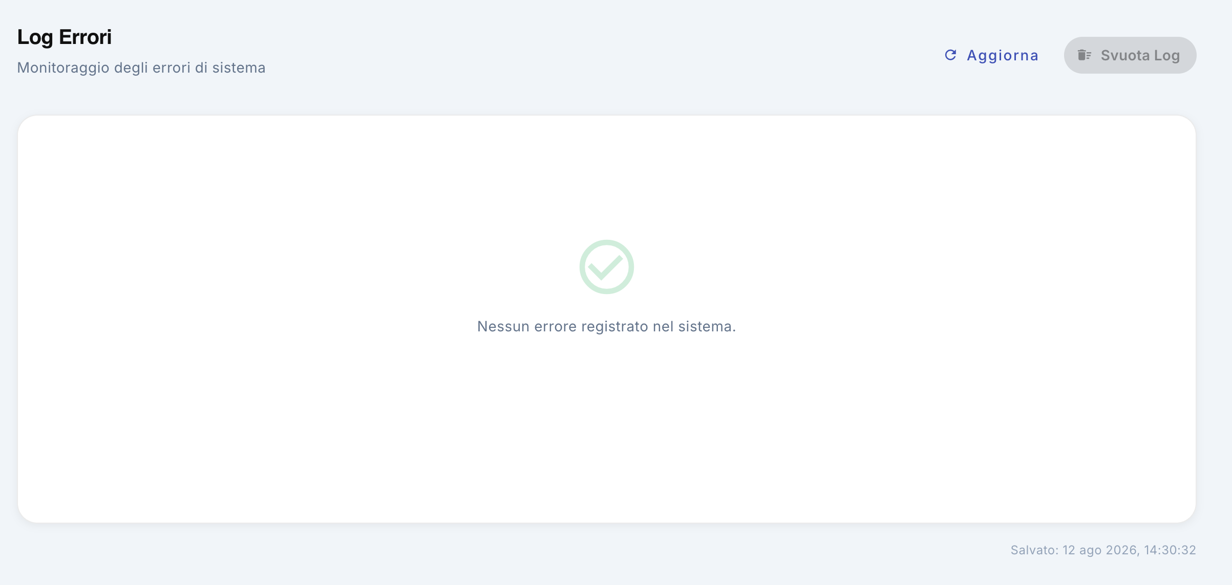

System error monitoring
The Log Error screen is reserved for the Administrator user and allows you to monitor any critical errors recorded by the application.
This feature is particularly useful for detecting system anomalies and providing technical support with the information they need to investigate and resolve any problems.

1. Viewing the log
The screen displays the list of errors logged by the system.
For each error, technical information may be available to help identify the nature of the problem. The log should be consulted especially when there are abnormal application behaviors, malfunctions or operations that are not completed correctly.
If there are no errors, the following message is displayed:
No errors are recorded in the system.
This indicates that there are no errors recorded in the log at the time of consultation.

2. Log update
To check for new errors, you can use the Update button, present at the top right.
The update allows you to reload the contents of the log and see if any new events have been logged in the meantime.
We recommend that you use Update before reporting an issue to support to ensure that you have the latest information.

3. Use in case of problems
In the event of a malfunction of the application:
- Access the Log Error screen.
- Press Update.
- Check for any errors logged.
- Write down or communicate information about the errors you see to support.
- If possible, also indicate the operation you were doing when the problem occurred.
The information in the log can help support more quickly pinpoint the cause of the anomaly.

4. Clear Log
The Empty Log button, present at the top right, allows you to delete the errors recorded in the log.
This should only be done when necessary, preferably after verifying that any errors are no longer useful for a diagnosis or for reporting to support.

Note to the administrator
Log Error is a diagnostic tool and does not normally require any activity from the administrator. If there are errors, its primary purpose is to gather information that can be used by technical support, not to correct the problem directly.

System
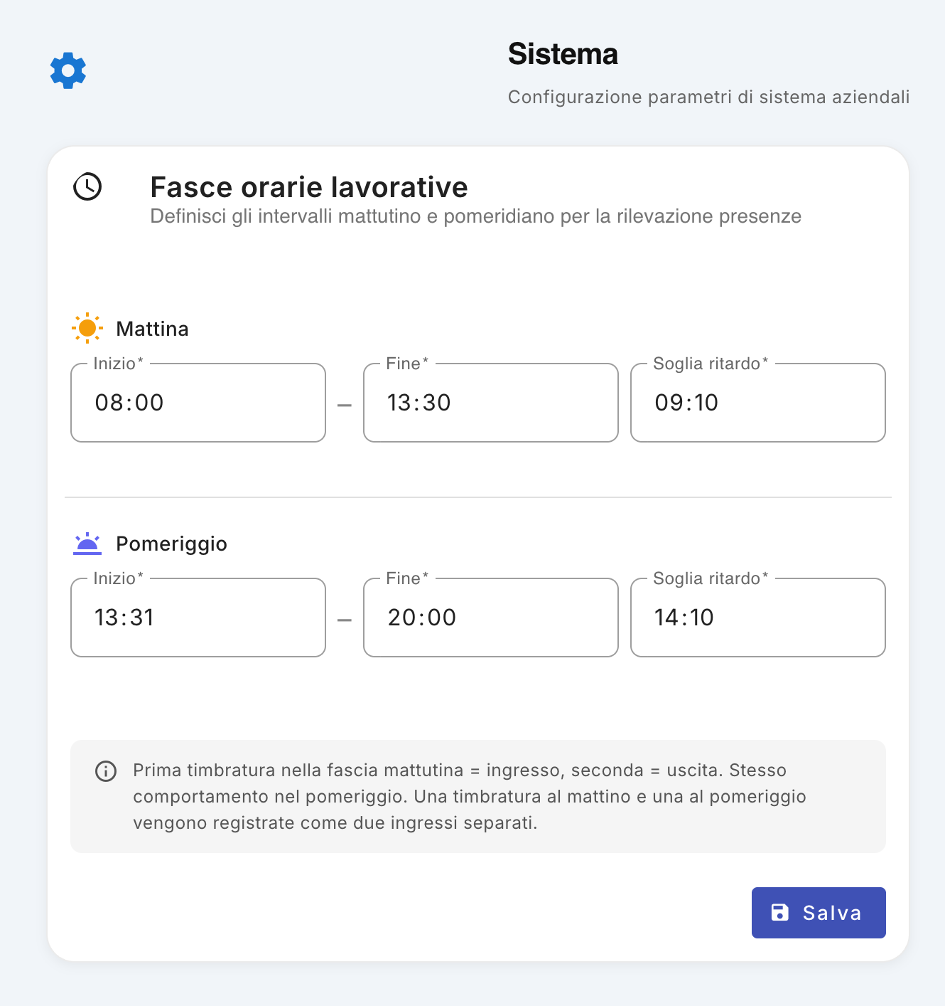
The System section, available in the administration menu, allows you to configure the general parameters relating to the company's working time slots. The settings defined in this section apply to all users in the company.

Working hours
The configuration includes two distinct bands:
- Morning
- Afternoon
For each band it is possible to set:
- Start – the start time of the working slot;
- End – the end time of the slot;
- Delay threshold – the time by which the user must clock in without generating a delay anomaly.

Example
Let's say that for the morning slot you have configured:
- Start: 08:00
- End: 13:30
- Delay Threshold: 09:10
In this case, the user must clock in by 09:10.
- A clocking in at 08:00 is recorded regularly.
- A clocking in at 08:45 is recorded regularly.
- A clocking in at 09:05 is still considered within the threshold.
- A clocking in at 09:11 instead generates a delay anomaly that can be verified by the administrator.
The same logic is applied to the afternoon slot.

Clocking management
The system uses the bands configured to interpret the clocking made by users.
Within each band:
- the first clocking is considered as entry;
- the second clocking is considered as the output.
A clocking carried out in the morning and one carried out in the afternoon are then recorded as two separate entrances, each referring to its own work slot.
Please note: the configuration of time slots is company-specific. The changes made in the System section do not affect a single user, but are applied to the entire company.

Change hours
To change the configuration:
- Go to the Admin menu.
- Open the System section.
- Change the start, end and delay times of the morning and/or afternoon slot.
- Check that the times entered are consistent with each other.
- Click Save.
The new settings will be used by the system for the management of attendance and for the detection of any delay anomalies.

User Manual 1
Web App v1.0 1
Customizing the navigation menu 2
1. Reorder menu items 2
2. Personal organization 3
In summary 3
Dashboard 4
1. User and work environment 4
2. KPIs and main reports 5
Low stock 5
Missing products 5
Movements today 5
3. Quick access to operations 5
New work 6
New movement 6
4. Inventory indicators 6
Positions 6
Products 6
Movements 6
Inventory value 7
5. Low stock 7
6. Recent movements 7
7. Dashboard Feature Summary 8
Products 9
1. Total number of products 9
2. Warehouse Export and Import 10
Export CSV 10
Import 10
3. Listing a new product 10
4. Product research 11
5. Filters 11
Category 11
Location 11
Low stock 11
6. Product Sheet 12
Product image and name 12
SKU 12
Category 12
7. Quantity in stock 12
8. Minimum quantity and low stock 13
9. Product Actions 13
Handling 13
Edit 14
Delete 14
10. Operational management of products 14
Creating a new product 16
1. Product Image 16
2. Product Name 17
3. SKU 17
4. Barcode / EAN 17
5. Category 18
6. Quantity 18
7. Units of measurement 18
8. Scorta minima 19
9. Location 19
10. Unit price 19
11. Tracking lots and expirations 20
12. Description 20
13. Notes 20
14. Product creation 20
15. Summary of product data 21
Scanner Barcode 22
1. Start the scanner 22
2. Barcode scanning 22
3. Access to the product sheet 23
4. Manual code entry 23
5. Operational Usage 23
Movements 25
1. Creating a new movement 25
2. Motion filters 26
Type 26
Date range 26
Quick filters 26
3. List of transactions 26
4. Transfer 27
5. Using a Product 27
6. Loading a product 28
7. Information associated with movement 28
8. Deleting a Motion 29
9. Summary 29
Creating a new movement 30
1. Movement Type Selection 30
Loading 30
Exhaust 31
Transfer 31
2. Product selection 31
3. Quantity 31
4. Location 32
5. Note and reference work 32
6. Purchase price 33
7. Motion recording 33
8. Examples of use 33
Example 1 — Load from supplier 33
Example 2 — Discharge for use 33
Example 3 — Transfer 34
9. Summary 34
Works / Construction sites 36
1. Creating a new job 36
2. Filters 37
Status 37
Customer 37
Product not available 37
3. Job sheets 37
Title and status 38
4. Customer, Worker and Date 38
5. Address of the intervention 38
6. Job Description 39
7. Movements associated with work 39
8. Available Actions 39
Open 39
Map 40
Edit 40
9. Product Not Available Reporting 40
10. Summary 40
Details of works 42
1. Main information of the work 42
2. Work Progress 43
3. Booking the van 43
4. Hours of the intervention and signature of the customer 44
5. PDF Report 44
6. Operational sections of the detail 44
6.1 Check availability 44
6.2 Record Motion 45
6.3 Photos 45
6.4 History 45
7. Work Workflow 45
Geolocation map of work 47
1. Map Header 47
2. Map View 47
3. Items recorded while working 48
4. Viewing photographs 48
5. Usefulness of geolocation 49
In summary 49
Creating a new job 50
1. Opening the mask 50
2. Compilation of work data 50
Speaking time 51
Priorities 51
Status 51
3. Planning via vehicle calendar 52
Selection of the available worker 52
4. Job creation and assignment 52
Purchase orders 54
1. Create a new order 54
2. Products under minimum stock 54
Quickly create a replenishment order 55
3. List of orders received 55
4. Using the Screen 55
Purchase Order Detail 57
1. Order Header 57
2. Order Information 57
3. Products under minimum stock 58
4. Item Management 58
Edit an article 59
Delete an article 59
5. Order total 59
6. Workflow 59
Charge van 61
1. Select warehouse and van 61
2. Search for a product 62
3. Select products 62
Change the quantity 62
4. Check your selection 63
5. Load 63
Operational example 63
Daily van summary 65
1. Select the report parameters 65
2. Summary of activities 65
3. Summary by product 66
4. Detail of movements 66
Example 67
5. Print or export the summary 67
Print / PDF 67
WhatsApp 67
6. Usefulness of the daily summary 67
Van availability 69
1. Calendar view 69
2. Check for an occupied van 70
3. Navigate between weeks 70
4. Manage vans 70
5. Use for Planning 70
Daily Reports 72
1. List of Reports 72
2. View the detail of a report 73
Completed works 73
Other movements 73
3. Daily Report Example 74
4. Create a new report 74
Summary 74
Margins and costs 75
1. Key KPIs 75
Inventory value – cost 75
Inventory value – list price 76
Potential inventory margin 76
Margin of works 77
Products with known cost 77
2. Price list 78
How to use this data 78
3. Margin of individual products 78
4. Analysis "For Work" 79
5. Material cost 80
6. Material value 80
7. Margin per job 80
Example 81
8. Movements 81
9. How to use the screen to generate value 81
Optimize inventory 82
Identify the most profitable products 82
Analyze the profitability of the works 82
Check the quality of economic data 83
10. Overall interpretation 83
Planning 85
1. Feature Description 85
2. Weekly View 86
Navigating between weeks 86
3. Filter by worker 86
4. Unplanned work 87
5. Create a new job 87
6. State of play 87
7. View the detail of a job 88
Changing the status 88
8. Open the job on the Jobs screen 88
9. Operational use of Planning 89
Recommended Workflow 89
Technical timelines 90
1. Feature Description 90
2. Timeline Navigation 91
Day / Week 91
Date selection 91
3. Technician filter 91
4. Reading the timeline 92
Duration of the activity 92
5. Task colors and status 92
6. Detail of an activity 92
Photos of the surgery 93
7. Access to job detail 93
8. Operational Usage 93
In summary 94
Statistics 95
1. Feature Description 95
2. Period selection 95
3. Weekly movement trend 96
How to interpret the chart 96
4. Top products handled 97
5. Operational use of statistics 97
Inventory planning 97
Organization of vans 97
Work activity analysis 98
6. Reading Example 98
7. Goal of the feature 98
Company badge and QR Code 100
1. Feature Description 100
2. Displaying the Company Badge 101
3. How to use the QR Code 101
4. Updating the QR Code 101
5. Use for Time and Attendance 102
6. Instructions displayed on the monitor 102
7. Operational indications 102
Attendance management 104
1. Overview 104
Selection of the day 104
Attendance summary 105
List of employees 105
Alert live 105
2. Events 106
Filters 106
Editing Events 107
3. Anomaly 107
4. Requests 108
Request management 108
5. Audit log 109
Feature summary 110
My absences 111
1. Access to the screen 111
View by employee 112
2. Absence calendar 112
3. Navigating Between Months 112
4. List of absences of the month 113
5. Types of absence 113
6. Impact on work planning 114
7. Entering absences 114
8. Usage by the Administrator 114
In summary 115
Administration 116
Customers 117
1. Access to customer management 117
2. Onboarding a new customer 118
3. Customer List 118
4. Viewing the client's jobs 119
5. Changing customer data 119
6. Deleting a customer 119
7. Search for a customer 119
Summary of operations 120
Data Import and Export 121
1. Accessing the Feature 122
2. Data export 122
Data included in the export 122
Structure of the archive 123
3. Data Import 123
Dragging and dropping the file 123
File selection 123
4. Data Recovery 124
5. Centralized Backup and Import/Export 124
Centralized backup 124
Import / Export della Company 124
6. Summary of operations 125
Positions 126
1. Viewing Locations 126
2. Creating a new location 127
Location States 127
3. Position management 127
Products 128
Change of status 128
Edit 128
Elimination 128
4. Using Positions in Product Management 128
5. Summary of operations 129
Suppliers 130
1. Consultation of suppliers 130
2. Onboarding a new supplier 131
3. Managing Existing Vendors 131
4. Summary information 132
Users 133
1. List of users 133
2. Add a new user 134
Available roles 134
3. Edit a user 135
4. Reset della password 135
5. Delete a user 135
6. Configuring the email service 135
SMTP Parameters 136
7. License Management 136
Summary of operations 137
Good administrative practice 137
Features 138
1. How a Feature Works 138
Important 138
2. Creating a Feature 139
Example 139
3. Configure the Features of a Company 139
Example 139
4. Effects of disabling 140
Web Application 140
Mobile Application 140
5. Re-enable a Feature 140
6. Features and user permissions 141
7. Full Example 141
Company A 141
Company B 142
Company C 142
8. Changing the configuration 142
9. Good practices 142
In summary 143
Fix Warehouse 144
1. Feature Description 144
2. Access to Fix Stock 144
3. Fault check 145
Correct situation 145
Unassigned products 145
4. Inventory correction 145
Procedure 146
5. Final check 146
Physical inventory 147
1. Select the location 148
2. Perform the count 148
Example 148
3. Apply adjustments 149
4. Uncount 149
5. Using Physical Inventory 149
Log Error 150
System error monitoring 150
1. Viewing the log 150
2. Log update 151
3. Use in case of problems 151
4. Clear Log 151
Note to the administrator 151
System 152
Working hours 152
Example 153
Clocking management 153
Change hours 154

